KWAME NKRUMAH UNIVERSITY OF SCIENCE AND TECHNOLOGY, KUMASI.
FACULTY OF PHYSICAL AND COMPUTATIONAL SCIENCES
DEPARTMENT OF COMPUTER SCIENCE

FINAL YEAR PROJECT



PROJECT TOPIC
ECHOLOCATE: A MULTIMODAL MOBILE SYSTEM FOR CROWDSOURCED INDOOR MAPPING AND ACCESSIBLE INDOOR NAVIGATION USING AUGMENTED REALITY AND ACOUSTIC DIGITAL SIGNAL PROCESSING

SUBMITTED BY:
FESTUS ABBOAH
ADAMA ABDUL-SAMED
ADOMAKO JOHN KWAKU

A PROJECT REPORT SUBMITTED TO THE DEPARTMENT OF COMPUTER SCIENCE,
KWAME NKRUMAH UNIVERSITY OF SCIENCE AND TECHNOLOGY, KUMASI,
IN PARTIAL FULFILMENT OF THE REQUIREMENTS FOR THE DEGREE OF
BACHELOR OF SCIENCE IN COMPUTER SCIENCE

SUPERVISOR: [SUPERVISOR’S NAME]

SEPTEMBER 2026

DECLARATION
We hereby declare that this project report is our own work towards the award of the Bachelor of Science degree in Computer Science, and that to the best of our knowledge it contains no material previously published by another person, nor material which has been accepted for the award of any other degree of this or any other university, except where due acknowledgement has been made in the text.
The system described in this report was designed and implemented by the authors. Where the work of others has been used, it is cited in the text and listed in full under References.

Name | Index number | Signature | Date
FESTUS ABBOAH
ADAMA ABDUL-SAMED
ADOMAKO JOHN KWAKU

Certified by:
Role | Name | Signature | Date
Supervisor
Head of Department

ACKNOWLEDGEMENT
We are grateful to our supervisor for the guidance, criticism and patience that shaped this project, and to the lecturers of the Department of Computer Science, Kwame Nkrumah University of Science and Technology, whose teaching prepared us for it.
We thank the staff of the College of Science building, who allowed us to trace their first floor and to walk it repeatedly while testing the guidance, and the friends and colleagues who lent their time, their phones and their patience to our trials.
Finally, we thank our families for their support throughout the year. Any errors that remain in this report are our own.

ABSTRACT
Indoor spaces are largely unmapped. Satellite positioning stops at a building’s entrance, and the tools capable of producing an indoor map are priced or provisioned beyond ordinary users: professional laser scanners cost upwards of £14,000, and consumer applications reach useful accuracy only on premium hardware. Most campuses, hospitals and public offices therefore have no digital map at all, and blind and low-vision people in particular must navigate them unaided.
This project designed, implemented and evaluated EchoLocate, a Flutter application that treats the production of an indoor map, rather than the precision of indoor sensing, as the binding constraint. A contributor traces a metrically scaled two-dimensional plan of a storey from a photographed floor plan or from the space itself, on any Android handset and without depth hardware. The traced geometry is cleaned and converted into a navigable graph in which rooms and corridors are nodes and doorways weighted edges, over which a custom Dart A* engine computes door-to-door routes and generates turn-by-turn instructions. Plans are published to a Supabase repository so that any user can load and navigate a building someone else has mapped, while a local-first on-device store keeps authoring and browsing available offline. A route is delivered in two co-equal modes: map-and-sound guidance, spoken with haptic cues and hardware step counting, requiring neither camera nor ARCore; and an augmented-reality arrow registered into the building by a similarity transform solved from one known position and one observed heading, re-anchored at every confirmed landmark. On-device machine learning raises obstacle alerts and reads signage aloud, and a Dart-native frequency-modulated chirp and Fourier pipeline classifies the type of space from its reverberation.
The delivered system comprises 40,389 lines of Dart, 4,749 lines of Kotlin and 927 passing automated tests across 24 screens. Eight routes were walked door to door in a university building: all three map-and-sound walks reached their destination, and three of five augmented-reality walks did. The eyes-free mode was exercised on an ARCore-uncertified handset, establishing that accessible guidance runs on the hardware the intended users own. The acoustic signal chain was shown to be sound and its reverberation fit window shown to be at fault — a negative result reported here with its diagnosis. Quantitative accuracy measurement across multiple environments remains the principal outstanding work.
Keywords: indoor navigation; crowdsourced indoor mapping; augmented reality; digital signal processing; room acoustics; accessibility; A* routing; Flutter.

TABLE OF CONTENTS
DECLARATION 3
ACKNOWLEDGEMENT 4
ABSTRACT 5
LIST OF FIGURES 9
LIST OF TABLES 10
CHAPTER ONE: PROJECT PROPOSAL 11
1.1 INTRODUCTION AND BACKGROUND 11
1.2 PROBLEM STATEMENT 11
1.3 AIM OF THE PROJECT 11
1.4 SPECIFIC OBJECTIVES 12
1.5 PROJECT SCOPE 13
1.6 MOTIVATION FOR UNDERTAKING THE PROJECT 15
1.7 JUSTIFICATION OF THE PROJECT 15
1.8 PROJECT METHODOLOGY 16
1.9 PROJECT DELIVERABLES 17
1.10 PROJECT PLAN AND TIMELINES 18
CHAPTER TWO: REVIEW OF RELATED SYSTEMS 22
2.1 INTRODUCTION 22
2.2 OVERVIEW OF EXISTING SYSTEMS 22
2.3 REVIEW OF EXISTING SYSTEMS 22
2.4 COMPARATIVE SYSTEM ANALYSIS 26
2.5 DISCUSSION OF COMPARATIVE ANALYSIS 27
2.6 JUSTIFICATION FOR THE PROPOSED SYSTEM 28
2.7 RESEARCH GAPS IDENTIFIED 28
2.8 CONCEPTUAL DESIGN 30
2.9 SUMMARY 32
CHAPTER THREE: METHODOLOGY 33
3.1 Introduction 33
3.2 Architecture of the Proposed System 33
3.3 Component Design and Descriptions 34
3.4 Evaluation and Analysis of Software System Type 35
3.5 Functional Requirements of the Proposed System 36
3.6 Identification of Stakeholders 36
3.7 Requirement Gathering Process 37
3.8 Requirement Specification 37
3.9 Non-Functional Requirements 42
3.10 Candidate Classes and UML Class Diagram 43
3.11 Algorithms for the System 45
3.12 Project Methods to be Employed 49
3.13 Software Process Model 49
3.14 Project Design Considerations (Logical Designs) 50
3.15 Development Tools 54
CHAPTER FOUR: IMPLEMENTATION, TESTING, AND RESULTS 56
4.1 Implementation 56
4.2 Testing 66
4.3 Results 68
CHAPTER FIVE: FINDINGS, CONCLUSIONS AND RECOMMENDATIONS 74
5.1 Introduction 74
5.2 Findings 74
5.3 Conclusions 80
5.4 Challenges Encountered 81
5.5 Lessons Learned 83
5.6 Novelty of the System 84
5.7 Recommendations for Future Works 86
REFERENCES 89

LIST OF FIGURES
Figure 2.1: EchoLocate Conceptual Design — the Five-Stage Authoring, Mapping and Navigation Pipeline 32
Figure 3.1: EchoLocate Layered System Architecture (On-Device Sensing with Crowdsourced Cloud Tier) 33
Figure 3.2: Use Case Diagram — EchoLocate Mobile Application (Front-End) 39
Figure 3.3: Use Case Diagram — EchoLocate Crowdsource Backend (Back-End) 39
Figure 3.4: Activity Diagram — Floor-Plan Authoring Flow 41
Figure 3.5: Activity Diagram — Indoor Navigation Flow 41
Figure 3.6: Sequence Diagram — Author and Publish a Floor Plan 42
Figure 3.7: Sequence Diagram — Navigate to a Room 42
Figure 3.8: UML Class Diagram — EchoLocate System 44
Figure 3.9: Flowchart — Floor-Plan Authoring and Graph Derivation Algorithm 45
Figure 3.10: Flowchart — Acoustic Room Classification Algorithm 46
Figure 3.11: Flowchart — A* Indoor Navigation Algorithm 48
Figure 3.12: Registration Geometry — the Plan Frame, the ARCore World Frame, and the One Point and One Direction that Relate Them 49
Figures 3.13–3.24: EchoLocate User-Interface Wireframes 52
Figure 3.25: Entity-Relationship Diagram — EchoLocate Database 53
Figure 3.26: Database Schema — EchoLocate Supabase Tables 54
Figure 4.1: Implemented Layered Architecture of EchoLocate 56
Figure 4.2: Principal Application Screens — Home, Explore, Maps and Profile 57
Figure 4.3: Welcome, Sign-In and Create-Account Screens 59
Figure 4.4: Floor-Plan Authoring — Tracing a Room, and the Completed Floor 60
Figure 4.5: A Planned Route Drawn over a Traced Floor, and Guidance in Progress 61
Figure 4.6: The Augmented-Reality Guidance Arrow, and Walking Assistance 63
Figure 4.7: A Captured FMCW Sweep, its Correlation, and the Fitted Decay Curve. Capture 3 of Table 4.9, taken in a quiet room of about 8 m × 10 m using the 2–8 kHz sweep. Panels (a) and (b) show the emission and the matched filter compressing it to a sharp impulse response; panel (c) shows the T20 fit falling inside the collapse of the direct pulse rather than the room’s decay — the failure diagnosed in §4.3.6. 65

LIST OF TABLES
Table 1.1: EchoLocate Action Plan by Phase 19
Table 1.2: Work Breakdown Structure 19
Table 1.3: Gantt Chart — Phases and Tasks against the Twelve-Week Timeline 20
Table 1.4: Project Milestones and Completion Criteria 21
Table 2.1: Comparative Analysis of Reviewed Systems against EchoLocate 27
Table 2.2: Research Gaps, the Systems Failing to Address Them, and EchoLocate’s Response 30
Table 3.1: EchoLocate System Components 34
Table 3.2: FMCW Acoustic Sensing Parameters 35
Table 3.3: On-Device Semantic Detection Targets (Google ML Kit) 35
Table 3.4: Functional User Requirements 37
Table 3.5: Functional System Requirements 38
Table 3.6: Use Case Description — UC-01: Author and Publish a Floor Plan 40
Table 3.7: Use Case Description — UC-02: Navigate to a Room 40
Table 3.8: Non-Functional Requirements with Justifications 43
Table 3.9: EchoLocate Candidate Classes 44
Table 3.10: Algorithm 1 — Floor-Plan Authoring and Graph Derivation 45
Table 3.11: Algorithm 2 — Acoustic Room Classification 46
Table 3.12: Algorithm 3 — A* Indoor Navigation 47
Table 3.13: Algorithm 4 — Route Registration 48
Table 3.14: EchoLocate Iterative Development Plan 50
Table 3.15: EchoLocate Development Tools 55
Table 4.1: Implemented Screens by Functional Group 57
Table 4.2: Native Augmented-Reality Layer — Kotlin Source Files 63
Table 4.3: FMCW Signal Parameters as First Proposed and as Implemented 64
Table 4.4: Room-Classification Thresholds 65
Table 4.5: Automated Test Suite Summary 66
Table 4.6: Augmented-Reality Test Handset Specification 68
Table 4.7: Revised Objectives against Delivered Outcome 69
Table 4.8: Routes Walked in Both Navigation Modes, with Outcome 71
Table 4.9: Three Acoustic Captures in a Quiet 8 m × 10 m Room 72
Table 4.10: Reverberation Time Recovered over Successively Later Fit Windows 72
Table 5.1: Summary of Principal Findings and Their Evidence 79
Table 5.2: Novel Elements of EchoLocate against the Nearest Prior Capability 86

CHAPTER ONE: PROJECT PROPOSAL

1.1 INTRODUCTION AND BACKGROUND
Modern smartphones can perceive and map indoor space without specialised equipment. EchoLocate pairs human-in-the-loop floor-plan authoring with three on-device modalities: ARCore motion tracking, which registers a planned route into the building so a guidance arrow points at the true destination; Frequency Modulated Continuous Wave (FMCW) chirps analysed by Digital Signal Processing (DSP) to classify a space from its reverberation; and Google ML Kit for reading signage aloud and warning of obstacles. Accessibility for blind and low-vision users is its organising concern.
Contributors share the plans they produce through a crowdsourced repository, so any user can load a building mapped by someone else and be guided inside it. Guidance comes in two co-equal modes: map-and-sound, drawing and speaking the route with haptic cues and step counting on any handset; and augmented reality, adding a registered arrow on ARCore-certified phones.

1.2 PROBLEM STATEMENT
GPS stops at the entrance of a building. Most campuses, hospitals, malls and public offices are not digitally mapped, so people routinely get lost inside them. The difficulty is greatest for blind and low-vision users: a white cane finds an obstacle but cannot say a target room lies ahead and to the left. Existing tools are expensive and hardware-dependent, single-platform, cloud-dependent, or limited to point measurements with no navigation, and indoor maps barely exist because producing one is costly and slow. A low-cost, privacy-preserving system in which ordinary users author and share indoor plans is therefore needed, so anyone — sighted or not — can navigate confidently indoors.

1.3 AIM OF THE PROJECT
To design, implement and evaluate EchoLocate, a Flutter application that lets ordinary users author metrically scaled 2D floor plans of previously unmapped buildings, share them through a crowdsourced repository, and navigate them turn by turn — including an augmented-reality arrow registered into the building and a fully eyes-free voice-and-haptic mode — using only commodity smartphone sensors, supported by an on-device acoustic DSP pipeline that classifies the type of space the user is in.

1.4 SPECIFIC OBJECTIVES
The following technical objectives will be pursued:
- Implement Human-in-the-Loop Floor-Plan Authoring: a module letting a contributor produce a metrically scaled 2D plan of a storey — by photographing a posted plan and tracing it, or tracing the space directly — yielding closed room polygons, corridors and connecting door openings.
- Derive a Navigable Graph from Traced Geometry: a pipeline converting traced polygons into a routable graph: rooms and corridors as nodes, doorways as weighted edges, corridor centrelines as the polyline a walker follows.
- Implement Graph-Based Indoor Route Planning: a custom Dart A* engine over that graph, computing door-to-door shortest paths and converting the node sequence into spoken turn-by-turn instructions.
- Implement Map-and-Sound Turn-by-Turn Guidance: deliver a route as a drawn line with spoken instructions, haptic cues and step counting, with per-user stride calibration so distances are spoken in the walker’s own paces — requiring no camera and no ARCore, so guidance runs eyes-free on any Android handset.
- Register a Planned Route into the Physical Building using Augmented Reality: implement a similarity transform carrying plan coordinates into the ARCore world frame from one known position and one observed heading, so the arrow points at the true destination rather than dead-reckoning from an assumed orientation, re-anchored at every confirmed landmark. This presents Objective 4’s route differently rather than replacing it.
- Implement On-Device Semantic Detection: integrate Google ML Kit object detection and text recognition to raise real-time obstacle alerts and read room numbers and signage aloud from the live camera feed, processed entirely on-device.
- Implement Acoustic Room Classification using Digital Signal Processing: a Dart-native FMCW chirp and FFT pipeline extracting reverberation time, early decay time and their ratio from a measured impulse response, classifying the space by physically interpretable rules.
- Build a Crowdsourced Map Repository with Local-First Persistence: a Supabase-backed repository letting users publish authored plans and browse, load and navigate plans contributed by others, over an on-device store keeping plans and drafts available offline.
- Evaluate and Document Performance Boundaries: test across at least three indoor environments, measuring dimensional accuracy against a tape measure, acoustic classification accuracy and navigation success rate for sighted and accessibility-mode users, documenting limitations and rejected approaches.

1.5 PROJECT SCOPE
Scope is bounded as follows, balancing feasibility against a 12-week academic timeline.

In Scope
- Cross-platform mobile application: A single-codebase Flutter application targeting Android, with the augmented-reality layer implemented natively.
- Human-in-the-loop floor-plan authoring: Metrically scaled 2D plans produced by tracing a photographed or observed floor, comprising room polygons, corridors, doorways and room type labels.
- Graph derivation and indoor route planning: Conversion of traced geometry into a navigable graph and computation of door-to-door shortest paths with a custom Dart A* engine, expanded along corridor centrelines.
- Map-and-sound turn-by-turn guidance: A route drawn over the floor plan and spoken turn by turn with haptic cues and step counting, requiring no camera and no ARCore.
- Augmented-reality route registration: A plan-to-world similarity transform allowing a planned route to be laid into the physical building, with re-anchoring at confirmed landmarks.
- Per-user stride calibration: Measurement of an individual walker’s step length so that stored distances are converted into that user’s steps.
- On-device semantic detection: Real-time obstacle alerts and reading of room numbers and signage from the live camera feed using Google ML Kit, processed entirely on the device.
- Acoustic room classification: FMCW chirp emission and FFT-based reverberation analysis classifying the type of space a user is in, evaluated as one modality within a multimodal system.
- Crowdsourced map repository: A community repository allowing contributors to publish the plans they author and any user to browse, load, and navigate buildings mapped by others.
- Local-first storage and sharing: An on-device hive_ce store holding authored plans, drafts and cached queries, keeping the application usable offline, with cloud-backed sharing of published plans.
- Prototype-level usability and structured testing: Core UI workflows (author, publish, browse, navigate) and structured benchmarking across three indoor environments.

Out of Scope
- Automatic floor-plan generation from depth sensing: reconstruction of wall geometry from an ARCore depth point cloud using RANSAC (Fischler & Bolles, 1981) and Hough-transform (Duda & Hart, 1972) line fitting. Depth capture survives as a diagnostic probe, but the line-fitting stage was superseded by tracing before producing navigable geometry; see §4.1.5.
- Extruded 3D preview: The system produces and renders 2D plans only.
- Learned acoustic classification: Room type is determined by interpretable decision rules over measured reverberation quantities rather than by a trained neural network — see §3.11.2 and §3.3.
- PDF export of floor plans: generating shareable documents from an authored plan. Sharing happens through the repository instead: a plan is published once and read by everyone. Recorded as future work, since the on-screen renderer is the one a document would use.
- Full photorealistic 3D reconstruction: The project is limited to 2D floor-plan authoring; dense, real-time photorealistic 3D mesh reconstruction is not included.
- Outdoor navigation and robustness guarantees: The system is optimised for indoor environments; outdoor navigation and conditions involving open spaces and high ambient noise are not supported.
- Fully automatic semantic room understanding: Detection is limited to the object and text classes provided by ML Kit; complete automatic interpretation of every element in a space is not included.
- CAD-grade geometric fidelity and direct CAD export: The system produces reference-grade spatial approximations; architectural-precision outputs and direct AutoCAD/CAD integration are outside the current scope.
- Guaranteed sub-centimetre accuracy: The system targets useful, reference-grade dimensional accuracy rather than the survey-grade precision of dedicated laser scanners.

1.6 MOTIVATION FOR UNDERTAKING THE PROJECT
The primary motivation is solving an everyday problem — getting lost inside buildings — with only the sensors already in a standard smartphone. Mapping applications transformed outdoor navigation, yet indoors a person is on their own. The team is drawn by combining augmented-reality motion tracking, acoustic signal processing and on-device machine learning into one multimodal system on commodity hardware.
A second motivation is accessibility. Blind and low-vision people struggle to navigate unfamiliar interiors independently — a population the World Health Organization (2019) estimates at more than 2.2 billion people living with a vision impairment worldwide, and existing tools do not address this. A voice-guided mode with obstacle alerts and haptic feedback extends indoor mapping to the users who need it most — a need underserved globally and especially in Ghana.
Finally, indoor maps for most buildings do not exist. The binding constraint is not the cost of sensing but of producing a map at all. Cheap crowdsourced authoring — a floor traced in roughly twenty minutes from the wall-posted plan, on any Android phone — addresses that supply problem, beginning with KNUST’s own buildings, with on-device processing keeping layout data private.

1.7 JUSTIFICATION OF THE PROJECT
EchoLocate is justified as a low-cost, accessible and privacy-preserving alternative to a fragmented landscape of tools. No current solution combines crowdsourced authoring, acoustic sensing, indoor navigation, accessibility and on-device privacy on commodity phones — least of all in a developing-country context. Human-in-the-loop authoring depends on no tracking quality, so it works on every Android handset; pairing it with an acoustic DSP pipeline retains a meaningful DSP contribution while delivering results on everyday hardware.

1.8 PROJECT METHODOLOGY
Development follows an Agile/Iterative methodology of five weekly-validated phases over twelve weeks, each with measurable acceptance criteria and a documented limitations log. This manages the technical uncertainty of multimodal sensing by correcting deficiencies in each layer before integration, favouring continuous benchmarking over feature completeness.
The five iterative phases, each with a defined acceptance gate, are:
- Phase 1 – Research and Foundation: literature review on crowdsourced indoor mapping, AR motion tracking and acoustic room classification; set up the Flutter, ARCore and ML Kit environment; validate camera capture and FMCW chirp emission. Acceptance gate: capture and chirp emission demonstrated on a physical device.
- Phase 2 – Floor-Plan Authoring and Routing: trace room and corridor polygons against a photographed plan, establish a metric scale from one known distance, clean the geometry, derive the navigable graph, implement the Dart A* planner and instruction generation. Acceptance gate: a scaled plan authored and a door-to-door route computed over it.
- Phase 3 – Acoustic DSP and Room Classification: implement FMCW chirp generation, the FFT pipeline and reverberation feature extraction; implement the rule-based classifier with its fit-quality and decay-range gate. Acceptance gate: classification operational, with noise-derived estimates rejected.
- Phase 4 – Guidance, AR Registration, Crowdsourcing and Accessibility: implement map-and-sound guidance with haptic cues and step counting; AR route registration and the waypoint arrow with landmark re-anchoring; ML Kit obstacle detection and sign reading; the Supabase repository, hive_ce local-first persistence, the accessibility voice mode and per-user stride calibration. Acceptance gate: a feature-complete application build.
- Phase 5 – Testing and Refinement: map-accuracy testing across three indoor environments, acoustic classification accuracy tests, and navigation success-rate testing for sighted and accessibility-mode users; profile performance and finalise the report. Acceptance gate: a validated, deployable build meeting the accuracy and usability targets.

Development Tools and Technologies
EchoLocate is built with Flutter (Dart), targeting Android from a single codebase. The presentation layer uses flutter_bloc; a custom ARCore platform channel supplies motion tracking and world-frame pose; Google ML Kit performs on-device object detection and text recognition; fftea provides the Fourier analysis at the centre of the acoustic pipeline, with flutter_soloud and record emitting the chirp and capturing the response; pedometer and sensors_plus give hardware step counting; a custom Dart A* engine computes routes; hive_ce holds plans, drafts and cached queries locally; Supabase backs the crowdsourced repository; and flutter_tts with speech_to_text provide the voice interface. Each tool and its role in the methodology is set out in Table 3.15 (Section 3.15).

1.9 PROJECT DELIVERABLES
The following deliverables will be produced and submitted within the 12-week timeline:
Deliverable 1 – Floor-Plan Authoring Module: A tracing workflow producing metrically scaled 2D floor plans of room polygons, corridors, doorways and room type labels, with draft persistence protecting partially completed work.
Deliverable 2 – Acoustic DSP and Room-Classification Module: a Dart-native FMCW and FFT pipeline extracting reverberation features from a measured impulse response, with an interpretable rule-based classifier mapping them to a space type. This is the project’s DSP contribution.
Deliverable 3 – Indoor Navigation and Routing System: A graph-derivation pipeline and custom Dart A* routing engine producing door-to-door routes and turn-by-turn instructions, with an AR waypoint overlay registered into the building and re-anchored at confirmed landmarks.
Deliverable 4 – EchoLocate Mobile Application (Flutter): An installable Flutter application providing authoring, browsing and navigation workflows, a 2D plan view, and an eyes-free voice-and-haptic guidance mode with obstacle alerts, sign reading and per-user stride calibration.
Deliverable 5 – Crowdsourced Map Repository with Local-First Persistence: A Supabase-backed community repository for publishing, browsing, loading and navigating shared floor plans, over a local-first on-device store supporting offline authoring and use.
Deliverable 6 – Evaluation and Test Report: a validation report covering dimensional accuracy against a tape measure across at least three indoor environments, acoustic classification accuracy and navigation success rate for sighted and accessibility-mode users, with raw data, analysis and a discussion of limitations and rejected approaches.
Deliverable 7 – Final Project Report and Source Code: a report meeting KNUST Department of Computer Science formatting standards, with all design diagrams, test results and reflective evaluation, plus documented source code in the designated repository.

1.10 PROJECT PLAN AND TIMELINES
The project runs over twelve weeks from March 2026 across the five phases above. The subsections below give the Action Plan, Work Breakdown Structure, Gantt Chart and Milestones.

Action Plan
The Action Plan sets out the activities and expected output of each phase against the twelve-week timeline.
Phase | Weeks (2026) | Principal activities | Expected output
1. Research and Foundation | 1–2 (17–30 Mar) | Literature review on crowdsourced indoor mapping, AR motion tracking and acoustic room classification; Flutter, ARCore and ML Kit environment configured; camera capture and FMCW chirp emission validated on a physical device. | Annotated bibliography; technology-stack decision; capture-and-chirp prototype
2. Floor-Plan Authoring and Routing | 3–5 (31 Mar–20 Apr) | Trace closed room and corridor polygons against a photographed plan, scaled from one known distance; geometry cleanup and navigable-graph derivation; custom Dart A* planner and turn-by-turn instruction generation; dimensional benchmark against a tape measure. | Tracing and cleanup module; graph derivation; route planner; accuracy benchmark
3. Acoustic DSP and Classification | 6–7 (21 Apr–4 May) | FMCW chirp generation, the FFT pipeline and reverberation feature extraction; rule-based classifier over RT60 and the EDT/RT60 ratio, with its fit-quality gate. | Acoustic feature-extraction module; classification module with rejection
4. Guidance, AR, Crowdsourcing and Accessibility | 8–9 (5–18 May) | Map-and-sound guidance with haptic cues and hardware step counting; ML Kit obstacle detection and sign reading; AR route registration and the arrow with landmark re-anchoring; Supabase, hive_ce, voice mode and stride calibration. | Guidance engine; detection demonstration; feature-complete build with crowdsource upload
5. Testing and Refinement | 10–12 (19 May–8 Jun) | Map-accuracy testing across three indoor environments; acoustic classification accuracy tests; navigation success-rate testing in both modes; profiling, regression testing, UI polish and accessibility audit; report completion. | Accuracy and classification report; navigation study results; final release build and project report
Table 1.1: EchoLocate Action Plan by Phase

Work Breakdown Structure (WBS)
The Work Breakdown Structure decomposes the project into deliverable-oriented tasks, each with a unique WBS identifier for traceability.
WBS ID | Task / deliverable description | Weeks
1.0 | EchoLocate — Multimodal Indoor Mapping and Navigation Application | 1–12
1.1 | Research and Foundation — literature review on crowdsourced mapping, AR motion tracking and acoustic room classification; evaluation and selection of ARCore, ML Kit and audio packages; development-environment setup; camera-capture and chirp-emission validation on the target device | 1–2
1.2 | Floor-Plan Authoring and Routing — plan photography, polygon tracing and metric scale from one known distance; geometry cleanup and navigable-graph derivation with corridor centrelines; custom Dart A* route planner and turn-by-turn instruction generation; dimensional accuracy benchmarking against a tape measure | 3–5
1.3 | Acoustic DSP and Room Classification — FMCW chirp generation and the Dart FFT pipeline; reverberation feature extraction (RT60, EDT, decay-fit r², usable decay range); rule-based classifier with fit-quality and decay-range gate; threshold parameterisation for later re-fitting against measured rooms | 6–7
1.4 | Guidance, AR Registration, Crowdsourcing and Accessibility — map-and-sound guidance with haptic cues and step counting; ML Kit obstacle detection and sign reading; AR route registration and the waypoint arrow with landmark re-anchoring; Supabase upload and browsing with hive_ce local-first persistence; accessibility voice mode and per-user stride calibration | 8–9
1.5 | Testing and Refinement — map-accuracy testing across three indoor environments; acoustic classification accuracy and statistical analysis; navigation success-rate study for sighted and accessibility-mode users; performance profiling and optimisation; final regression testing, UI polish and accessibility audit; report compilation and source-code submission | 10–12
Table 1.2: Work Breakdown Structure

Gantt Chart
The Gantt Chart maps each phase and its tasks against the 12-week timeline (March – June 2026); shaded cells indicate active work.
Task / Phase | W1 | W2 | W3 | W4 | W5 | W6 | W7 | W8 | W9 | W10 | W11 | W12
Phase 1: Research & Foundation
1.1 Literature review & tech stack
1.2 ARCore/ML Kit setup & camera+chirp validation
Phase 2: Floor-Plan Authoring & Routing
2.1 Tracing, metric scale & geometry cleanup
2.2 Graph derivation & A* route planner
2.3 Dimensional accuracy benchmark
Phase 3: Acoustic DSP & Room Classification
3.1 FMCW + FFT + reverberation features
3.2 Rule-based classifier & fit-quality gate
Phase 4: Guidance, AR, Crowdsource & Accessibility
4.1 Map-and-sound guidance & ML Kit detection
4.2 AR registration, crowdsource, persistence, accessibility
Phase 5: Testing & Refinement
5.1 Map accuracy & classification testing
5.2 Navigation study & profiling
5.3 Final testing & report
Table 1.3: Gantt Chart — Phases and Tasks against the Twelve-Week Timeline

Milestones — Major Targets and Achievements
Five milestones are the checkpoints against which progress is evaluated. Each corresponds to a phase completion gate, reviewed by the team and supervising lecturer before the next phase begins.
ID | Milestone | Target date | Completion criterion and evidence
M1 | Project Foundation Complete | End of Week 2 (30 Mar 2026) | Foundational research on crowdsourced indoor mapping, AR motion tracking and acoustic room classification documented; the Flutter, ARCore and ML Kit environment configured; camera capture and FMCW chirp emission demonstrated on a physical device. Evidence: literature review · environment checklist · capture-and-chirp demo build.
M2 | Floor-Plan Authoring Engine Operational | End of Week 5 (20 Apr 2026) | A contributor can trace room and corridor polygons against a photographed plan, set a metric scale, mark door openings, and have the geometry cleaned and converted into a navigable graph. Evidence: tracing and cleanup module · graph derivation and A* planner · dimensional accuracy report.
M3 | Acoustic Sensing Complete | End of Week 7 (4 May 2026) | FMCW chirp generation, the FFT pipeline, reverberation feature extraction and the rule-based classifier return a space type with a confidence or an explicit rejection. Evidence: FMCW and FFT module · feature extraction · rule-based classifier with fit-quality gate.
M4 | Feature-Complete Application | End of Week 9 (18 May 2026) | Map-and-sound guidance, the registered AR arrow, obstacle detection and sign reading, the Supabase repository, local-first persistence, stride calibration and the eyes-free mode integrated into one build. Evidence: integrated Android build · navigation and crowdsource demonstration · voice-mode demonstration · AR registration demonstration.
M5 | Validated and Deployable Product | End of Week 12 (8 Jun 2026) | Map-accuracy tests across at least three indoor environments, acoustic classification tests and navigation success-rate testing for sighted and accessibility-mode users passed, with defects resolved. Evidence: evaluation report (three environments) · final release build · profiling report · report and source code.
Table 1.4: Project Milestones and Completion Criteria

CHAPTER TWO: REVIEW OF RELATED SYSTEMS

2.1 INTRODUCTION
This chapter reviews systems related to EchoLocate’s core functionality: indoor spatial mapping, 2D floor-plan generation, indoor navigation and accessible spatial awareness. Key features, strengths and limitations are identified for each, followed by a comparative table and a justification for the proposed system.

2.2 OVERVIEW OF EXISTING SYSTEMS
Conventional indoor mapping once required total stations and laser rangefinders, making it expensive and inaccessible to ordinary users (Gu et al., 2009). Smartphones carrying accelerometers, gyroscopes, magnetometers, capable cameras and good microphones have since opened consumer-grade spatial sensing (Mirowski et al., 2013).
Contemporary solutions fall into four groups: AR and computer-vision measurement tools using visual-inertial odometry; dedicated laser and LiDAR instruments; acoustic sensing systems; and hybrid multi-modal approaches (Faggion et al., 2020). Almost all stop at measurement; very few extend to navigation, and none combine community-contributed maps with accessibility support.
Four representative systems are examined below, illustrating the state of the art and the unmet needs — navigation, crowdsourcing, accessibility and on-device privacy — that motivate EchoLocate.

2.3 REVIEW OF EXISTING SYSTEMS

A. MagicPlan
MagicPlan, by Sensopia Inc., captures room dimensions and generates 2D floor plans on phones and tablets (Sensopia, 2023). It originally used the gyroscope and camera for corner detection and has since added ARKit, ARCore and LiDAR scanning on newer Apple devices, exporting to DXF, PDF and JPG for real estate, insurance and interior design (Prattico et al., 2021).
- AR-assisted room scanning using the device camera and gyroscope.
- LiDAR integration on compatible Apple devices for enhanced accuracy.
- Automatic 2D and 3D floor plan generation.
- Export to industry-standard formats including DXF, PDF, and JPG.
- Cloud project storage and team collaboration features.

Good Features of the System (MagicPlan):
- Supports manual and AR-assisted measurement, catering to a range of skill levels and devices (Prattico et al., 2021).
- Generates professional-quality 2D and 3D plans automatically, eliminating manual drafting (Sensopia, 2023).
- Exports plans in DXF, enabling direct compatibility with CAD tools such as AutoCAD (Sensopia, 2023).
- Cross-platform availability on iOS and Android broadens accessibility (Sensopia, 2023).

Limitations of the System (MagicPlan):
- The free tier restricts export and project count; professional features require a paid subscription, cost-prohibitive in developing economies (Sensopia, 2023).
- High accuracy depends on LiDAR available only on premium Apple devices, a hardware barrier for Android and mid-range users (Prattico et al., 2021).
- Requires cloud connectivity for synchronisation and export, raising privacy concerns for sensitive floor-plan data (Gu et al., 2009).
- Provides no indoor navigation, no community-contributed maps, and no accessibility features for blind or low-vision users (Sensopia, 2023).

B. Google Measure / AR Ruler Apps
Google Measure used ARCore for real-time AR distance and area measurement on Android, overlaying results on the camera feed through visual-inertial odometry (Google LLC, 2021). Google discontinued it in 2021, but its functionality persists in AR Ruler applications built on ARCore and ARKit (Faggion et al., 2020).
- Real-time AR distance and area measurement via the device camera.
- Point-and-tap measurement interface requiring no physical contact with surfaces.
- Instant on-screen display of measurements overlaid on the camera view.
- No additional hardware beyond a standard ARCore-compatible device.

Good Features of the System (Google Measure / AR Ruler Apps):
- Intuitive, touchscreen-driven interface requiring no technical expertise (Google LLC, 2021).
- Operates on standard smartphone hardware without dedicated sensors, making it broadly accessible (Mirowski et al., 2013).
- Real-time AR overlay provides immediate visual feedback (Faggion et al., 2020).
- Built on the actively maintained ARCore framework, ensuring broad device compatibility — the same foundation EchoLocate builds on to register a route into a building (Google, 2024).

Limitations of the System (Google Measure / AR Ruler Apps):
- Accuracy is highly sensitive to lighting; poor illumination degrades feature tracking and introduces errors (Google LLC, 2021).
- Cannot generate complete floor plans; supports only point-to-point or area measurements (Faggion et al., 2020).
- AR-based tracking is susceptible to drift over longer distances, causing cumulative errors (Prattico et al., 2021).
- Provides no navigation, no shared maps, and no accessibility support (Google LLC, 2021).

C. Leica BLK360 Imaging Laser Scanner
The Leica BLK360 is a professional imaging laser scanner for high-accuracy 3D capture (Leica Geosystems, 2022). Pulsed lasers sweep 360 degrees to build a dense point cloud at millimetre accuracy, with panoramic and thermal imaging, processed in Leica Register 360. It is the gold standard for indoor scanning and a benchmark for accuracy (Gu et al., 2009).
- Full 360-degree laser scanning at millimetre-level accuracy.
- Acquisition of up to 360,000 points per second.
- Integrated panoramic HDR photography and thermal imaging.
- Compatibility with Register 360, AutoCAD, and Revit for professional processing.

Good Features of the System (Leica BLK360):
- Delivers millimetre-range accuracy across complex environments, far exceeding smartphone tools (Leica Geosystems, 2022).
- Full 360-degree scanning eliminates blind spots, producing a comprehensive 3D model in one session (Gu et al., 2009).
- Outputs industry-standard point-cloud data for CAD and BIM workflows (Leica Geosystems, 2022).

Limitations of the System (Leica BLK360):
- Extremely high cost (£14,000–18,000 per unit) puts it beyond individual users, students and small-scale professionals — directly motivating affordable alternatives like EchoLocate (Leica Geosystems, 2022).
- Requires dedicated post-processing software and technical expertise (Gu et al., 2009).
- No smartphone integration; a standalone instrument that cannot perform on-the-move mapping (Leica Geosystems, 2022).
- Offers no navigation, no community maps, and no accessibility features (Leica Geosystems, 2022).

D. RoomScan Pro
RoomScan Pro, by Locometric Ltd., uses the iPhone’s microphone and compass to scan room boundaries into 2D plans (Locometric, 2022). The user holds the phone against each wall; the microphone detects contact and the compass records orientation. As the reviewed system closest to EchoLocate’s use of smartphone audio, it is the primary point of technical comparison (Mirowski et al., 2013).
- Acoustic contact detection using the device microphone to identify wall positions.
- Compass-driven orientation recording for wall angle measurement.
- Automatic 2D floor plan assembly from sequential wall measurements.
- Export to PDF and DXF.

Good Features of the System (RoomScan Pro):
- Demonstrates that smartphone audio hardware supports meaningful spatial sensing — a premise EchoLocate extends through acoustic room classification (Mirowski et al., 2013).
- Performs all processing on-device with no cloud dependency, ensuring privacy and offline use (Locometric, 2022).
- Produces closed, geometrically consistent 2D floor plans exportable to DXF (Locometric, 2022).

Limitations of the System (RoomScan Pro):
- Exclusive to iOS; unavailable on Android, the dominant global platform, limiting accessibility in developing markets (Locometric, 2022).
- The contact method requires touching the phone to every wall, impractical around obstacles and for elevated surfaces (Mirowski et al., 2013).
- Provides no indoor navigation and no community-contributed maps (Locometric, 2022).
- Cannot support assistive use, requiring precise physical alignment with surfaces and providing no audio or haptic spatial feedback (Mirowski et al., 2013).

2.4 COMPARATIVE SYSTEM ANALYSIS
Table 2.1 compares the four systems against criteria relevant to EchoLocate’s design goals. The “Proposed System” column reflects the capabilities specified in the project objectives.
Criteria | MagicPlan | Google Measure | Leica BLK360 | RoomScan Pro | Proposed System (EchoLocate)
Primary Technology | AR + LiDAR / Manual | AR (ARCore/ARKit) | Laser LiDAR scanner | Acoustic + compass contact | Human-in-the-loop tracing + AR route registration + acoustic DSP
Floor Plan Generation | Automatic 2D/3D plan | Point-to-point only; no plan | Full 3D point cloud | Automated room outline (iOS) | Traced, metrically scaled 2D plan with derived navigable graph
Indoor Navigation | None | None | None | None | Turn-by-turn A* navigation, by map-and-sound or AR overlay
Crowdsourced Maps | No (private cloud only) | No | No | No | Yes — community map repository
Hardware Required | Smartphone (LiDAR optional) | ARCore/ARKit device | Dedicated LiDAR unit (~£15,000) | iPhone only | Any commodity Android phone (AR overlay where certified)
Offline / Privacy | Cloud-dependent for export | Cloud-dependent | Offline capable | Fully on-device | Fully on-device, local-first; cloud only for shared maps
Cost | Freemium (paid export) | Free | Very high (£14,000+) | Low (App Store purchase) | Free — no additional hardware
Cross-platform | iOS & Android | iOS & Android | No (proprietary) | iOS only | Android (Flutter)
Accessibility Features | None | None | None | None | Voice + haptic guidance for blind/low-vision users
Table 2.1: Comparative Analysis of Reviewed Systems against EchoLocate

2.5 DISCUSSION OF COMPARATIVE ANALYSIS
The analysis shows a consistent pattern: each tool addresses a narrow slice of the problem — measurement or capture — and none maps, navigates, shares and supports accessibility together on commodity smartphones.
MagicPlan is the most feature-complete consumer tool reviewed, with automatic 2D and 3D generation and CAD export. Its reliance on LiDAR, cloud architecture and lack of navigation or accessibility disqualify it for users without premium devices or in privacy-sensitive settings (Prattico et al., 2021; Sensopia, 2023).
Google Measure and its ARCore equivalents offer the widest device reach and confirm that motion tracking is feasible on commodity hardware — the foundation EchoLocate adopts. They support only point-to-point measurement, with no plans, navigation, sharing or accessibility (Faggion et al., 2020; Google LLC, 2021).
The BLK360 sets the domain’s ceiling at millimetre accuracy, but at over £14,000 and requiring dedicated software it is inaccessible to the users EchoLocate targets (Leica Geosystems, 2022; Gu et al., 2009). It shows comprehensive indoor mapping is achievable while underlining the affordability gap.
RoomScan Pro is the only reviewed system using smartphone audio for spatial sensing, showing that acoustic methods produce usable on-device output. Its iOS exclusivity, contact-based method and absence of navigation and accessibility mark the gaps EchoLocate fills (Locometric, 2022; Mirowski et al., 2013).
No existing system simultaneously achieves affordable floor-plan authoring, crowdsourced indoor maps, turn-by-turn indoor navigation, on-device privacy and accessibility support in a single cross-platform application. EchoLocate addresses all five dimensions.

2.6 JUSTIFICATION FOR THE PROPOSED SYSTEM
The review reveals a consistent gap: no solution combines low hardware cost, cross-platform support, affordable authoring, crowdsourced maps, on-device privacy, indoor navigation and accessibility. MagicPlan and Google Measure depend on the cloud and offer neither navigation nor accessibility (Faggion et al., 2020; Prattico et al., 2021); the BLK360 is accurate but cost-prohibitive (Leica Geosystems, 2022; Gu et al., 2009); RoomScan Pro is iOS-only and contact-based (Locometric, 2022; Mirowski et al., 2013).
EchoLocate closes these gaps by making plan production cheap enough to crowdsource: a contributor traces a metrically scaled storey from the wall-posted plan, on any Android phone, and publishes it. An acoustic DSP pipeline classifies the space from its reverberation. Any user can then load a building mapped by others and navigate it — as a drawn route with speech and haptics, or an AR arrow registered into the building, with obstacle alerts throughout. A local-first architecture keeps data on-device, and a voice-and-haptic accessibility mode extends navigation to blind and low-vision users — absent from every reviewed system.

2.7 RESEARCH GAPS IDENTIFIED
The review reveals five research gaps that together leave accessible indoor mapping and navigation unsolved for commodity smartphone users. They are structural absences: no reviewed system addresses more than two at once.

Gap 1: No Affordable Route to an Indoor Map for Buildings Nobody Has Mapped
MagicPlan is accurate only with LiDAR on premium Apple devices, and Google Measure cannot generate plans at all (Prattico et al., 2021; Faggion et al., 2020). The deeper problem is not precision but supply: indoor maps barely exist because producing one costs time, hardware and expertise, and every reviewed tool assumes one operator with the right device capturing a space from scratch. This motivates EchoLocate’s human-in-the-loop authoring, which produces a metrically scaled storey in roughly twenty minutes on any Android handset.

Gap 2: No Crowdsourced Community Database of Indoor Maps
Every reviewed system treats a plan as a private artefact captured for one user’s own use; none contributes to a shared repository others can reuse. Because maps are costly to make, most everyday buildings remain unmapped. This motivates EchoLocate’s crowdsourced repository.

Gap 3: No Indoor Navigation Built on User-Generated Maps
All four systems stop at measurement or capture; none routes a user to a destination indoors (Locometric, 2022; Sensopia, 2023) or converts a captured plan into a navigable graph. This motivates EchoLocate’s graph-based A* navigation, AR overlay and obstacle detection.

Gap 4: No Accessibility-Oriented Indoor Navigation Tool
All four are visually oriented, relying on screens, viewfinders or alignment with visible surfaces (Prattico et al., 2021; Locometric, 2022). None offers haptic feedback, spatial audio or voice guidance for visually impaired users. This motivates EchoLocate’s voice-and-haptic accessibility mode.

Gap 5: No Unified, On-Device, Privacy-Preserving Multimodal System
The landscape is fragmented across hardware tiers, operating systems and sensing modalities (Faggion et al., 2020; Leica Geosystems, 2022). No system unifies authoring, acoustic classification, crowdsourced sharing, indoor navigation and accessibility in one on-device application. This is the primary justification for EchoLocate’s design.
Table 2.2 summarises the five gaps, the systems failing to address each, and the EchoLocate component that closes it.
Research Gap | Systems Failing to Address | EchoLocate Phase | EchoLocate Response
Gap 1: No affordable route to an indoor map | All four (MagicPlan: LiDAR-dependent; Measure: no plans; Leica: hardware; RoomScan: iOS contact) | Phase 2 | Human-in-the-loop tracing producing a metrically scaled 2D plan on any commodity phone, at near-zero marginal cost
Gap 2: No crowdsourced indoor map database | All four (each treats maps as private artefacts) | Phase 4 | Supabase community repository for uploading, browsing, and reusing shared floor plans
Gap 3: No navigation on user-generated maps | All four (measurement/capture only; no routing) | Phases 2 and 4 | Graph-based A* routing, turn-by-turn guidance, AR overlay, and obstacle detection
Gap 4: No accessibility-oriented indoor navigation | All four (screen/contact-based; no audio/haptic guidance) | Phase 4 | Voice-and-haptic accessibility mode for blind and low-vision users
Gap 5: No unified on-device multimodal system | All four (each addresses only one layer) | Phases 1–5 | Single application unifying plan authoring, acoustic DSP, crowdsourcing, navigation, and accessibility
Table 2.2: Research Gaps, the Systems Failing to Address Them, and EchoLocate’s Response

2.8 CONCEPTUAL DESIGN

How the System Works
EchoLocate operates as the five-stage pipeline shown in Figure 2.1. The stages are interlocking layers rather than independent modules, each building on the data the one before it established. All sensing, routing and plan computation run on-device; the only network operation is publishing and retrieving shared maps.

Stage 1 – Human-in-the-Loop Floor-Plan Authoring
A contributor photographs the plan posted on the building’s wall, or observes the space directly, tracing closed polygons for each room and corridor with the connecting door openings, and marking one known distance to set the metric scale. The traced geometry is then cleaned — corners merged, walls squared, degenerate polygons discarded — needing no tracking quality, so it works identically on every Android phone.

Stage 2 – Graph Derivation and Route Planning
The cleaned geometry becomes a navigable graph with rooms and corridors as nodes and doorways as weighted edges. A custom Dart A* engine computes the door-to-door shortest path, and each corridor leg is expanded along that corridor’s centreline to give the polyline a walker follows. The node path is then converted into turn-by-turn instructions.

Stage 3 – Acoustic Room Classification
EchoLocate emits a linear FMCW up-sweep in the 13–19 kHz band and records the response. Rather than measuring distance, the DSP engine correlates the recording against the transmitted sweep, applies an FFT and derives the energy decay curve, from which reverberation time, early decay time and their ratio are extracted. Interpretable rules identify the space — corridor, small room or large hall — rejecting estimates derived from noise.

Stage 4 – Crowdsourcing, Guidance and Accessibility
The contributor publishes the finished plan to the Supabase repository, tagged with building and floor; any user can load it, choose a destination and navigate. Guidance is presented in two co-equal modes over the same route: map-and-sound, drawing and speaking the route with haptic cues and step counting, needing no camera and no ARCore; and augmented reality, additionally laying an arrow into the building via a similarity transform from one known position and one observed heading, re-anchored at every confirmed landmark. ML Kit raises obstacle alerts and reads signage aloud throughout.

Stage 5 – Local-First Persistence and Sharing
Authored plans, drafts and cached queries are persisted on-device, so an incomplete trace survives interruption and browsing works offline. Drafts sit under a separate key prefix, making it impossible for partial work to overwrite the plan it is a draft of. Sharing happens through the repository: published once, read by everyone.

Conclusion of Conceptual Design
The pipeline overcomes the limitations of the systems reviewed here. Unifying low-cost authoring, acoustic classification, crowdsourced sharing, two co-equal navigation modes and local-first persistence yields a more accessible, privacy-preserving and hardware-independent solution than any comparable tool. The stages close a loop: a space is authored by somebody who can see it, characterised acoustically, shared, and navigated by anyone — by sight or by sound.
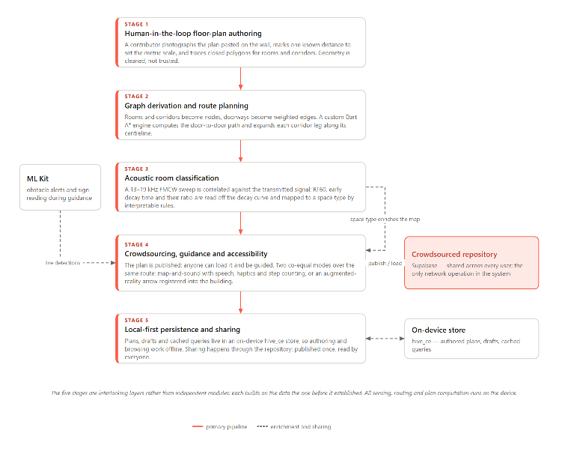
Figure 2.1: EchoLocate Conceptual Design — the Five-Stage Authoring, Mapping and Navigation Pipeline

2.9 SUMMARY
This chapter reviewed four systems — MagicPlan, Google Measure / AR Ruler Apps, the Leica BLK360 and RoomScan Pro — identifying the features, strengths and limitations of each against EchoLocate’s target capabilities across nine functional criteria.
Current systems are constrained by hardware dependency, platform exclusivity, cloud reliance, and the absence of indoor navigation, crowdsourced maps and accessibility. The five research gaps justify EchoLocate’s design, addressed by combining human-in-the-loop authoring with acoustic classification, crowdsourced sharing, graph-based navigation in two co-equal modes and an accessibility mode, from one Flutter codebase — the five-stage pipeline of §2.8.

CHAPTER THREE: METHODOLOGY

3.1 Introduction
This chapter presents the methodology used to design and develop EchoLocate — system architecture, component design, requirements, process model, logical design and development tools — shaped by the Chapter One constraints (commodity phones without LiDAR or depth hardware, on-device privacy-preserving sensing, accessibility for blind and low-vision users) and responding to Chapter Two’s five research gaps.

3.2 Architecture of the Proposed System
EchoLocate is a local-first, layered client architecture with a thin cloud tier. The presentation layer is Flutter with flutter_bloc for state and Go Router for navigation: each screen owns a Bloc, and live-sensing screens subscribe to long-lived services rather than opening hardware directly. A repository layer exposes typed models — buildings, floors, room plans, landmarks, routes — behind abstract interfaces, so on-device and cloud implementations are interchangeable. The sensing and processing layer is the analytical core: it derives a navigable graph from traced geometry, routes over it with a custom A* engine, registers routes into the ARCore world frame, runs ML Kit detection, and runs the Dart-native FMCW pipeline that classifies a space from its reverberation. A hive_ce store keeps plans, drafts and queries available offline, with Supabase backing the crowdsourced repository; all computation runs on the device.
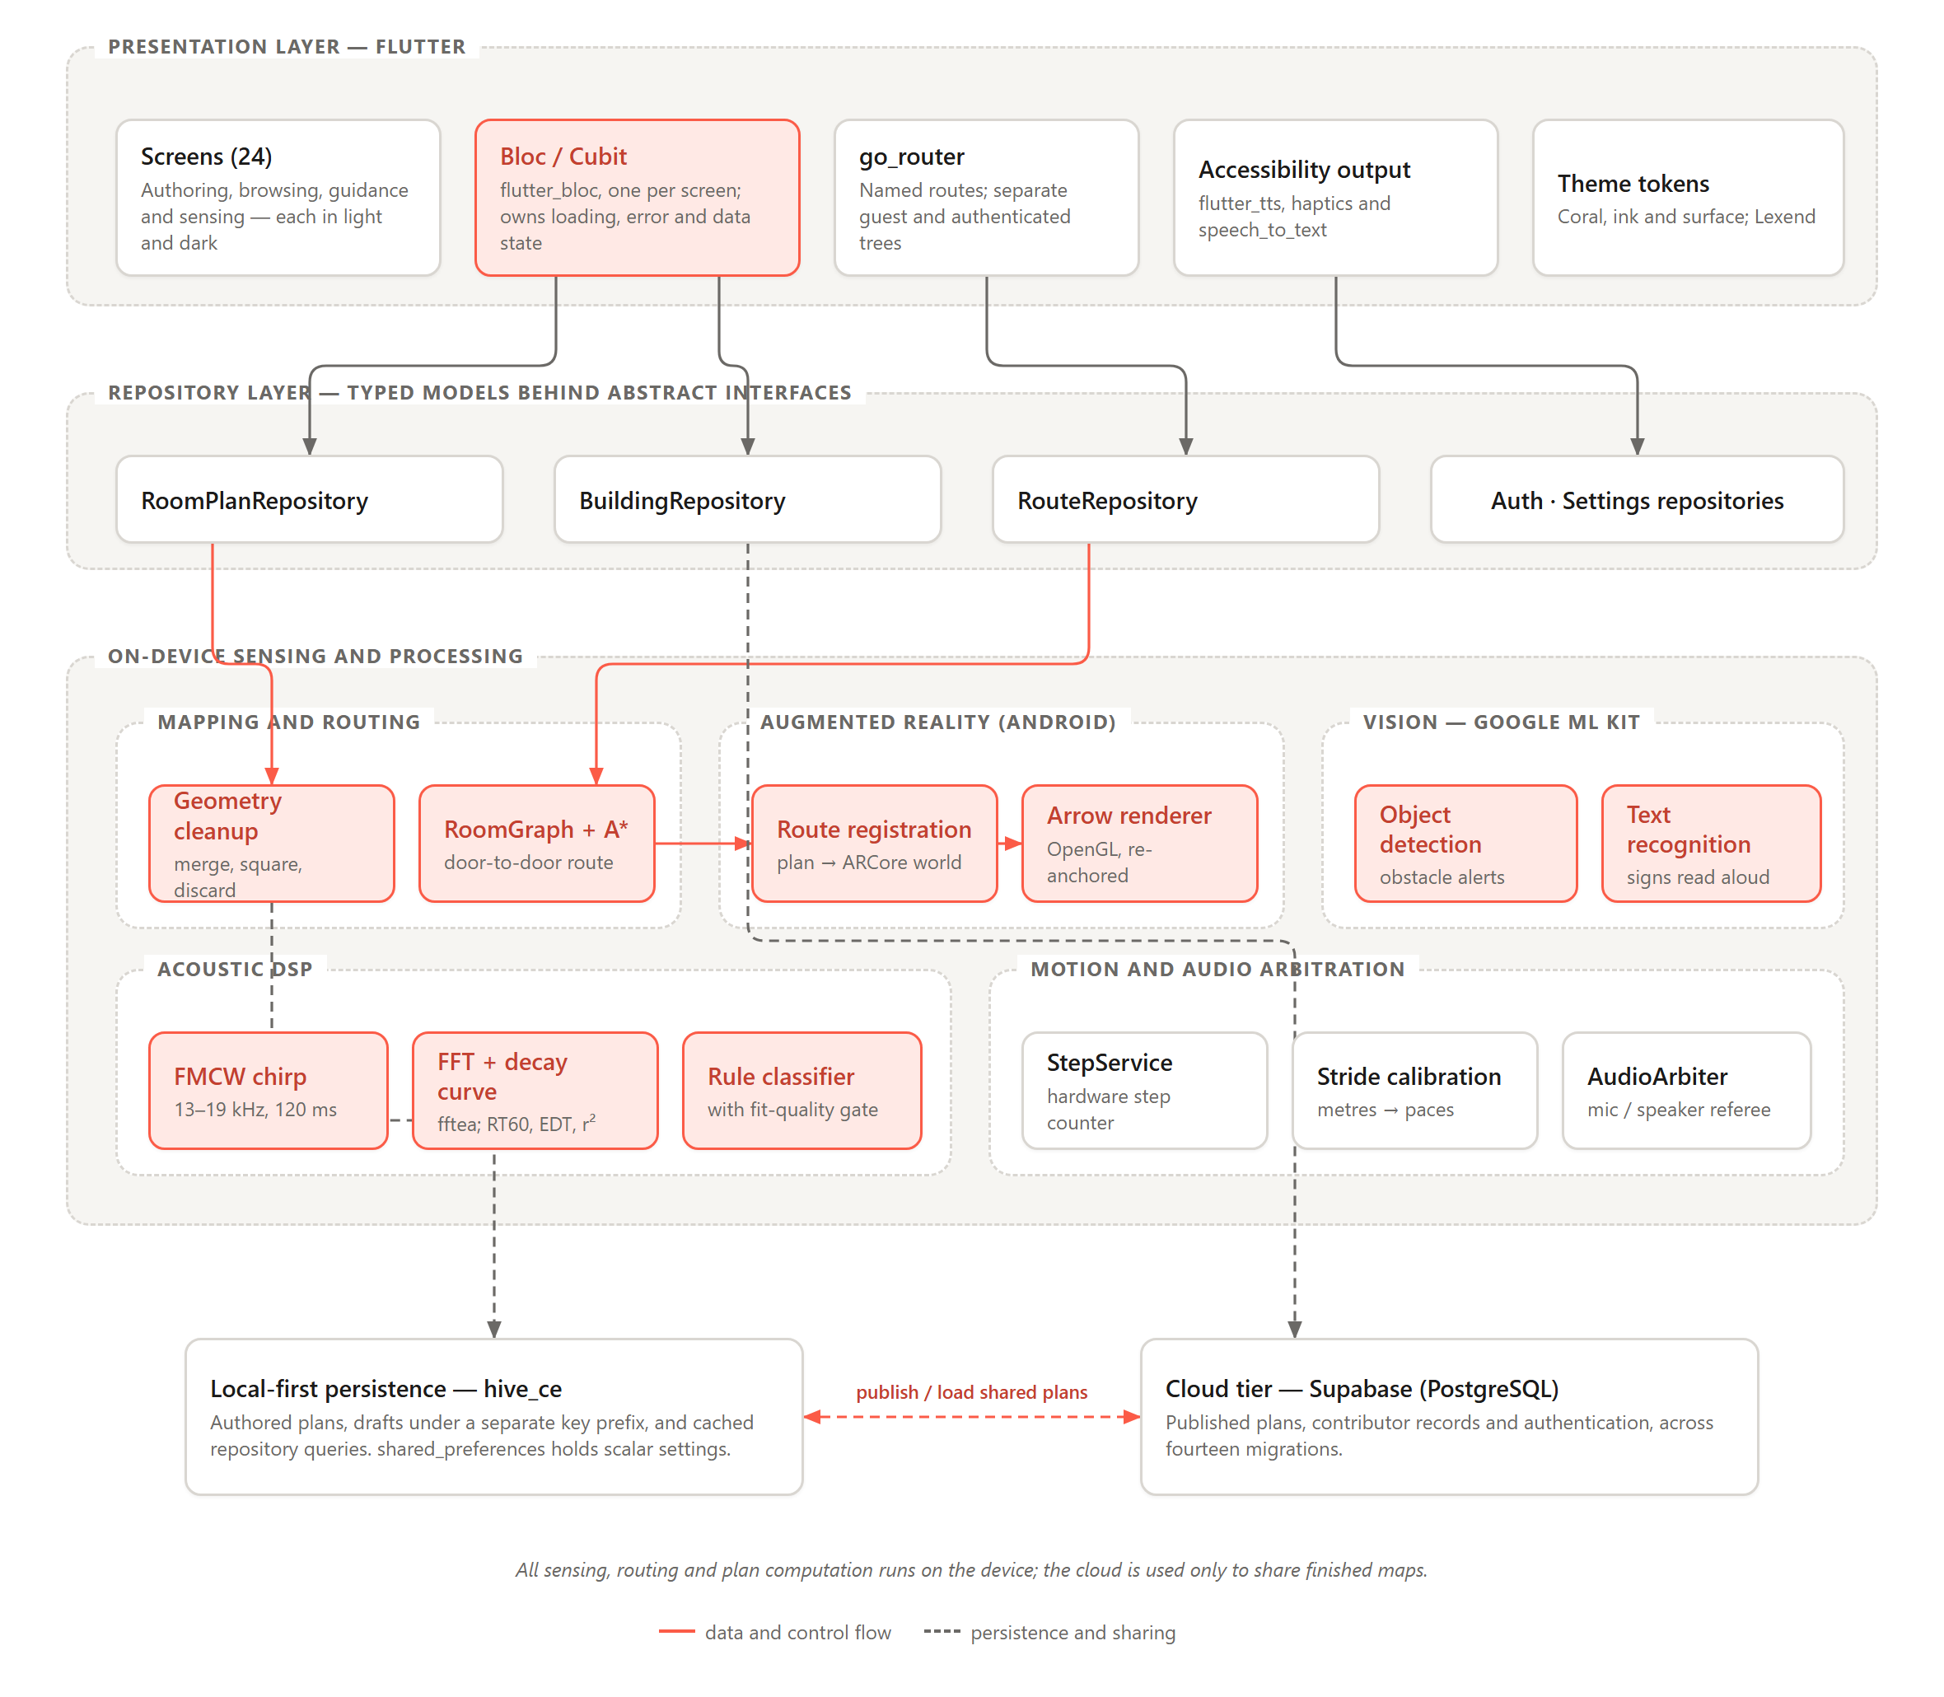
Figure 3.1: EchoLocate Layered System Architecture (On-Device Sensing with Crowdsourced Cloud Tier)

3.3 Component Design and Descriptions
EchoLocate comprises seven core components, each mapping to one or more of the objectives in Chapter One.
Component | Function
Floor-Plan Authoring Module | Captures a photograph of a posted plan and lets a contributor lay down room polygons, corridors and door openings, assign room types and set a metric scale. A draft is written on every structural change.
Graph Derivation and Routing Engine | Converts traced geometry into a navigable graph — rooms and corridors as nodes, doorways as weighted edges — computes door-to-door paths with a custom Dart A*, expands each leg along the corridor centreline, and converts the node path into turn-by-turn instructions.
AR Route Registration and Guidance Layer | Computes the similarity transform carrying plan coordinates into the ARCore world frame from one known position and one observed heading, lays the route into the room, and re-anchors at every confirmed landmark. Reports along-leg distance as a refinement only.
Semantic Detection Module | Runs ML Kit object detection and text recognition on the live feed to raise obstacle alerts and read signage aloud, entirely on-device. Shares one camera stream with the AR layer, since ARCore holds the camera exclusively.
Acoustic DSP Pipeline | Emits a linear FMCW chirp and applies a Dart-native FFT to the response, extracting RT60, early decay time, decay linearity and usable range, and mapping them to a space type by interpretable rules. The project’s DSP contribution.
Accessibility and Motion Services | Delivers guidance as speech and haptic patterns for eyes-free use, arbitrates microphone and speaker between the voice interface and the acoustic pipeline, and counts steps against a calibrated stride.
Crowdsource & Persistence Service | Manages local-first hive_ce storage and synchronises published plans with Supabase — upload, browsing, loading and contributor records.
Table 3.1: EchoLocate System Components
The acoustic pipeline is parameterised for reliable operation across commodity speakers and microphones. Table 3.2 summarises its key FMCW signal parameters.
Parameter | Value / Range | Purpose
Chirp type | Linear FMCW (up-sweep) | Wide-band excitation that can be correlated against the transmitted sweep to recover the room’s impulse response.
Frequency sweep | 13 kHz – 19 kHz | Near-ultrasonic band above almost all speech, footstep and HVAC energy, so ambient noise contributes little; also faint or inaudible to most listeners. Bandwidth stays 6 kHz, so range resolution is unaffected.
Chirp duration | 120 ms per sweep | Matched-filter gain follows the time–bandwidth product: at 6 kHz, 120 ms gives TB ≈ 720 (≈ 28.6 dB) against 240 (≈ 24 dB) at 40 ms. Pulse width is set by bandwidth, not duration.
Sampling rate | 44.1 kHz | Standard mobile rate; satisfies Nyquist for the 19 kHz bound with margin for microphone roll-off.
FFT window | Hann-windowed, applied over the correlated response | Balances spectral resolution against latency for reverberation feature extraction.
Feature set | RT60, early decay time (EDT), EDT/RT60 ratio, decay-fit r², usable decay range (dB) | Reverberation descriptors for the rule-based classifier. The r² and decay-range tests gate the fit, requiring it to be linear and to span at least 10 dB. As §4.3.6 reports, a decay far too fast to be a room can satisfy both, so the gate does not by itself establish that a measurement is physical.
Table 3.2: FMCW Acoustic Sensing Parameters
The Semantic Detection Module targets a small, navigation-relevant set of object and text classes. Table 3.3 lists the targets and how each is used on the floor plan.
Detection Target | ML Kit Capability | Use in EchoLocate
Doors and doorways | Object detection | Marked as graph connection points between spaces so the navigation engine can route between rooms.
Obstacles (furniture, pillars) | Object detection | Flagged on the floor plan and used for real-time obstacle alerts during navigation.
Room numbers and signs | Text recognition (OCR) | Attached as semantic labels to spaces, enabling destination search by room name or number.
Directional / exit signage | Text recognition (OCR) | Used to annotate exits and assist wayfinding, including spoken cues in accessibility mode.
Table 3.3: On-Device Semantic Detection Targets (Google ML Kit)

3.4 Evaluation and Analysis of Software System Type
EchoLocate is a mobile-first, sensor-driven spatial computing application. It is primarily stand-alone: authoring, graph derivation, routing, acoustic classification, semantic detection and persistence all execute locally and remain available offline. When online it also acts as a client to the Supabase repository. Because it is an assistive-navigation tool rather than a regulated safety system, the design treats output as guidance complementing the user’s judgement, gives redundant visual, audio and haptic feedback, and keeps the route independent of any optional sensing layer — landmarks decide progress, while distance and pose refine it.

3.5 Functional Requirements of the Proposed System
The functional requirements below derive from the Chapter One objectives, each mapping to at least one of the five research gaps in Chapter Two.
- FR-01: Allow a contributor to author a metrically scaled 2D floor plan by tracing a photographed posted plan or the space itself, producing room polygons, corridors, doorways and room type labels.
- FR-02: Derive a navigable graph from traced geometry, with rooms and corridors as nodes and doorways as weighted edges, and extract corridor centrelines as the walkable spine.
- FR-03: Detect obstacles and read room numbers and signage on the live camera feed using on-device Google ML Kit, raising alerts and spoken callouts during navigation.
- FR-04: Emit an FMCW chirp and apply an FFT pipeline to extract reverberation features and classify the type of space a user is in, rejecting estimates that fail a fit-quality gate.
- FR-05: Allow contributors to publish authored floor plans to a crowdsourced repository and any user to browse, load, and navigate plans contributed by others.
- FR-06: Compute door-to-door indoor routes over a loaded floor plan using a graph-based A* engine and convert the node path into turn-by-turn instructions.
- FR-07: Deliver a planned route as a drawn line over the floor plan with spoken instructions, haptic cues and step counting, requiring no camera and no ARCore.
- FR-08: Register a planned route into the ARCore world frame from one known position and one observed heading, presenting a waypoint arrow in the building and re-anchoring at every confirmed landmark.
- FR-09: Calibrate an individual walker’s stride length so that stored distances are spoken in that user’s own paces, falling back to a documented default when uncalibrated.
- FR-10: Persist authored plans, unpublished drafts and cached repository queries in a local-first on-device store, keeping authoring and browsing fully available offline.

3.6 Identification of Stakeholders
Five stakeholder groups are identified. Sighted end users author plans, publish them and follow turn-by-turn navigation by map and sound or the AR overlay. Blind and low-vision users are equally central, shaping the map-and-sound mode, the redundant audio and haptic cues and the obstacle alerts — the reason guidance works without a camera or ARCore. Community contributors trace and publish maps, and the repository’s value depends on their participation, so contributing must stay simple. Building administrators want accurate, navigable maps of their premises. The developer and maintainer maintains the Supabase backend, re-fits classifier thresholds and resolves deployment issues after handover.

3.7 Requirement Gathering Process
Requirements were gathered three ways. Literature and gap synthesis drew on Chapter Two’s review, mapping each of the five gaps to at least one functional requirement in Section 3.5. Comparative analysis examined the four tools against the capabilities EchoLocate targets, identifying functionality worth replicating and limitations worth addressing. Standards review consulted WCAG 2.1 for the accessibility mode and redundant non-visual feedback, and Ghana’s Data Protection Act 2012, Act 843 (Republic of Ghana, 2012), for the on-device, data-minimising design.

3.8 Requirement Specification

3.8.1 Functional User Requirements
ID | User Requirement | Stakeholder
FUR-01 | As a contributor, I want to trace a floor plan from the plan posted on a building’s wall, so a metrically scaled 2D plan of the storey is produced without special hardware. | Community Contributor
FUR-02 | As a user, I want the app to read room signs and warn me of obstacles, so I know where I am and what is in front of me. | Sighted / Low-Vision User
FUR-03 | As a contributor, I want to publish the plans I author and browse plans shared by others, so I can navigate buildings I have never mapped. | Community Contributor
FUR-04 | As a user, I want turn-by-turn directions to a room within a loaded building, so I can find my destination indoors. | Sighted User
FUR-05 | As a blind or low-vision user, I want spoken directions and haptic feedback, so I can navigate indoors without looking at the screen. | Blind / Low-Vision User
FUR-06 | As a user, I want the app to keep working without internet, so I can author and navigate where connectivity is poor. | Sighted / Low-Vision User
FUR-07 | As a sighted user, I want an arrow laid into the building itself, so I can see where to go rather than read a map. | Sighted User
Table 3.4: Functional User Requirements

3.8.2 Functional System Requirements
ID | System Requirement | Satisfies
FSR-01 | The system shall let a contributor trace closed room and corridor polygons with door openings against a photographed plan, establish a metric scale from one known distance, and clean the geometry. | FUR-01
FSR-02 | The system shall derive a navigable graph from traced geometry — rooms and corridors as nodes, doorways as weighted edges — and extract corridor centrelines. | FUR-01, FUR-04
FSR-03 | The system shall run on-device ML Kit object and text detection, raising obstacle alerts and reading room numbers and signage aloud. | FUR-02
FSR-04 | The system shall classify the type of space from FMCW reverberation features by interpretable rules, rejecting estimates that fail a fit-quality and decay-range gate. | FUR-01
FSR-05 | The system shall publish floor plans to the Supabase repository and list, load, and open community plans. | FUR-03
FSR-06 | The system shall compute a door-to-door A* route and present it both as a drawn line with spoken turn-by-turn steps and as an AR arrow registered into the building. | FUR-04, FUR-07
FSR-07 | The system shall deliver spoken guidance through flutter_tts with haptic cues and hardware step counting against a calibrated stride, and accept voice commands via speech_to_text. | FUR-05
FSR-08 | The system shall persist authored plans, drafts and cached repository queries in a local-first hive_ce store, isolating drafts from published plans by key prefix. | FUR-06
Table 3.5: Functional System Requirements

3.8.3 UML Diagrams

Use Case Diagram 1 — Mobile Application (Front-End)
The front-end use case diagram captures the interactions available to the Sighted User and the Blind / Low-Vision User: tracing and publishing a plan, browsing community plans, navigating by map and sound, and using the AR overlay.
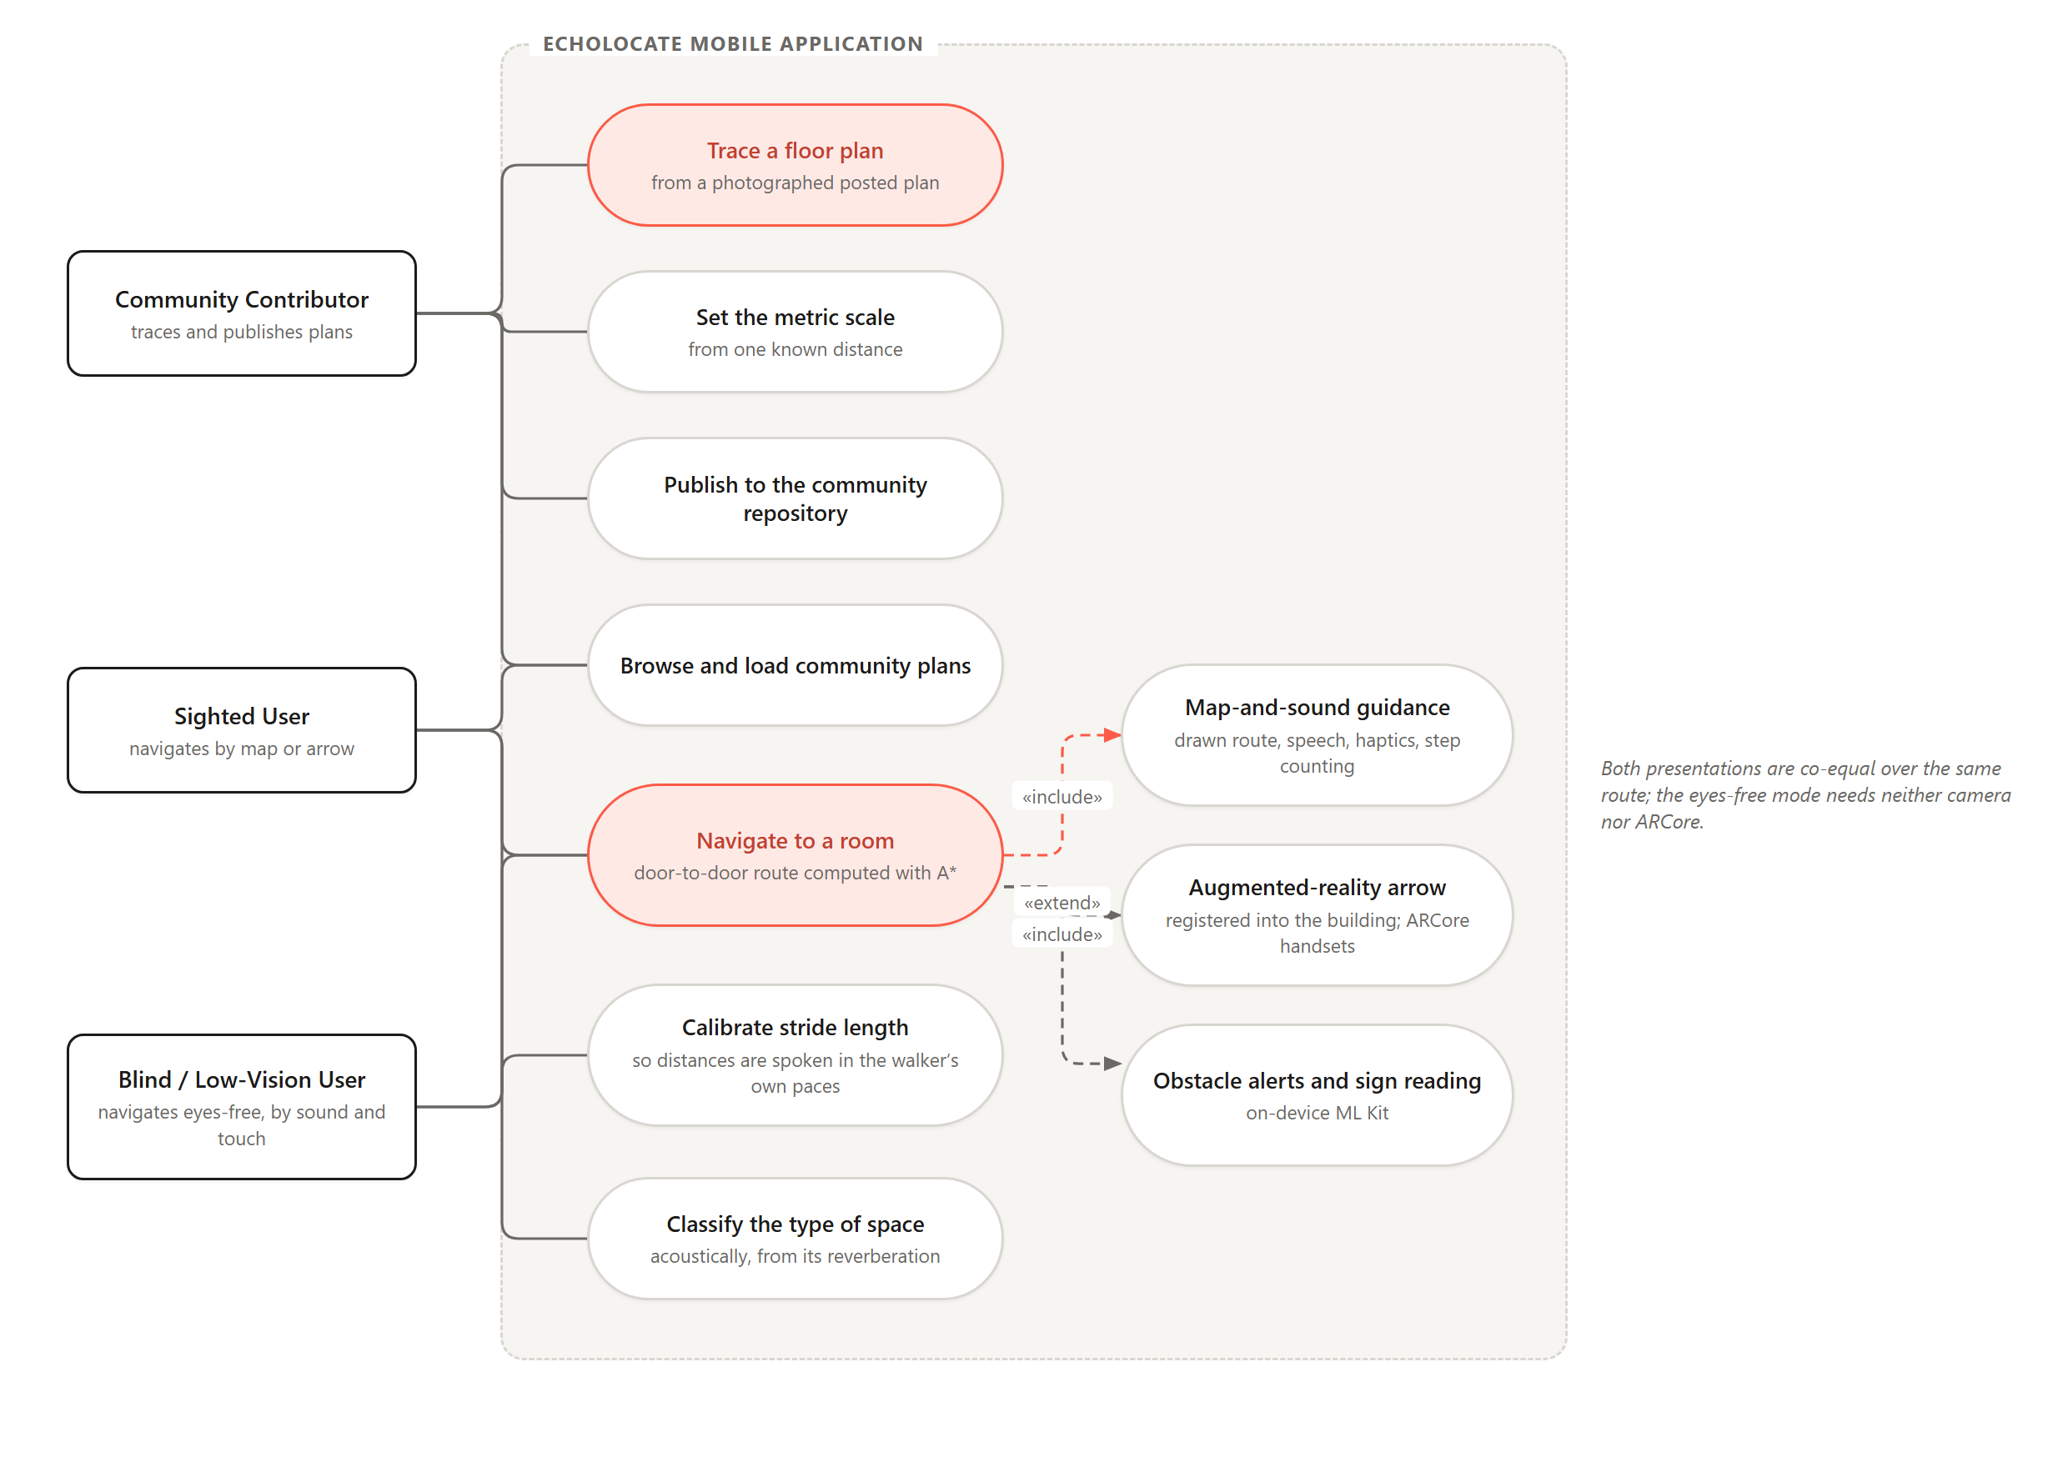
Figure 3.2: Use Case Diagram — EchoLocate Mobile Application (Front-End)

Use Case Diagram 2 — Crowdsource Backend (Back-End)
The back-end use case diagram covers the Supabase repository: publishing an authored plan, browsing and loading community plans, and synchronising contributor records.
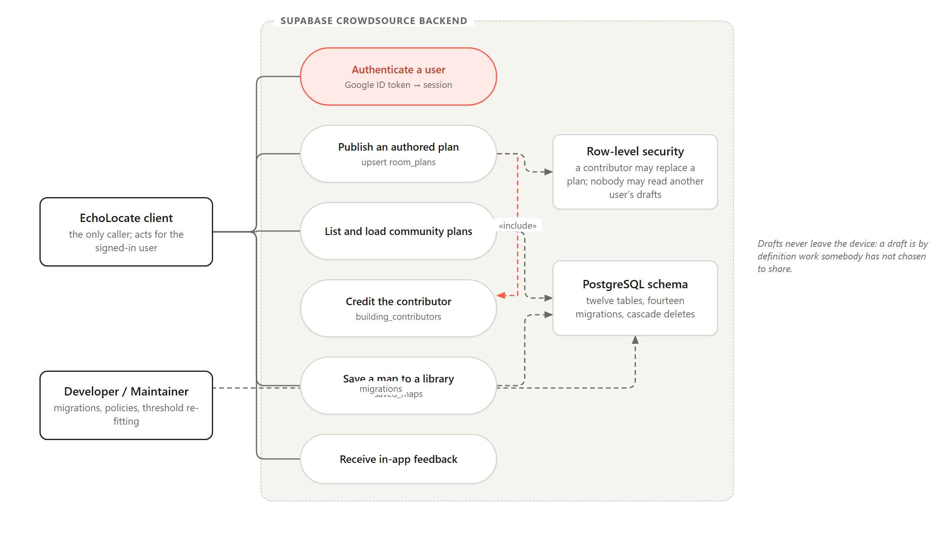
Figure 3.3: Use Case Diagram — EchoLocate Crowdsource Backend (Back-End)

Use Case Description — UC-01: Author and Publish a Floor Plan
Element | Description
Actor(s) | Community Contributor, Mobile Device Camera
Precondition | Camera permission is granted, and the contributor is standing in the space or has the building’s posted floor plan in view.
Main Flow | 1. Contributor photographs the posted floor plan, or begins tracing the space directly. 2. Contributor marks one known real-world distance to establish a metric scale. 3. Contributor traces closed polygons for each room and corridor and assigns a room type to each. 4. Contributor marks the door openings on shared walls. 5. System cleans the traced geometry, merging near-coincident corners and squaring near-orthogonal walls. 6. System derives the navigable graph and persists the plan. 7. Contributor publishes the plan to the crowdsourced repository.
Alternative Flow | A draft is written on every structural change, so an interrupted trace can be resumed rather than lost. A large floor may be traced a wing at a time, the wings reconciled by dragging one into place against another.
Postcondition | A metrically scaled 2D floor plan and its derived graph are persisted locally and, once published, available to other users for navigation.
Performance | Tracing a single storey shall take roughly twenty minutes, and graph derivation shall complete within a second of the trace being closed.
Table 3.6: Use Case Description — UC-01: Author and Publish a Floor Plan

Use Case Description — UC-02: Navigate to a Room
Element | Description
Actor(s) | Sighted User, Blind / Low-Vision User
Precondition | A floor plan for the building has been loaded, either authored locally or downloaded from the crowdsourced repository.
Main Flow | 1. User selects or speaks a destination room.  2. System builds a navigation graph from the floor plan and computes the shortest route using A*.  3. System presents turn-by-turn steps with a 2D map and an AR waypoint overlay.  4. ML Kit raises real-time obstacle alerts as the user proceeds.  5. System announces arrival at the destination.
Alternative Flow | In accessibility mode the route is delivered entirely through speech and haptic cues (for example “Turn right in 5 metres”), the screen overlay is optional, and voice commands control the session.
Postcondition | The user is guided from the start point to the destination, with the session recorded in local history.
Performance | Route computation shall complete within one second for a typical single-building floor plan after the destination is selected.
Table 3.7: Use Case Description — UC-02: Navigate to a Room

Activity Diagram — Floor-Plan Authoring
The activity diagram models the authoring workflow, from establishing a metric scale and tracing polygons through geometry cleanup and graph derivation to draft persistence and publication.
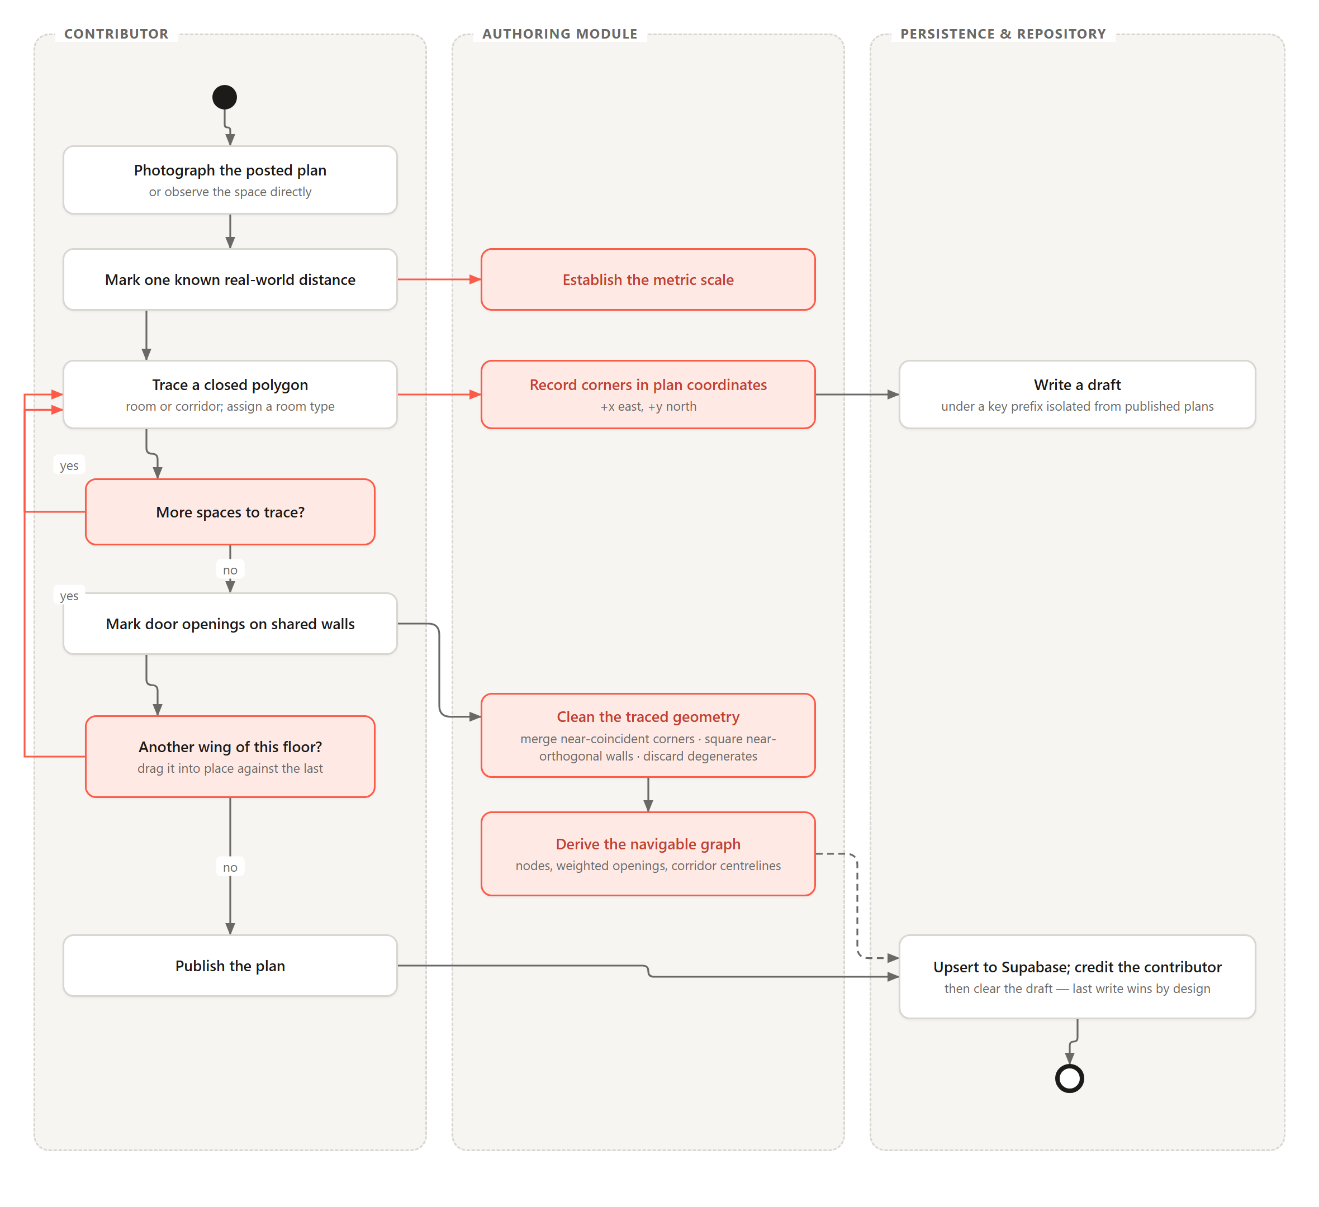
Figure 3.4: Activity Diagram — Floor-Plan Authoring Flow

Activity Diagram — Indoor Navigation
The second activity diagram models the navigation workflow, from loading a map and selecting a destination through A* routing, turn-by-turn guidance, obstacle alerts and the accessibility voice-and-haptic branch.
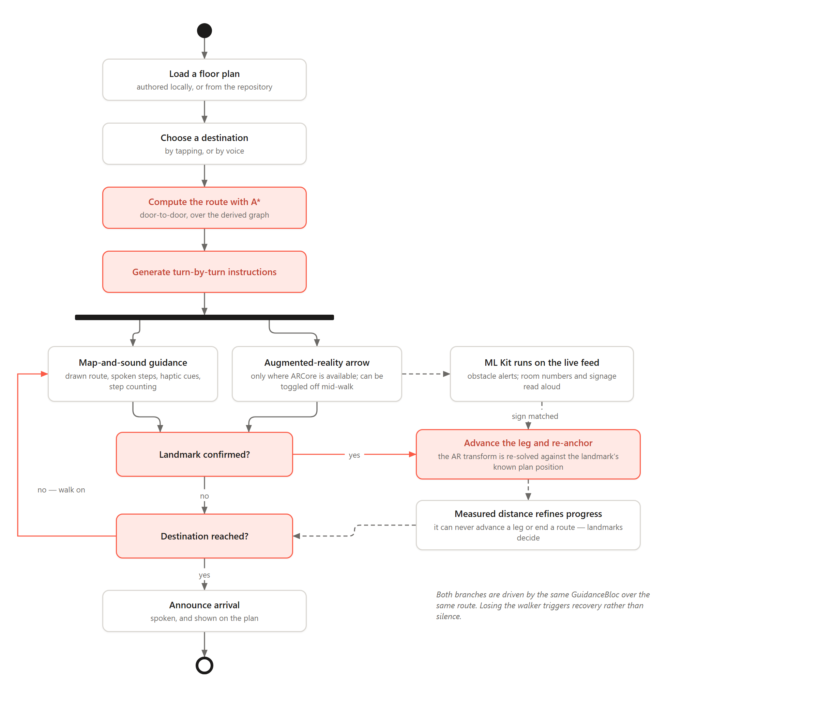
Figure 3.5: Activity Diagram — Indoor Navigation Flow

Sequence Diagram — Author and Publish a Floor Plan
The authoring sequence diagram shows the message exchange between the contributor, the Flutter UI, the Floor-Plan Authoring Module, the Graph Derivation and Routing Engine, the local hive_ce store and the Crowdsource & Persistence Service.
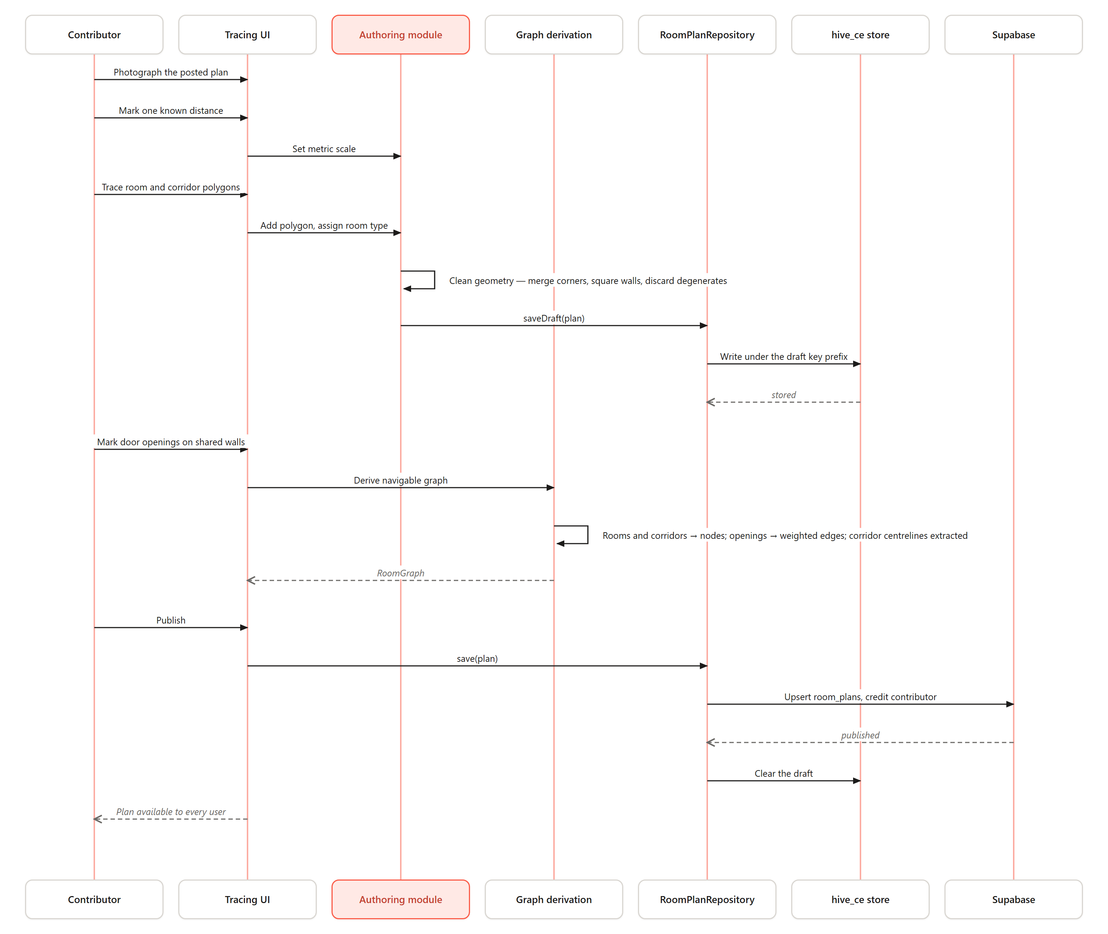
Figure 3.6: Sequence Diagram — Author and Publish a Floor Plan

Sequence Diagram — Navigate to a Room
The navigation sequence diagram shows the interaction between the user, the Flutter UI, the Map Repository, the Navigation Engine, the Accessibility Service and the Semantic Detection Module during a routing session.
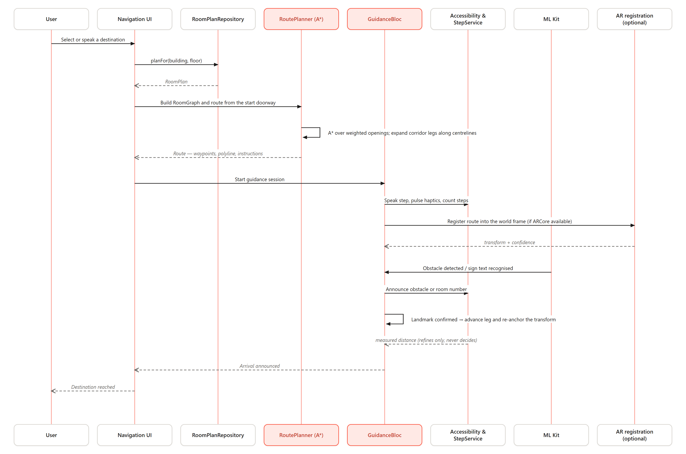
Figure 3.7: Sequence Diagram — Navigate to a Room

3.9 Non-Functional Requirements
ID | Category | Requirement | Justification
NFR-01 | Performance | Route computation shall complete within 1 second for a typical single-building floor plan on a mid-range Android device. | Consistent with user tolerance thresholds (Nielsen, 1994); responsiveness is essential for live wayfinding.
NFR-02 | Performance | Geometry cleanup and navigable-graph derivation shall complete within one second of a traced floor being closed. | Keeps the trace-and-confirm loop tight enough for field use on commodity hardware.
NFR-03 | Reliability | Floor-plan authoring, graph derivation, routing, guidance and persistence shall remain fully functional with no internet connectivity. | Many indoor environments have weak connectivity; offline operation is core, not optional.
NFR-04 | Reliability | Navigation shall remain fully functional on handsets with no ARCore and no hardware step counter; AR and measured distance refine guidance but never decide it. | ARCore certification is a property of the handset, and most handsets in the target setting lack it.
NFR-05 | Usability / Accessibility | All navigation guidance shall be available through redundant visual, audio, and haptic channels. | Satisfies WCAG 2.1 (W3C, 2018) and makes the system usable by blind and low-vision users.
NFR-06 | Portability | The application shall run from a single Flutter codebase on Android (primary) and iOS. | Cross-platform reach is a stated objective and addresses the platform-exclusivity gap of Chapter Two.
NFR-07 | Privacy / Security | All sensing and floor-plan computation shall occur on-device; only finished maps the user chooses to share are uploaded. | Complies with the data-minimisation principle of Ghana’s Data Protection Act 2012 (Act 843).
Table 3.8: Non-Functional Requirements with Justifications

3.10 Candidate Classes and UML Class Diagram
The candidate classes below are identified from the functional requirements, each encapsulating a distinct responsibility with well-defined interfaces to adjacent classes.
Class | Layer | Responsibility
RoomPlan | Mapping | Central entity: traced polygons, corridors, openings, type labels and metric scale for one floor.
RoomPolygon | Mapping | A closed traced polygon — room or corridor — with corners in plan coordinates and a room type.
Opening | Mapping | A door opening on a shared wall, recording the two spaces it connects; becomes a weighted edge.
Landmark | Mapping | A confirmable feature at a known plan position, used to advance a leg and re-anchor AR registration.
RoomGraph | Navigation | Graph derived from a RoomPlan: rooms and corridors as nodes, openings as weighted edges.
RoutePlanner | Navigation | Custom Dart A*; computes the door-to-door path and expands each leg along the corridor centreline.
Route | Navigation | Value object: waypoints, the drawn polyline, and turn-by-turn instructions.
GuidanceBloc | Presentation | Drives a guidance session in either mode, advancing legs on confirmed landmarks.
RouteRegistration | Sensing | Solves and holds the plan-to-ARCore transform with a confidence, re-solved at every landmark.
AcousticSample | Sensing | An FMCW capture with its correlated response and energy decay curve.
ReverbFeatures | DSP | RT60, early decay time, decay-fit r² and usable decay range from a decay curve.
RoomClassifier | DSP | Applies interpretable rules over ReverbFeatures to give a space type, confidence and reason, or a rejection.
AccessibilityService | Presentation | Converts route steps into speech and haptic cues; handles voice commands.
StepService | Sensing | Wraps the hardware step counter and converts counts to distance using calibrated stride.
RoomPlanRepository | Persistence | Abstract interface over hive_ce and Supabase implementations for plans and drafts.
CrowdsourceService | Cloud | Publishes and retrieves shared plans and contributor records via Supabase.
Table 3.9: EchoLocate Candidate Classes
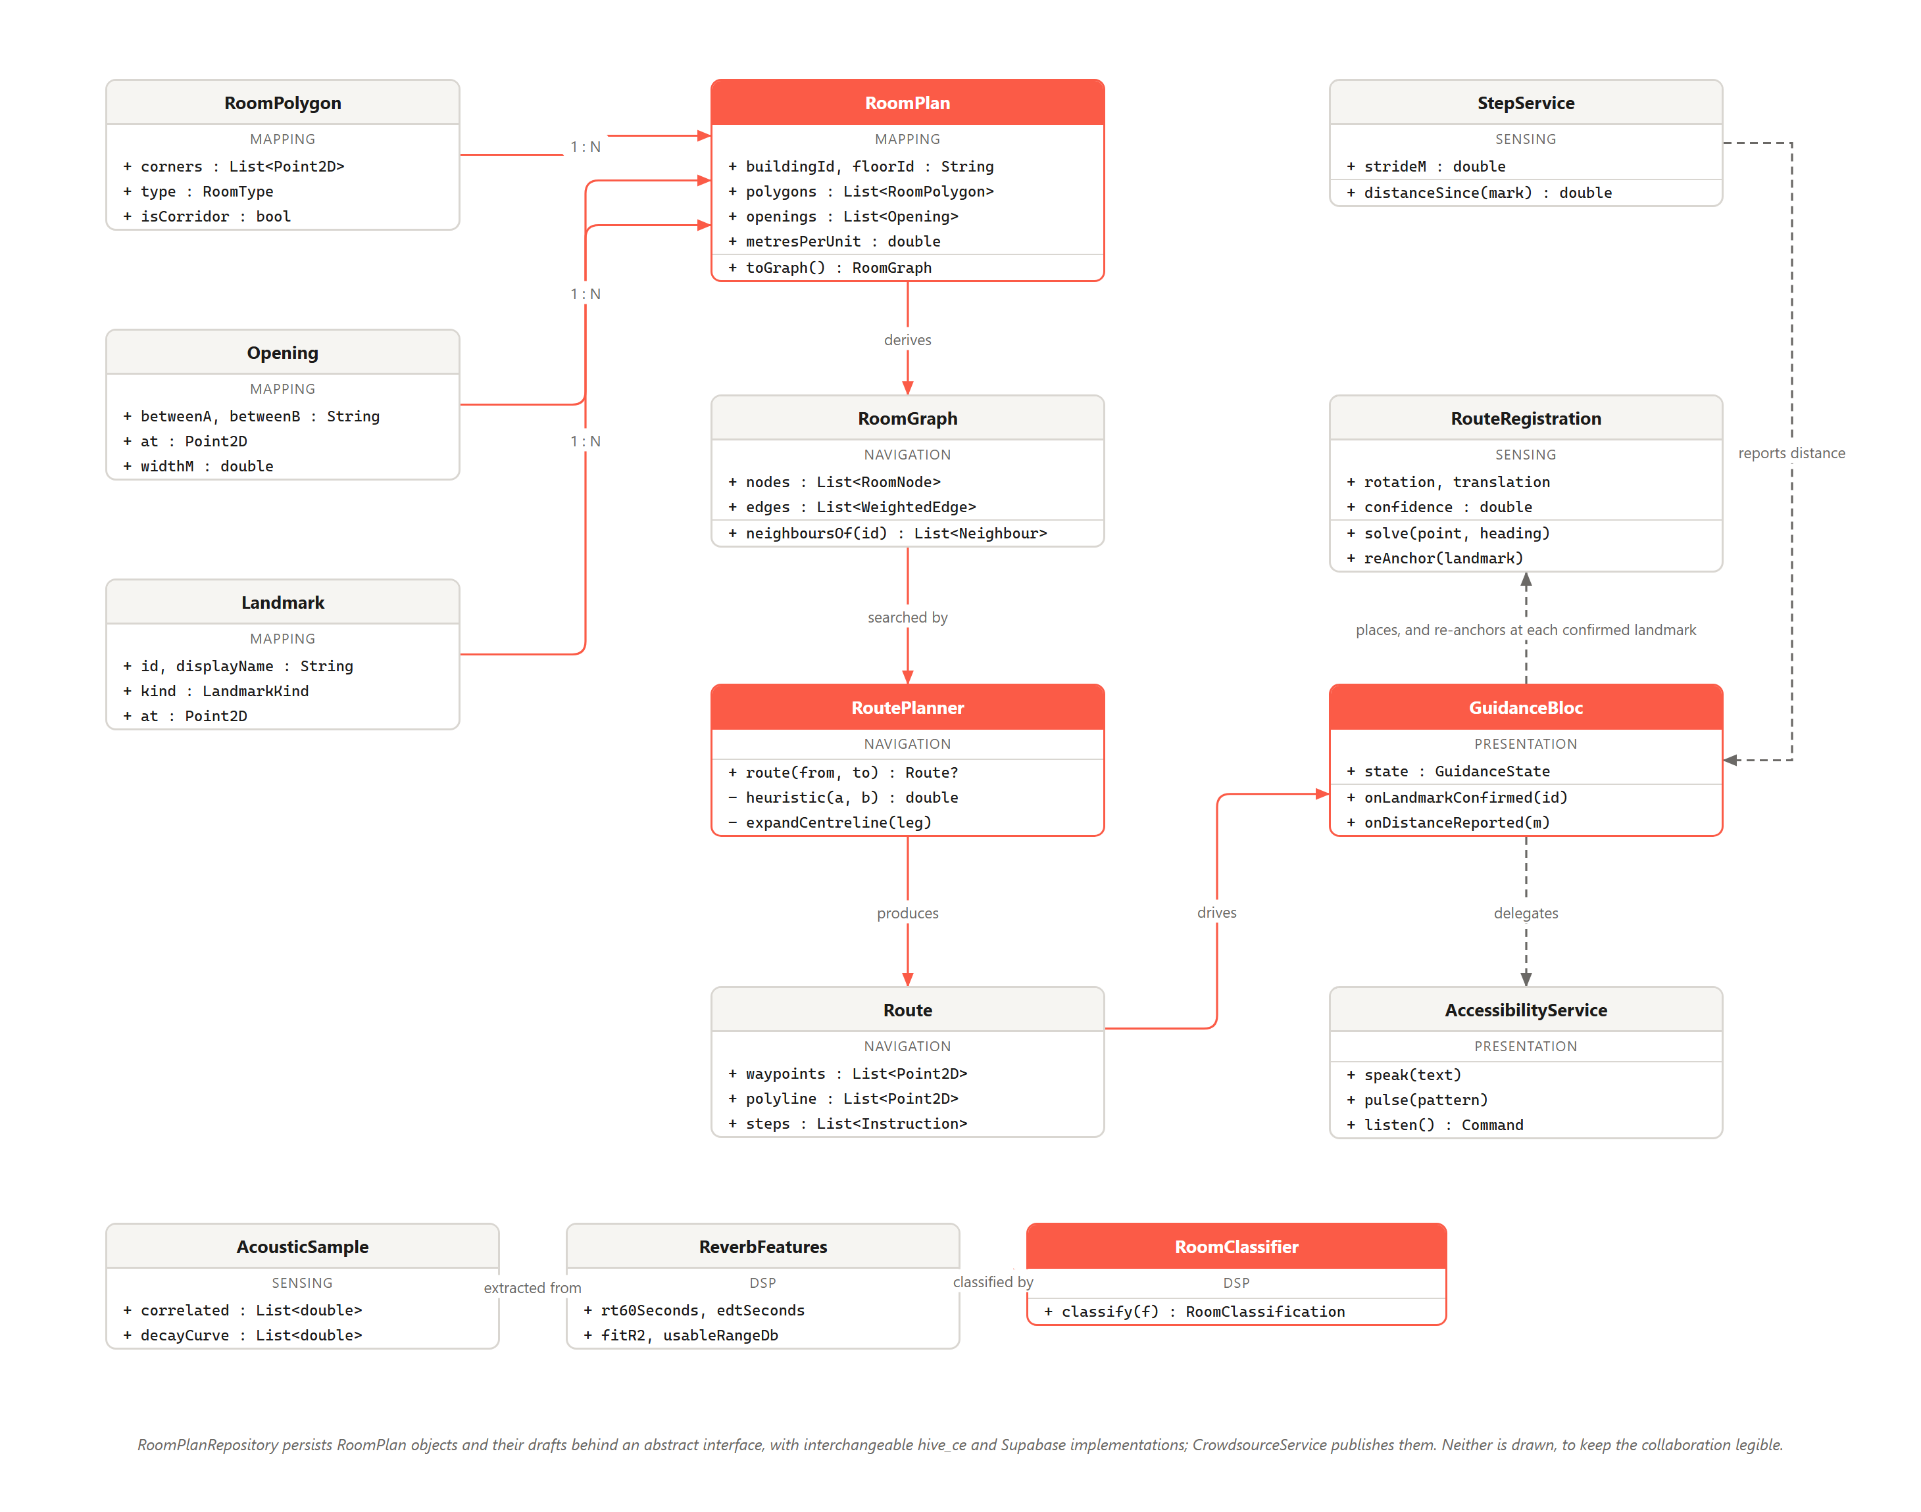
Figure 3.8: UML Class Diagram — EchoLocate System
RoomPlan is the central entity — many RoomPolygon and Opening objects, with Landmarks placed on the floor, authored rather than captured. RoomGraph derives from it, and RoutePlanner computes a Route over that graph. GuidanceBloc drives a session from a Route, delegating non-visual output to AccessibilityService, distance to StepService and, where ARCore is available, world placement to RouteRegistration, re-solved at each confirmed Landmark. RoomClassifier consumes ReverbFeatures from an AcousticSample; RoomPlanRepository persists plans and drafts locally, and CrowdsourceService synchronises published ones.

3.11 Algorithms for the System

3.11.1 Algorithm 1: Floor-Plan Authoring and Graph Derivation
Step | Operation
Input | A photograph of a posted floor plan, or the space itself; contributor input.
Step 1 | Establish a metric scale by having the contributor mark a known real-world distance on the plan.
Step 2 | Trace closed polygons for each room and corridor, capturing corners in plan coordinates (+x east, +y north).
Step 3 | Assign a room type from a fixed vocabulary chosen so every entry is identifiable from a doorway.
Step 4 | Mark door openings on shared walls, recording which two spaces each connects.
Step 5 | Clean the traced geometry: merge near-coincident corners, square near-orthogonal walls, and discard degenerate polygons.
Step 6 | Derive the navigable graph — rooms and corridors become nodes, openings weighted edges, corridor centrelines the walkable spine.
Output | A RoomPlan of room polygons, corridors, openings, type labels and a metric scale, with the graph derived from it.
Table 3.10: Algorithm 1 — Floor-Plan Authoring and Graph Derivation
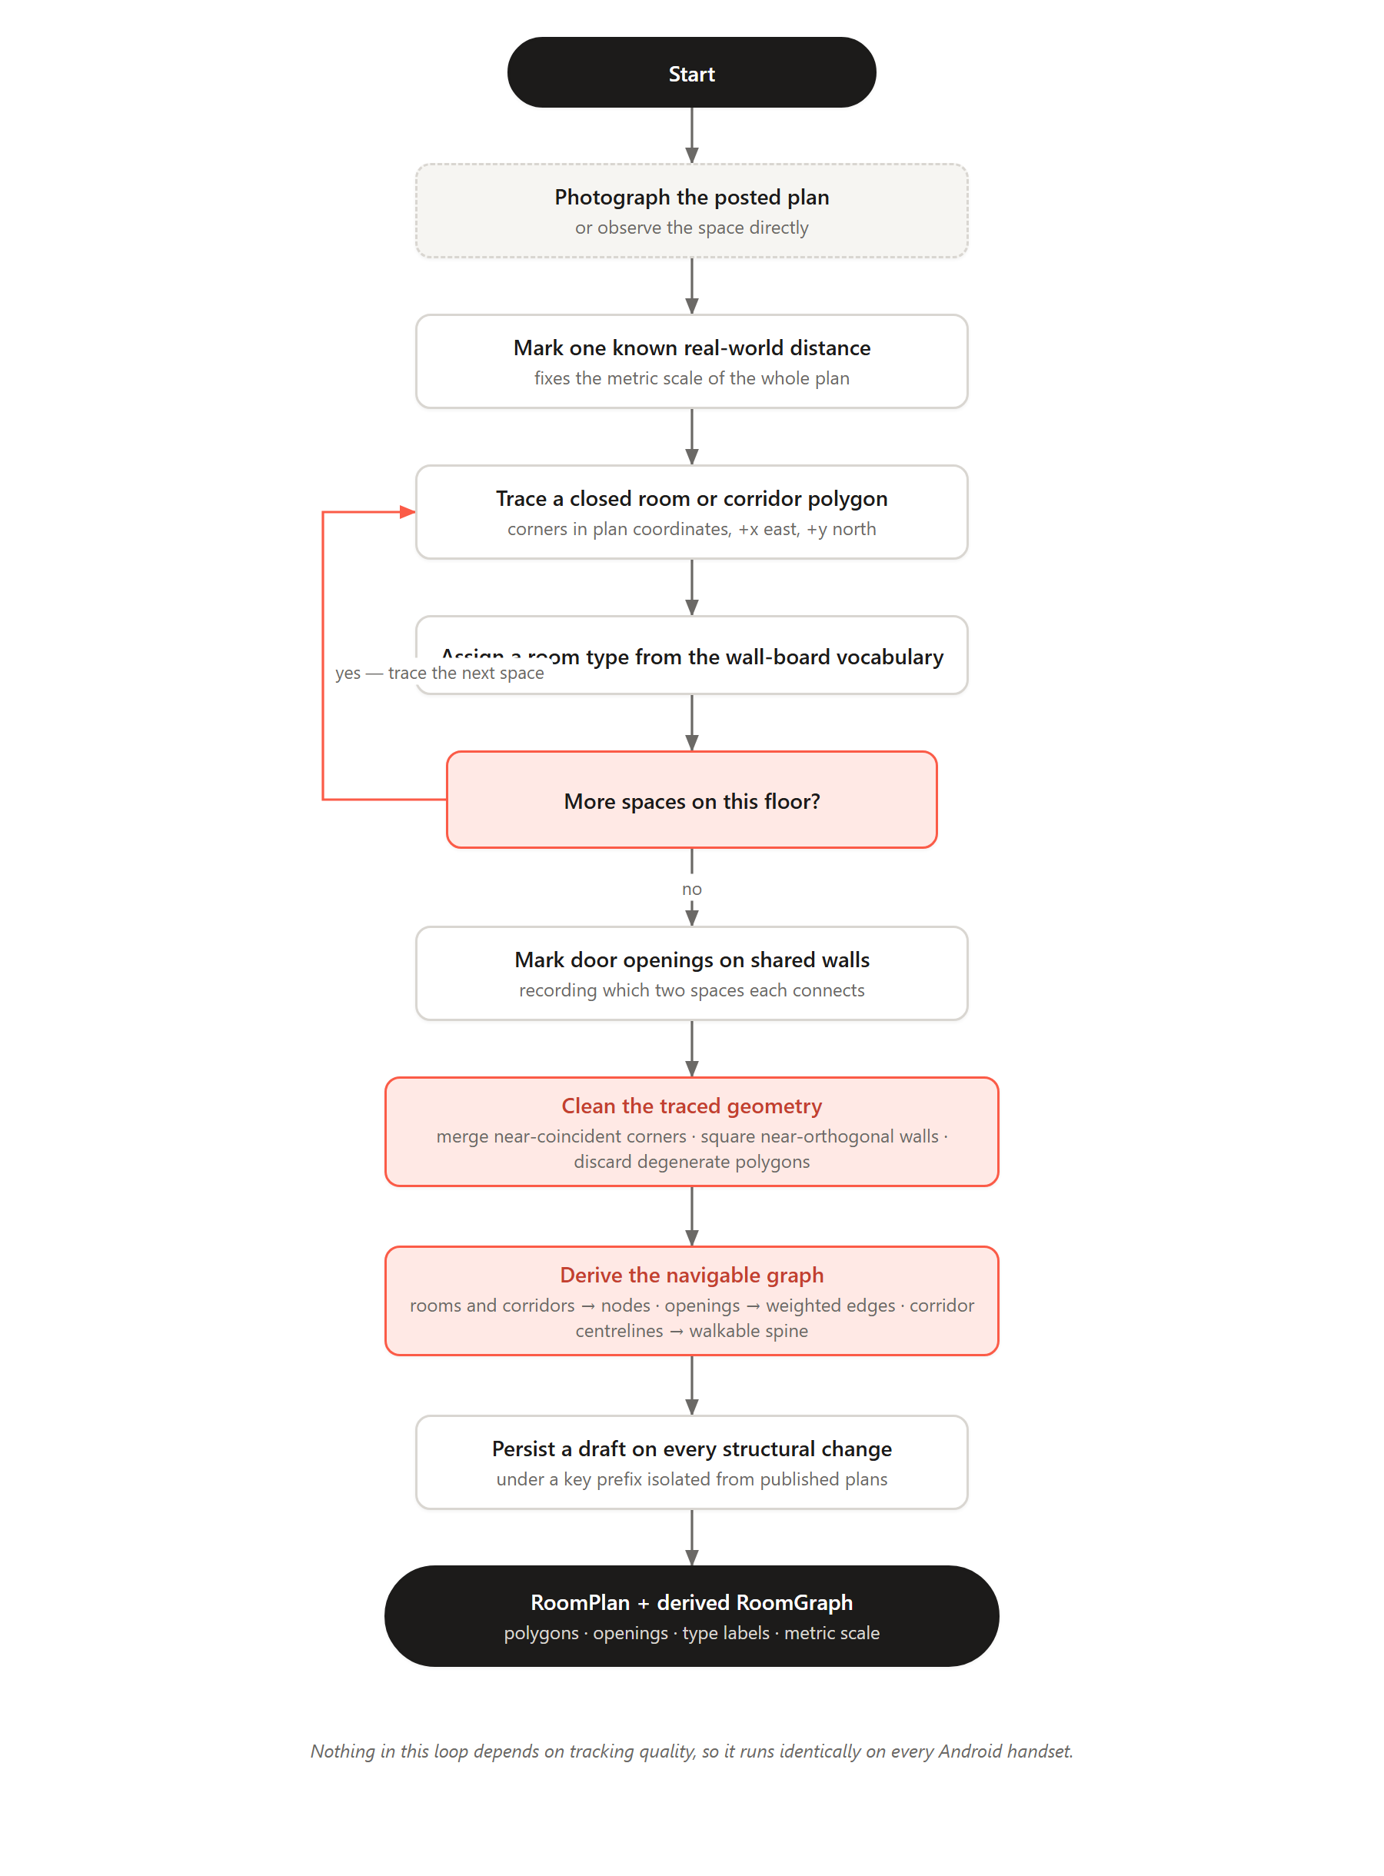
Figure 3.9: Flowchart — Floor-Plan Authoring and Graph Derivation Algorithm

3.11.2 Algorithm 2: Acoustic Room Classification
Step | Operation
Input | Microphone and speaker access; a trigger from the user or from a room-labelling action.
Step 1 | Emit a linear FMCW up-sweep of 13–19 kHz over 120 ms at 44.1 kHz and record the response. The near-ultrasonic band sits above almost all speech, footstep and HVAC energy, so ambient noise contributes little, and is faint or inaudible to most listeners.
Step 2 | Correlate the recording against the transmitted sweep. Matched-filter gain follows the time–bandwidth product: at 6 kHz, 120 ms gives TB ≈ 720 (≈ 28.6 dB), leaving range resolution unchanged.
Step 3 | Apply a windowed FFT and derive the energy decay curve of the response.
Step 4 | Fit a straight line to the decay in dB and extract RT60, early decay time (the same slope over the first 10 dB), fit quality r², and usable decay range.
Step 5 | Gate on fit quality and decay range: an estimate from noise, or from too short a capture, is rejected rather than classified.
Step 6 | Classify by rules over RT60 and the EDT/RT60 ratio. A low ratio means a non-diffuse field — a corridor, where parallel reflections shorten early decay. Short RT60 with a diffuse field is a small room; long RT60 a large hall.
Output | A space-type classification with an associated confidence, or an explicit rejection.
Table 3.11: Algorithm 2 — Acoustic Room Classification
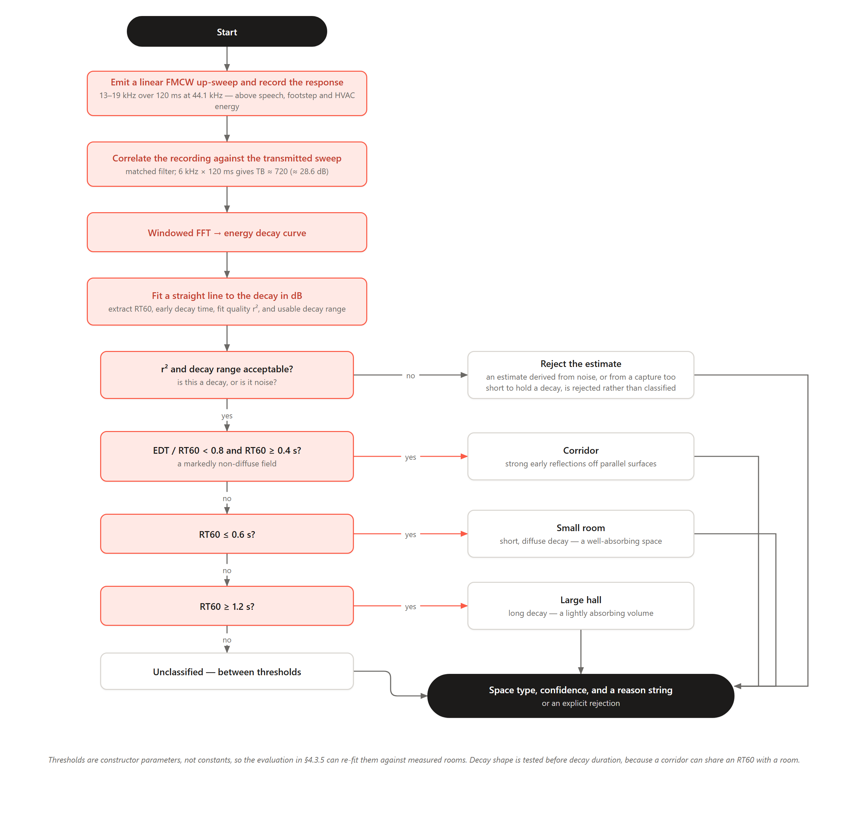
Figure 3.10: Flowchart — Acoustic Room Classification Algorithm
A rule-based classifier is preferred over a learned model. The thresholds derive from Sabine’s relation (Sabine, 1922), which ties reverberation time to volume and absorption, so classes separate along RT60 for physical reasons and every decision can be defended from room acoustics. A network trained on the few samples obtainable in twelve weeks could not be, and would carry unquantified generalisation risk for little separation. The thresholds are parameters so Chapter Four’s evaluation can re-fit them, and the interface is unchanged, so a learned model can replace it later.

3.11.3 Algorithm 3: A* Indoor Navigation
Routing uses the A* best-first search of Hart, Nilsson and Raphael (1968), which expands the node minimising the sum of the cost already incurred and an admissible estimate of the cost remaining, and is therefore guaranteed to return a shortest path while exploring far fewer nodes than an uninformed search.
Step | Operation
Input | A RoomPlan and its RoomGraph; start doorway s and destination doorway d. Both endpoints sit on doorways, not room centres, so a route begins and ends at a door the walker can see.
Step 1 | Build the RoomGraph from the RoomPlan: rooms and corridors become nodes, doorways become weighted edges carrying their real-world length.
Step 2 | Initialise the open set with s; set g(s) = 0 and f(s) = h(s, d) using a straight-line (Euclidean) heuristic, admissible because the plan preserves recorded distances.
Step 3 | WHILE the open set is not empty: take the node n with the lowest f; IF n = d, reconstruct the path and RETURN it.
Step 4 | FOR each neighbour m of n: tentative_g = g(n) + cost(n, m); IF better, update g(m), set f(m) = g(m) + h(m, d), and record the parent.
Step 5 | Expand each corridor leg along its centreline to give the polyline the walker follows, and convert the waypoints into turn-by-turn instructions — one per pair of decision points, not one per bend.
Step 6 | Deliver the route in the selected mode: map-and-sound draws the polyline and speaks each step with haptics and step counting, needing no camera or ARCore; augmented reality additionally lays a registered arrow into the building (§3.11.4). Both raise ML Kit obstacle alerts, and route, instructions and arrival logic are identical.
Output | A Route — waypoints, drawn polyline and turn-by-turn instructions — delivered in the selected mode, with obstacle alerts.
Table 3.12: Algorithm 3 — A* Indoor Navigation
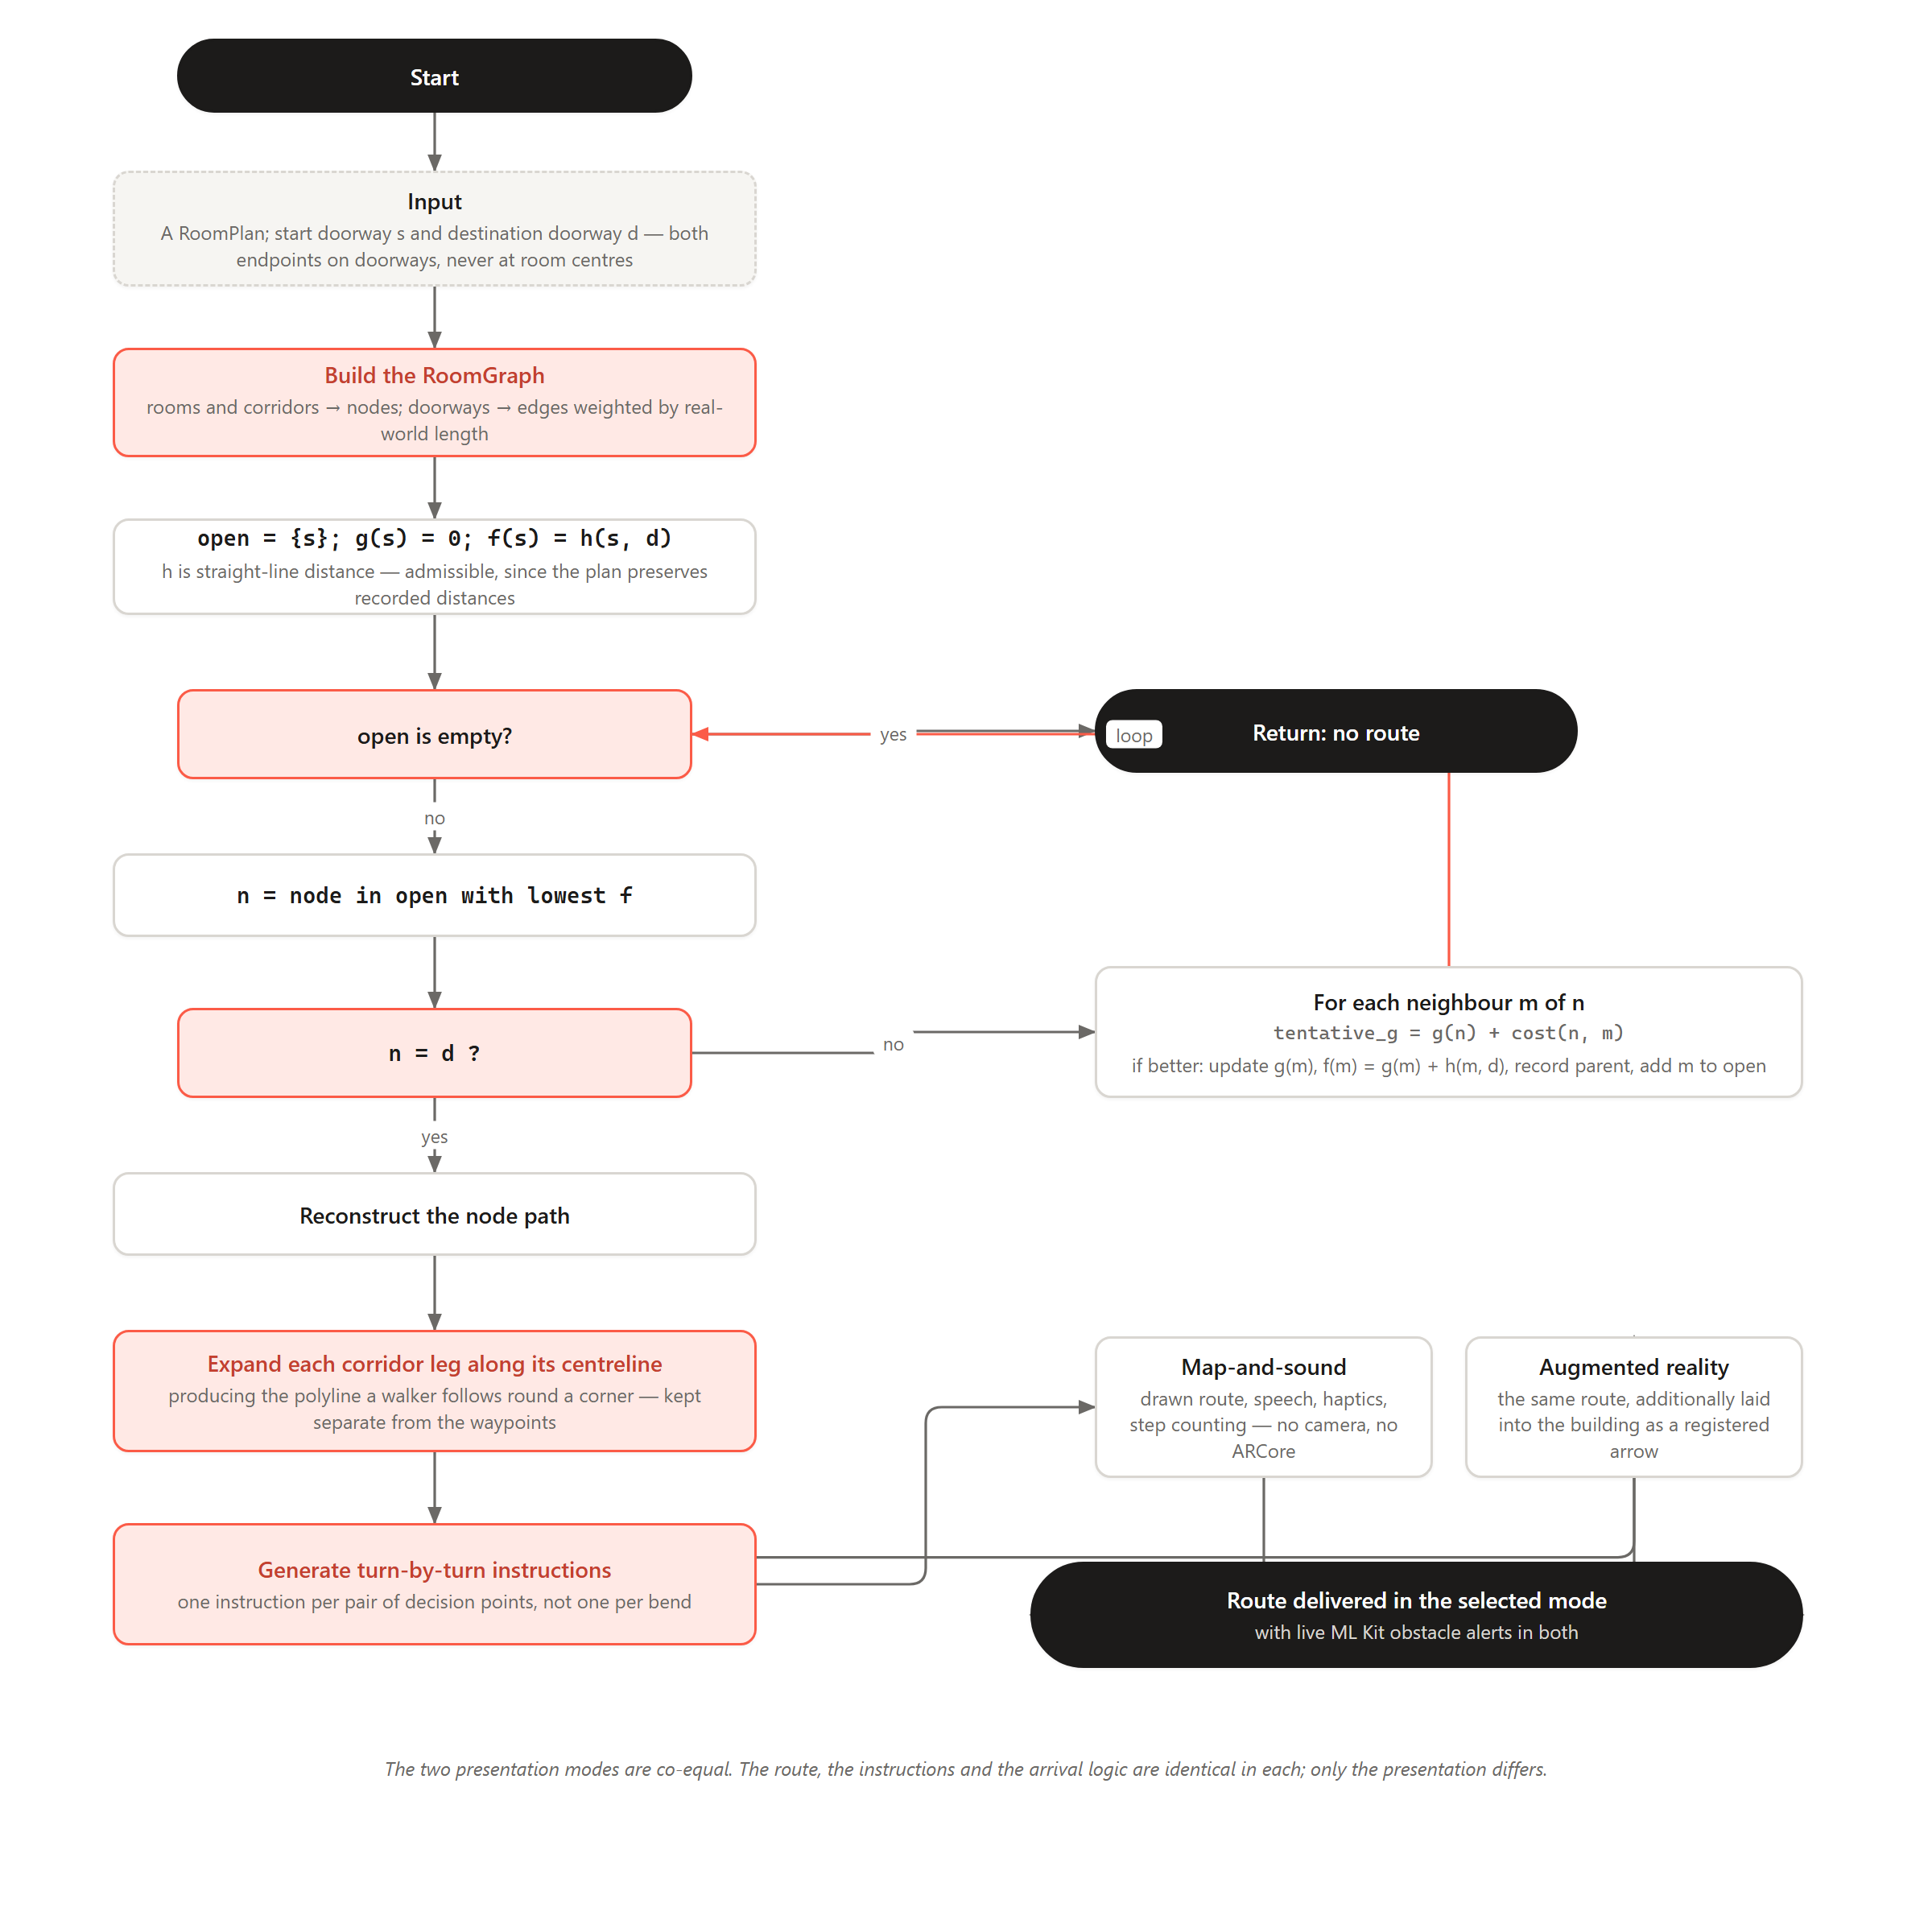
Figure 3.11: Flowchart — A* Indoor Navigation Algorithm

3.11.4 Algorithm 4: Route Registration
The AR arrow described in Algorithm 3 cannot point at a destination unless the route is first carried from the plan’s own frame into the frame ARCore (Google, 2024) invents at session start. Algorithm 4 solves that transform — a planar similarity transform of the kind formalised by Umeyama (1991), though solved here in closed form from one point and one direction rather than by least squares — and it is what distinguishes a registered route from a floating waypoint marker.
Step | Operation
Input | A planned route in plan coordinates; a live ARCore session; the room the walker has declared themselves to be in.
Step 1 | Take the walker’s ARCore position when guidance starts as their known position on the plan. This fixes the translation.
Step 2 | After a few steps, read the direction of travel from ARCore and the bearing of the route’s first leg from the plan. Assume they coincide; the rotation follows.
Step 3 | Scale is not an unknown: the plan’s metres-per-unit is set by the contributor, so both frames are metric. The transform therefore has three unknowns, and one point plus one direction supplies exactly three constraints.
Step 4 | Correct for handedness: the plan is right-handed read from above, the ARCore floor left-handed.
Step 5 | Apply the transform to lay the whole route into the room at once, with a confidence from the quality of the heading estimate.
Step 6 | On each confirmed landmark, re-solve against that landmark’s known plan position, replacing the heading assumption with a measurement.
Output | A rotation and translation carrying plan coordinates into the ARCore world, with confidence, refreshed at every landmark.
Table 3.13: Algorithm 4 — Route Registration
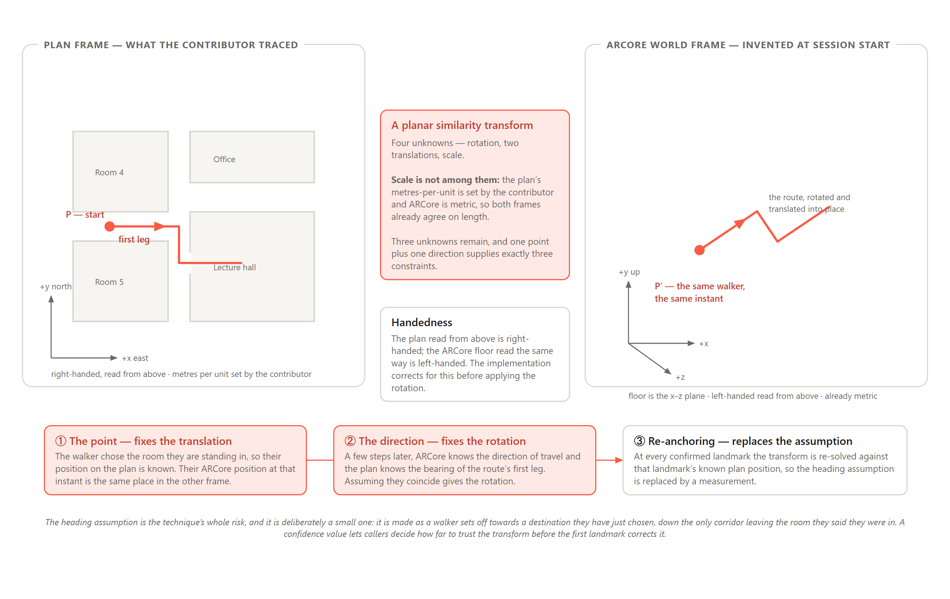
Figure 3.12: Registration Geometry — the Plan Frame, the ARCore World Frame, and the One Point and One Direction that Relate Them

3.12 Project Methods to be Employed
EchoLocate adopts an Agile/Iterative approach. This suits a project carrying significant technical uncertainty across several novel sensing layers — AR route registration, acoustic DSP, semantic detection, accessible navigation — where behaviour on commodity hardware can only be established empirically. Iterations with measurable acceptance gates let deficiencies be corrected before integration and favour continuous benchmarking over feature completeness. It also allowed two proposed sensing approaches to be implemented, evaluated on hardware and replaced by better-evidenced alternatives within the project window.

3.13 Software Process Model
EchoLocate follows an Agile/Iterative Development Model, delivering the system through five weekly-validated phases, each with a defined acceptance gate, over a 12-week timeline.
Phase | Focus | Key Activities | Acceptance Gate
1 | Research and Foundation | Literature review; set up Flutter, ARCore and ML Kit; validate camera capture and chirp emission. | Camera capture and chirp emission demonstrated on a physical device.
2 | Floor-Plan Authoring and Routing | Tracing against a photographed plan; metric scale and geometry cleanup; graph derivation and the Dart A* planner. | A metrically scaled plan authored and a door-to-door route computed over it.
3 | Acoustic DSP and Room Classification | FMCW chirp, FFT pipeline and reverberation features; the rule-based classifier and its fit-quality gate. | Room-type classification operational with rejection of unreliable estimates.
4 | Guidance, AR Registration, Crowdsourcing and Accessibility | Map-and-sound guidance with haptics and step counting; AR registration and arrow; ML Kit detection; Supabase, hive_ce, voice mode and stride calibration. | Feature-complete application build.
5 | Testing and Refinement | Map-accuracy, acoustic-accuracy and navigation success-rate testing; performance profiling; finalise report. | Validated, deployable build meeting accuracy and usability targets.
Table 3.14: EchoLocate Iterative Development Plan
This model was chosen because the sensing layers carry uncertainty that must be retired empirically, unlike Waterfall, whose upfront design assumes stable requirements. Validating each modality at its gate before integration reduces compounding failures and keeps a limited timeline focused on the highest-risk components.

3.14 Project Design Considerations (Logical Designs)

3.14.1 User Interface Design
The interface follows an accessibility-first, high-contrast language on a single warm accent — coral #FB5B47 — against near-black ink (#1C1B1A) and an off-white surface (#F6F5F2), set in Lexend, chosen for its reading-fluency research. Touch targets are large, iconography plain, and every colour-coded status also carries a text label, so guidance is never conveyed by colour alone. Each screen is defined in light and dark from one token set. Figures 3.13–3.24 present the principal screens as wireframes drawn from the delivered application, so the layouts shown are the ones that were built.
  Figure 3.13: Welcome / Landing |   Figure 3.14: Create Account |   Figure 3.15: Sign In
  Figure 3.16: Home — “Where to?” |   Figure 3.17: Explore Buildings |   Figure 3.18: Maps — the Offline Library
  Figure 3.19: Profile and Contribution Counts |   Figure 3.20: Tracing a Floor Plan |   Figure 3.21: Route Preview and Turn-by-Turn Steps
  Figure 3.22: Map-and-Sound Guidance |   Figure 3.23: Augmented-Reality Guidance |   Figure 3.24: Assistance — Obstacle Alerts and Sign Reading
Figures 3.13–3.24: EchoLocate User-Interface Wireframes

3.14.2 Database Design
EchoLocate uses a local-first hive_ce store on-device, with a Supabase (PostgreSQL) tier holding published copies of shared plans. Locally, plans and their unpublished drafts sit under separate key prefixes so an incomplete trace can never overwrite the plan it is a draft of, and repository queries are cached to keep browsing usable offline. The cloud side is defined across fourteen migrations under supabase/migrations/ and is presented below as the conceptual entity-relationship model and the relational schema derived from it. Foreign keys from a building or floor cascade on delete, so removing a building removes its plans, landmarks and routes with it.

(i) Entity-Relationship Diagram
Figure 3.25 presents the conceptual model in Chen notation: rectangles are entities, ellipses their attributes with primary keys underlined, and diamonds the relationships, each leg marked with its cardinality. ROOM_PLAN and ROUTE_STEP are weak entities because neither is identified on its own — a plan by its building, a step by its route and position in it. The two many-to-many relationships, contributes and saves, are what the junction tables below implement; contributes carries its own attributes, since how many floors and rooms a contributor mapped is a property of the pairing, not of either side.
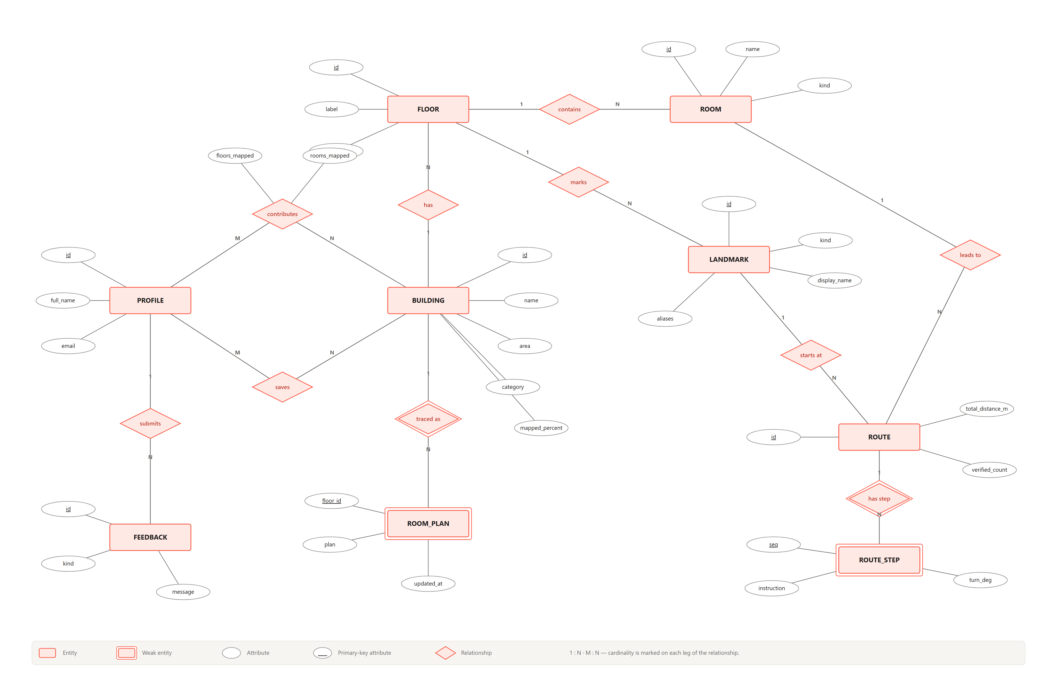
Figure 3.25: Entity-Relationship Diagram — EchoLocate Database

(ii) Database Schema
The relational schema in Figure 3.26 shows each of the twelve tables as a row of attribute boxes. Underlined fields are primary keys — several tables key on a composite, such as room_plans on (building_id, floor_id) and route_steps on (route_id, seq) — and italic fields are foreign keys, each pointing to the primary key it references. Where the entity-relationship diagram models nine conceptual entities, the schema shows every table that exists, including traced_plans and the junction tables building_contributors and saved_maps.
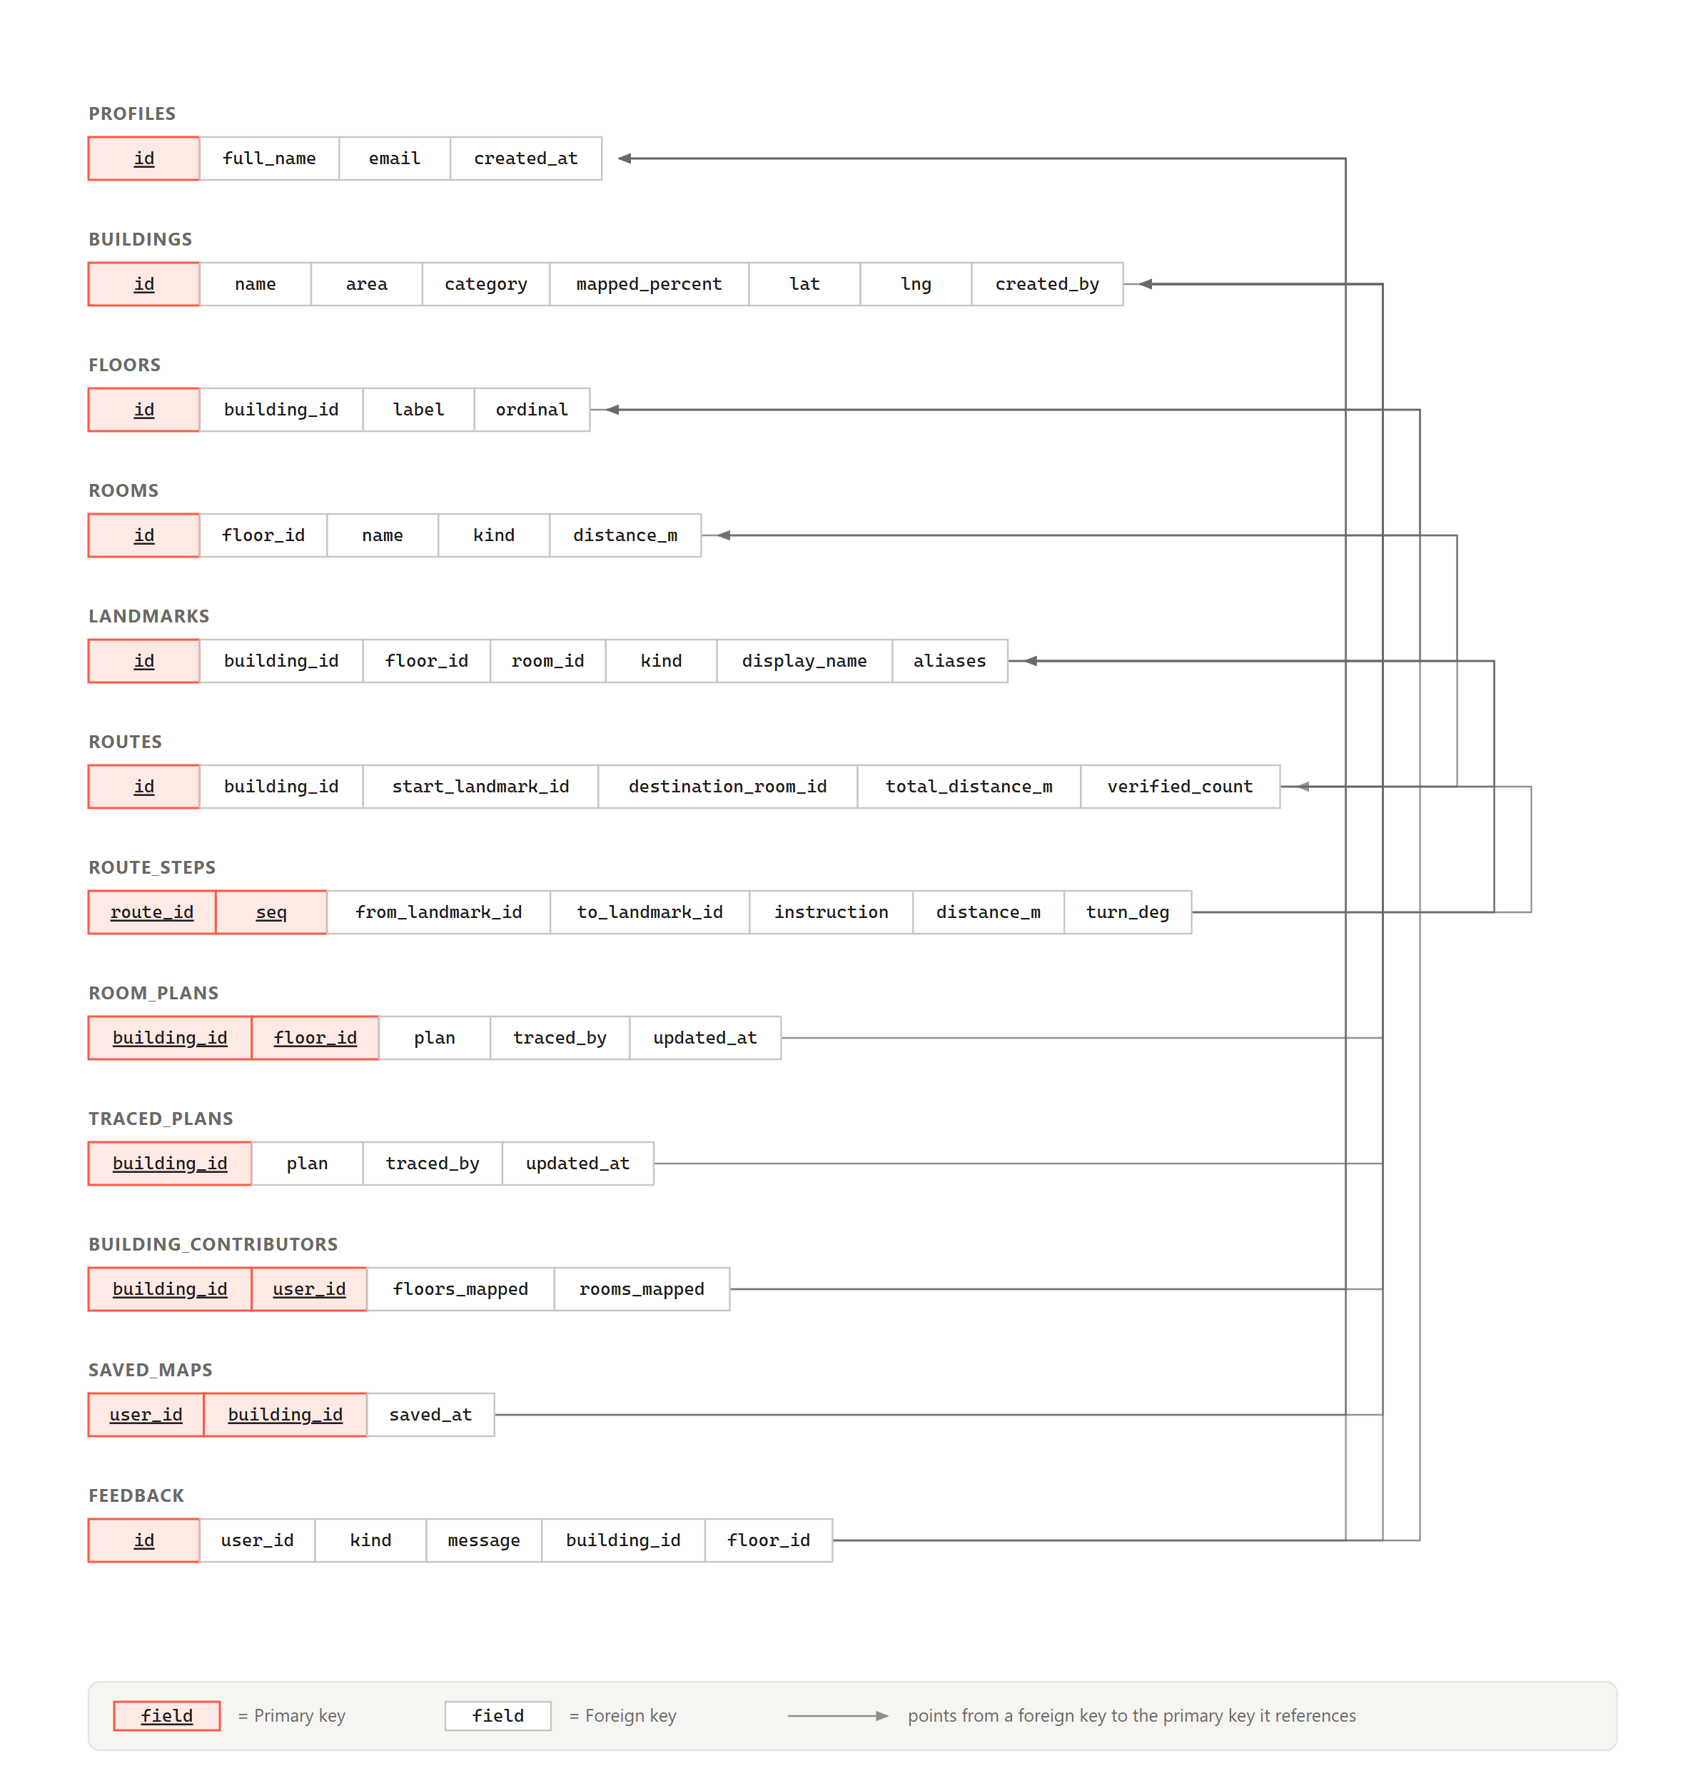
Figure 3.26: Database Schema — EchoLocate Supabase Tables

3.15 Development Tools
Table 3.15 summarises the primary development tools and technologies, with their role in the methodology described in this chapter.
Tool / Technology | Role in EchoLocate
Flutter (Dart) | Primary cross-platform framework; provides a single codebase for the application, all user-interface screens, and core application logic.
flutter_bloc | Presentation-layer state; each screen owns a Bloc or Cubit exposing loading, error and data states to the widget tree.
ARCore (custom platform channel) | Motion tracking and world-frame pose for the AR waypoint overlay and route registration, reached from Flutter through a native Android platform channel.
Google ML Kit | On-device computer vision: object detection for obstacle alerts and text recognition of room numbers and signage during navigation, with no cloud processing.
fftea | Fast Fourier Transform over captured audio, supporting reverberation feature extraction — the project’s Digital Signal Processing component.
flutter_soloud / record | Chirp emission through the device speaker and synchronised capture of the returning signal.
pedometer / sensors_plus | Hardware step counting for distance estimation along a route leg, with stride length calibrated per user.
A* Routing Engine (custom Dart) | Computes the shortest navigable path through the graph derived from a traced floor plan, driving turn-by-turn navigation.
hive_ce | Local-first on-device store holding authored plans, drafts and cached repository queries, keeping the application usable offline.
Supabase | Cloud backend for the crowdsourced map repository; stores and serves community-published floor plans and contributor records.
flutter_tts & speech_to_text | Voice interface; delivers spoken turn-by-turn guidance and accepts voice commands for the accessibility mode.
Table 3.15: EchoLocate Development Tools

CHAPTER FOUR: IMPLEMENTATION, TESTING, AND RESULTS

4.1 Implementation

4.1.1 Introduction
Chapter Three specified EchoLocate’s architecture, components and algorithms. This chapter reports how that specification was realised, how the result was verified and what it achieves. Where the delivered system departs from the specification, the departure and its reason are stated: the chapter describes what was built, not what was proposed.
The delivered system comprises 40,389 lines of Dart across 179 files, 4,749 lines of Kotlin implementing the native augmented-reality layer, and 18,258 lines of automated test code covering 927 test cases across 64 test files. The application presents 24 screens, each implemented in both light and dark themes.
Three conventions were held throughout, since a multimodal system accumulates coupling quickly without them. Repositories return typed models, each domain exposing an abstract interface with interchangeable on-device and cloud implementations. Blocs own screen state while services own hardware — sensing services are singletons Blocs subscribe to, rather than each screen opening the camera itself, since ARCore holds the camera exclusively. And every screen is built in light and dark from a shared token set, so none carries a hard-coded colour.
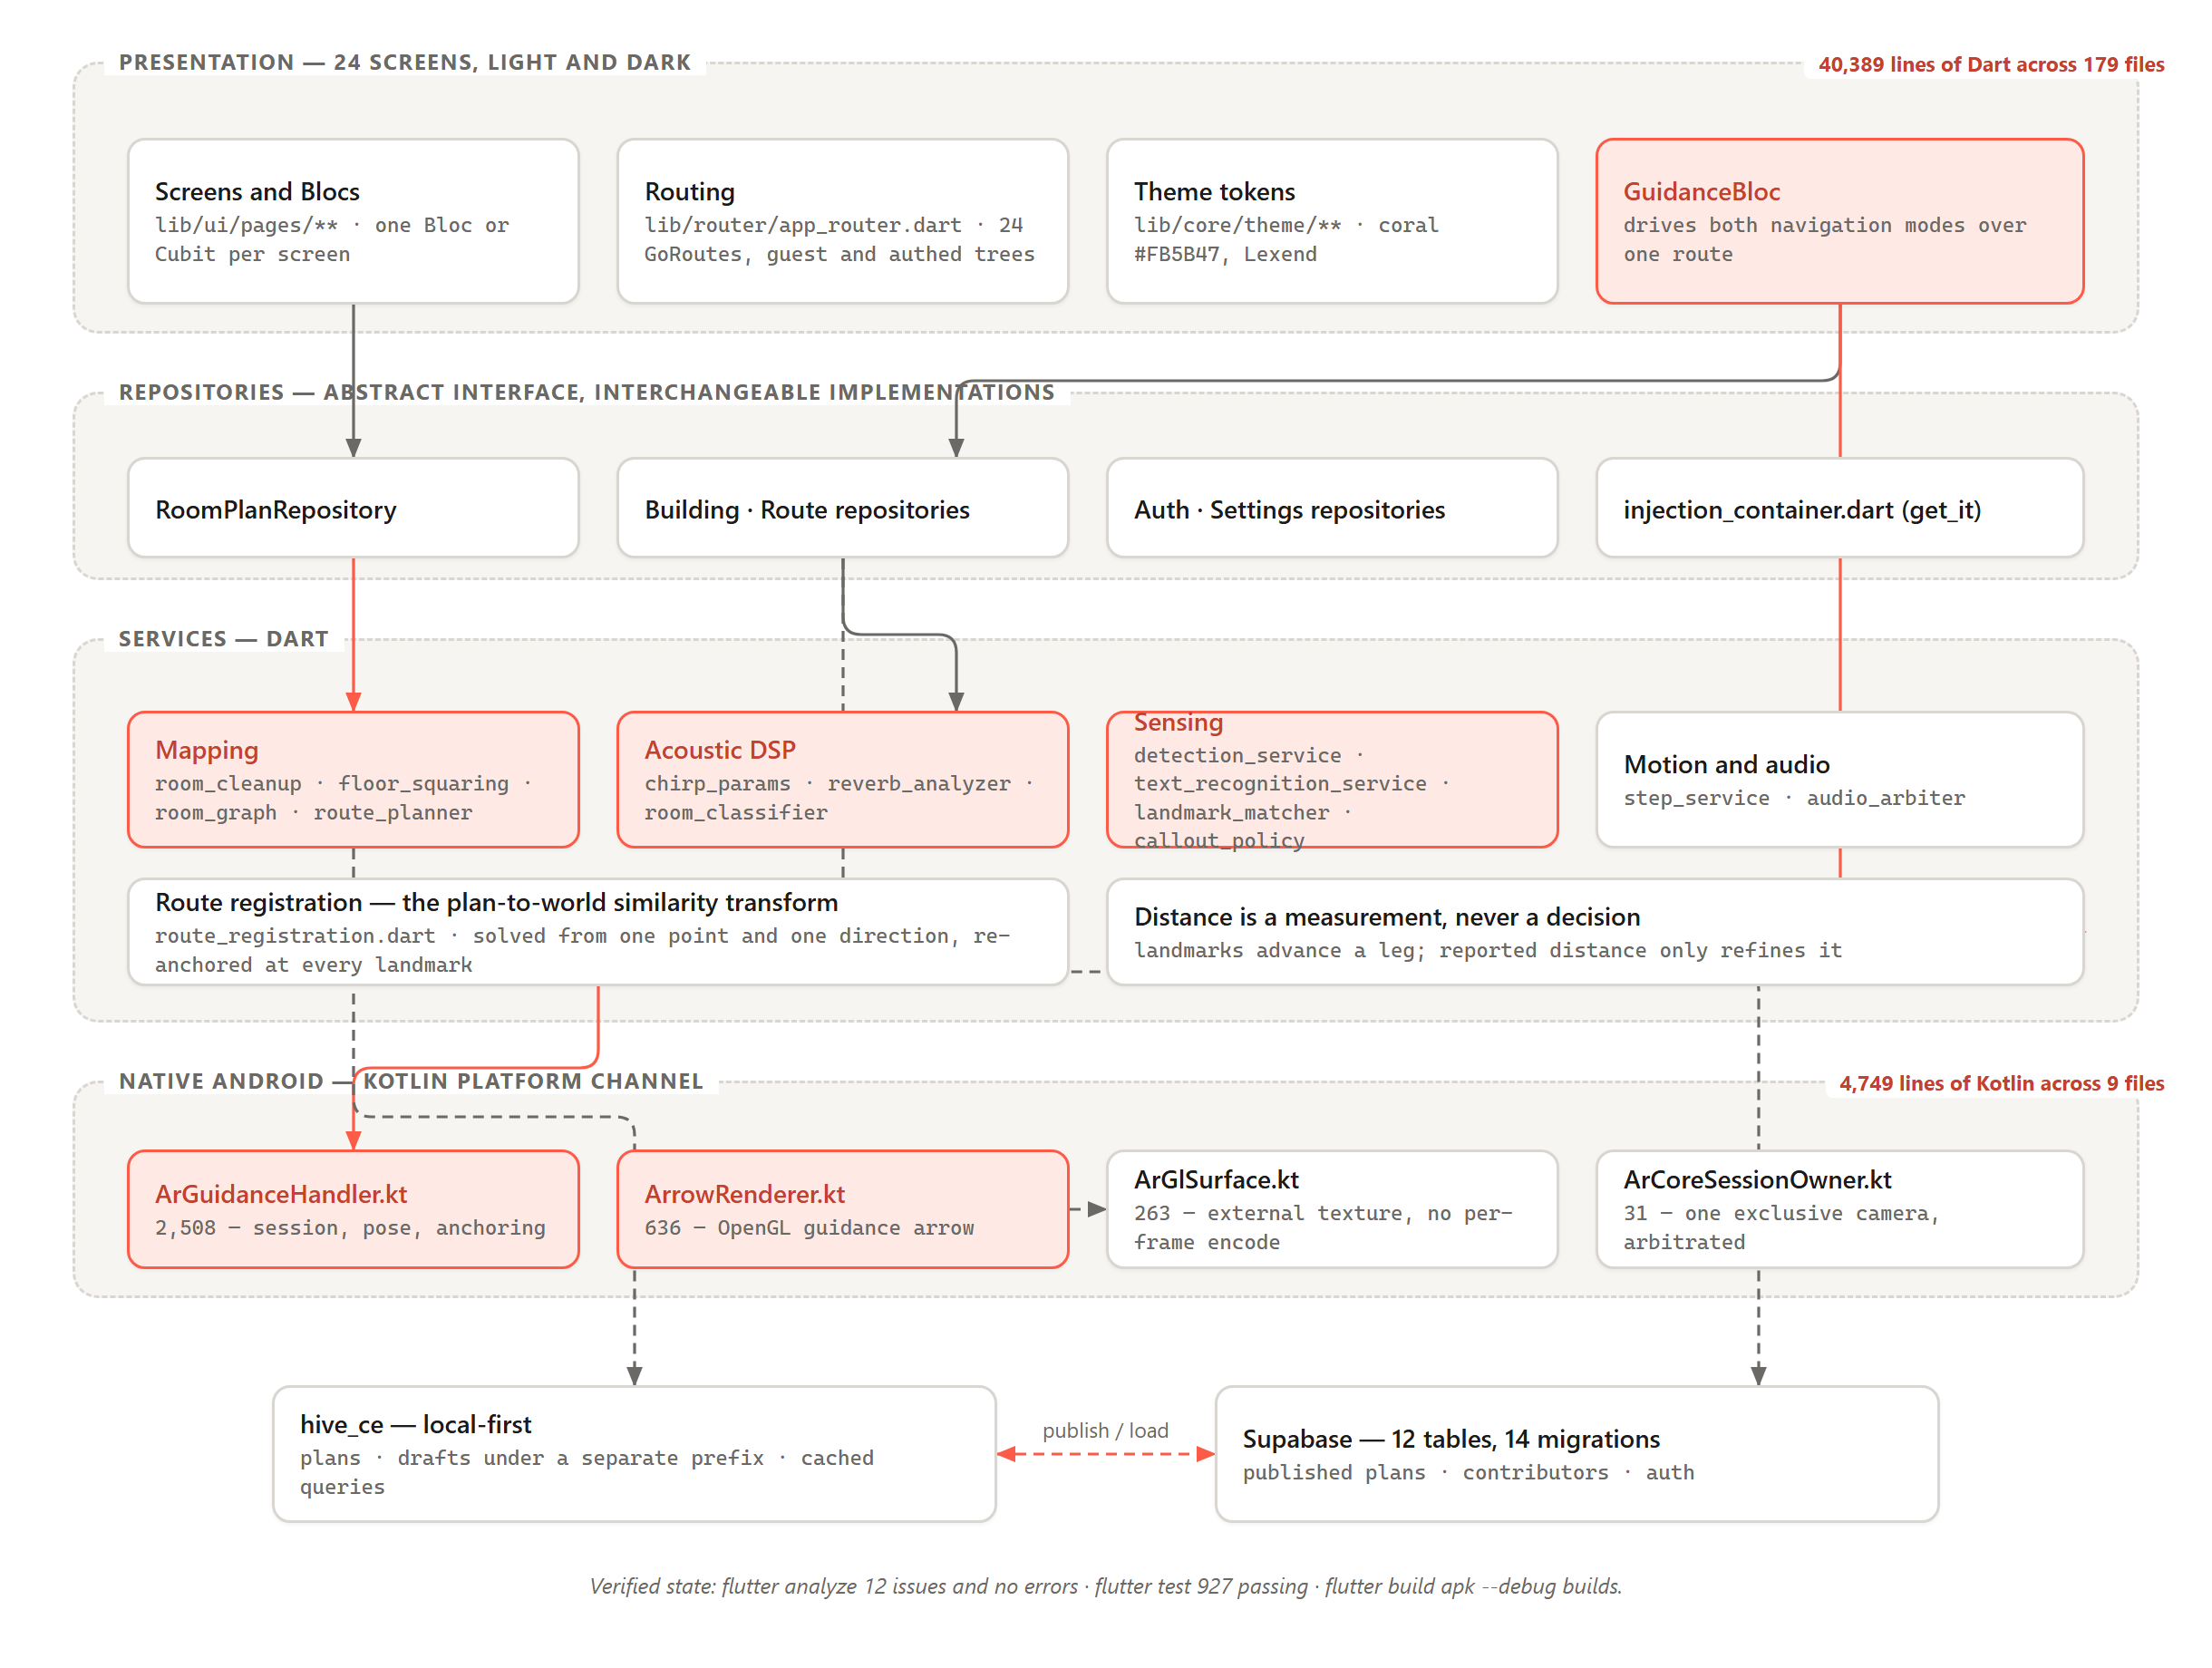
Figure 4.1: Implemented Layered Architecture of EchoLocate

4.1.2 Implementation of the Frontend
The interface follows a five-destination bottom navigation pattern — Home, Explore, a centre action, Maps, Profile — with full-screen flows pushed above it. Twenty-four screens were implemented, grouped as in Table 4.1.
Group | Screens
Onboarding and authentication | onboarding, welcome, sign in, sign up, camera primer, location primer
Browsing | home, explore, maps
Authoring | map building, building mapping hub, plan trace, room trace, plan editor
Navigation | navigate, room navigate, guidance
Sensing | assist, acoustic, sonar, depth probe, room plan probe
Profile | profile, stride calibration
Table 4.1: Implemented Screens by Functional Group
The visual system uses one warm accent (coral #FB5B47) against near-black ink and an off-white surface, set in Lexend, with rounded cards and soft shadows. Every colour and spacing value comes from a token file rather than the point of use, which makes the dark theme a redefinition of tokens rather than a second set of screens.
Permission priming is handled by dedicated primer screens shown once before the first camera or location request, rather than by raising a system dialogue cold. A user who denies a permission unexpectedly is expensive to recover.
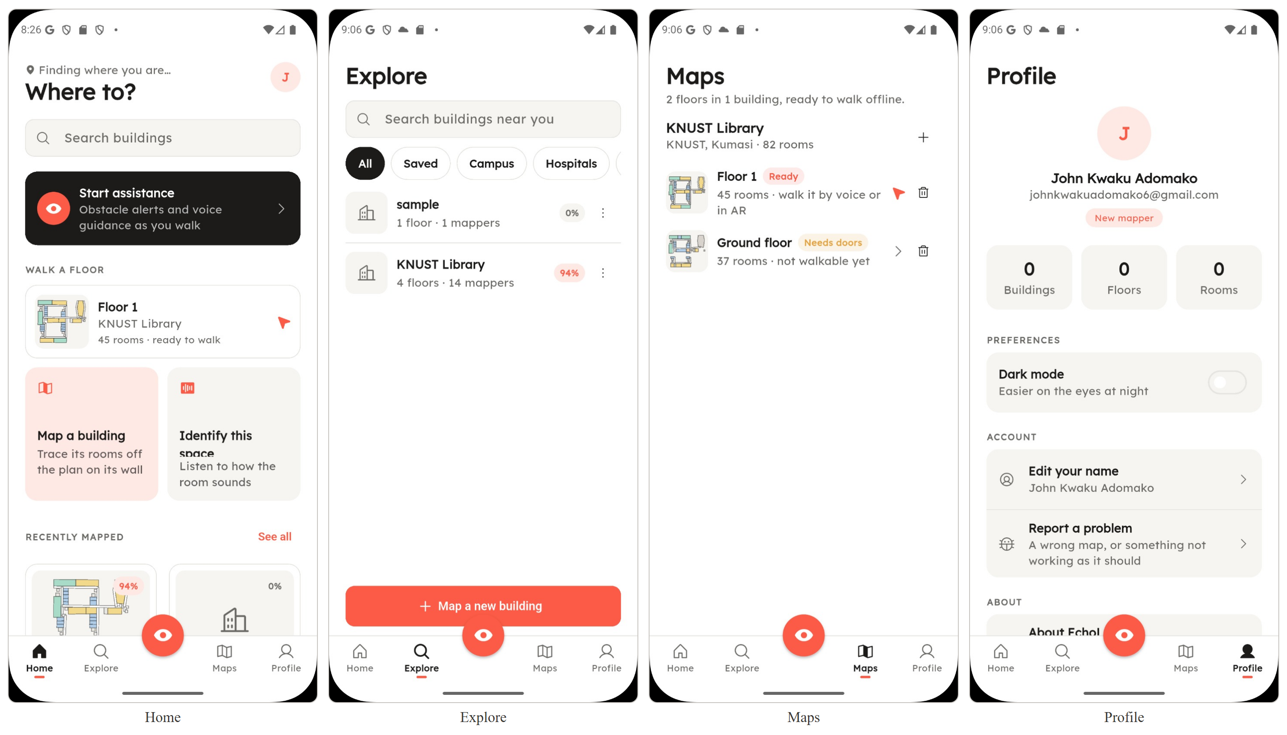
Figure 4.2: Principal Application Screens — Home, Explore, Maps and Profile
Each screen owns a Bloc or Cubit and renders from its state. explore_page.dart is representative: a BlocBuilder rebuilds on state change, every branch of the state — loading, failure, data — is rendered explicitly, and a buildWhen restricts filter-chip rebuilds to the field that actually changed rather than rebuilding on every emission.

4.1.3 Implementation of the Backend
The backend is local-first: everything works offline against an on-device hive_ce store, and published plans synchronise with a Supabase (PostgreSQL) tier.
The cloud schema, defined across fourteen migrations under supabase/migrations/, is normalised around buildings and its dependent floors and rooms: room_plans holds traced polygon geometry per floor, traced_plans the photographed backdrop it was traced over, landmarks the confirmable features on it, routes and route_steps recorded walks, profiles and building_contributors attribution, saved_maps a user’s library, and feedback in-app reports. Foreign keys with cascade deletion keep a plan and its dependent rows consistent (Figure 3.26).
Three design decisions are worth reporting. Drafts are isolated from published plans by key prefix, so an incomplete trace can never overwrite the plan it drafts. Plans are stored as encoded JSON strings rather than maps, because the nested immutable models within a plan are not types the local store recognises and it fails at the moment of saving; encoding once at the boundary turns that failure impossible rather than intermittent. Plan replacement is last-write-wins by design: two contributors tracing one floor produce two opinions of the same geometry, and merging polygons cannot be done sensibly without asking a person which is right.
Storage is reached through an abstract interface, so the on-device and Supabase implementations are interchangeable: RoomPlanRepository (lib/features/room_trace/room_plan_repository.dart) exposes planFor, plansOf, save and delete for published plans, alongside a parallel saveDraft, draftFor and clearDraft trio that is always device-local, keeping an unpublished draft isolated from the plan it drafts by construction rather than by convention.
Implementations are selected once at startup — a single registerLazySingleton call in lib/services/injection_container.dart choosing SupabaseRoomPlanRepository or LocalRoomPlanRepository from configuration — so no screen knows which is in use.

4.1.4 The Login Module
Authentication is provided by Supabase, with native Google sign-in through Android’s Credential Manager yielding an ID token that Supabase exchanges for a session.
The module comprises AuthRepository (abstract), SupabaseAuthRepository (production) and MockAuthRepository (used when no Supabase configuration is present). AuthBloc holds session state for the application, and the router listens to it, redirecting between a guest route tree and the authenticated tree whenever the Bloc emits.
Network and credential failures are translated into readable messages at the repository boundary rather than surfaced as exceptions, behaviour covered by supabase_auth_repository_test.dart.
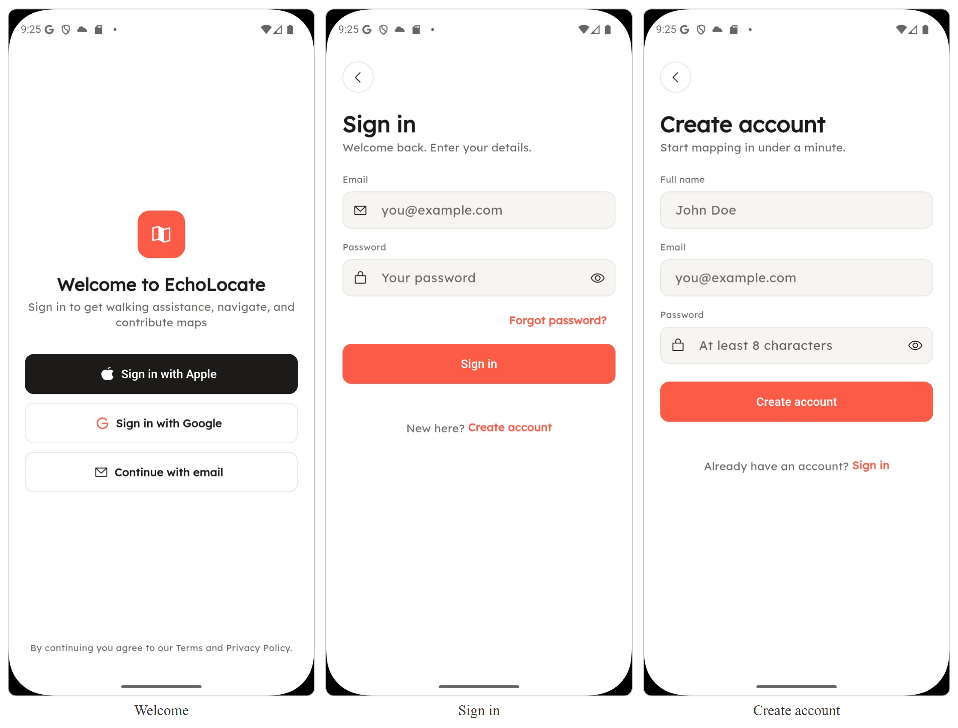
Figure 4.3: Welcome, Sign-In and Create-Account Screens

4.1.5 The Floor-Plan Authoring Module
This module replaces the depth-based plan generation named in the original proposal; §3.11.1 was revised to specify tracing instead. Tracing produces a metrically scaled floor in about twenty minutes, depends on no tracking quality, and works on every Android phone rather than only ARCore-certified ones — so contributing is open to everyone.
A contributor produces a floor plan by photographing a posted plan, or tracing the space directly, and laying down closed polygons for rooms and corridors. Corners are captured in plan coordinates with +x east and +y north; a metric scale is established by marking one known real-world distance.
Traced geometry is cleaned rather than trusted (room_cleanup.dart, floor_squaring.dart): near-coincident corners merged, near-orthogonal walls squared, degenerate polygons discarded. Room types come from a short wall-board vocabulary rather than a building-code classification, because a contributor chooses one while standing in a corridor and every entry must be identifiable from a doorway.
Because a large building cannot be traced in one sitting, a floor is authored a wing at a time and wings are reconciled by dragging one into place against another — human-in-the-loop alignment in place of pose-graph optimisation, on the grounds that the latter is weeks of work and the former is a contributor who can see the building.
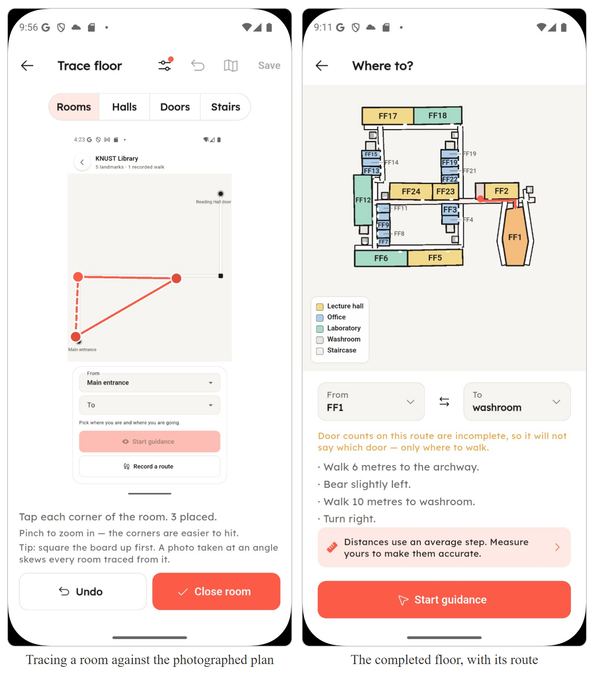
Figure 4.4: Floor-Plan Authoring — Tracing a Room, and the Completed Floor

4.1.6 Implementation of the Graph Derivation and Routing Method
Traced geometry is converted into a navigable graph in which rooms and corridors are nodes and doorways weighted edges (room_graph.dart). Routes are computed by a custom Dart A* implementation (route_planner.dart) using a straight-line Euclidean heuristic, admissible because the layout preserves recorded distances.
final open = <String>[from];
final costSoFar = <String, double>{from: 0};
while (open.isNotEmpty) {
// A list scan rather than a heap: a floor holds tens of landmarks, and
// the constant factor of a priority queue is not worth the code.
final current = _lowestEstimate(open, costSoFar, graph, to);
if (current == to) return _reconstruct(graph, cameFrom, from, to, landmarks, recorded);
for (final neighbour in graph.neighboursOf(current)) {
final cost = costSoFar[current]! + neighbour.distanceM;
final known = costSoFar[neighbour.landmarkId];
if (known != null && known <= cost) continue;
costSoFar[neighbour.landmarkId] = cost;
cameFrom[neighbour.landmarkId] = Neighbour(landmarkId: current, edge: neighbour.edge);
if (!open.contains(neighbour.landmarkId)) open.add(neighbour.landmarkId);
}
}
return null;
Two details distinguish the implementation from the textbook algorithm. Both endpoints sit on doorways rather than room centres — a route between centres begins and ends in open floor with no door in sight — so endpoints move onto the doorway while the final instruction still names the room. Waypoints and the drawn polyline are also kept separate: waypoints are decision points producing one instruction per pair, while the polyline expands each corridor leg along its centreline so the route follows the hallway round a corner. Merging them would generate an instruction for every bend.
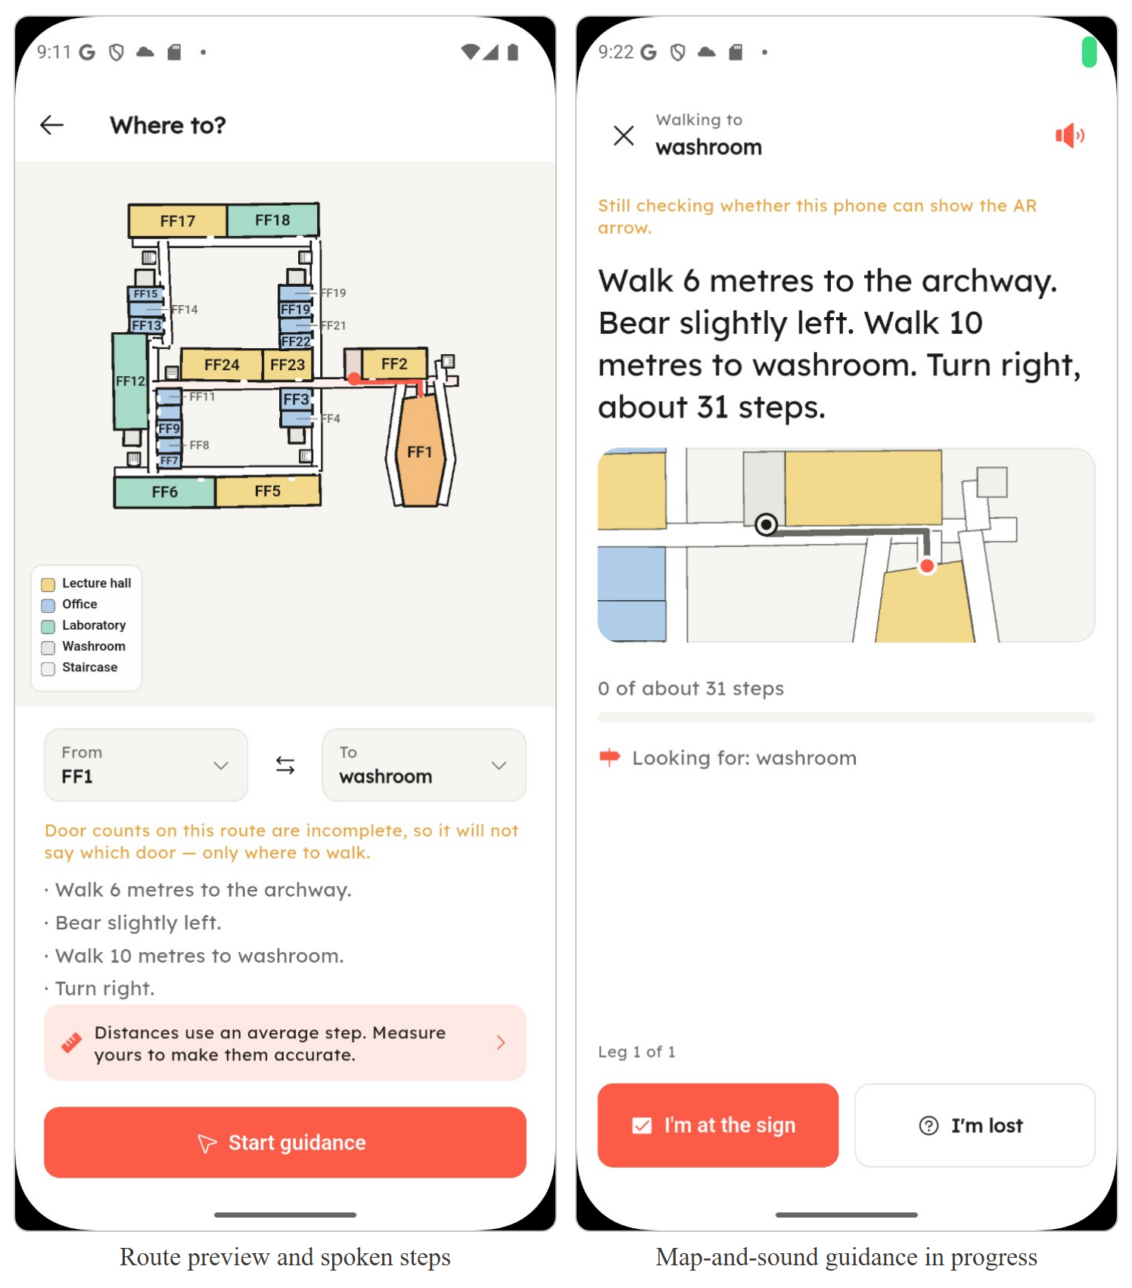
Figure 4.5: A Planned Route Drawn over a Traced Floor, and Guidance in Progress

4.1.7 Implementation of the Augmented-Reality Route Registration Technique
This is the most substantial component of the system, corresponding to Algorithm 4 in §3.11.4. It was built because the waypoint arrow specified in Chapter Three could not work without it.
The problem is one of coordinate frames. Plan geometry uses its own frame: +x east, +y north, origin wherever tracing began. ARCore invents a frame at session start, +y up, floor in the x–z plane. Guidance originally bridged the two by refusing to — walking a chain of relative turns each measured from the last. That is why the arrow could not navigate: such a chain is only as good as the direction its first link was hung from, whichever way the phone happened to be pointing.
The solution rests on the transform’s degrees of freedom. A planar similarity transform has four unknowns, but scale is not one here: the contributor sets the plan’s metres-per-unit, so both frames are already metric. That leaves three, and one point plus one direction supplies exactly three constraints. The point is the walker’s position on the plan, known at the start since they chose the room they are in; their ARCore position at that instant is the same place in the other frame. The direction follows a few steps later, once ARCore knows the direction of travel and the plan knows the first leg’s bearing. Handedness is also corrected: the plan is right-handed from above, the ARCore floor left-handed.
The heading assumption is the technique’s whole risk, deliberately a small one: made as a walker sets off toward a destination just chosen, down the only corridor leaving the declared room. A confidence value lets callers decide whether to trust the transform, and re-registration at each confirmed landmark replaces the assumption with a measurement.
A second mechanism reduces residual error. Because corridors are rectilinear, the route’s legs imply a grid. Leg bearings are summed as unit vectors at four times their bearing, weighted by length — quadrupling makes legs at 0°, 90°, 180° and 270° reinforce rather than cancel, whereas averaging bearings directly would place a corridor and the one crossing it at 45°, the one answer that cannot be right. Measured yaw selects the quarter turn; the grid supplies the value.
for (var i = 0; i + 1 < path.length; i++) {
final delta = path[i + 1] - path[i];
final length = delta.distance;
if (length < minLegM) continue; // short legs do not vote
final quadrupled = 4 * planBearingOf(delta);
sumSin += length * math.sin(quadrupled);
sumCos += length * math.cos(quadrupled);
weight += length;
}
if (weight <= 0) return null;
final resultant = math.sqrt(sumSin * sumSin + sumCos * sumCos) / weight;
if (spreadOfResultant(resultant) > maxSpreadRad) return null;
return foldToQuarter(math.atan2(sumSin, sumCos) / 4);
ARCore integration was written directly rather than taken from a plugin, comprising 4,749 lines of Kotlin across nine main-source files, distributed as shown in Table 4.2.
File | Lines | Role
ArGuidanceHandler.kt | 2,508 | Session lifecycle, pose streaming, route anchoring
ArrowRenderer.kt | 636 | OpenGL rendering of the guidance arrow
ArCoreDepthHandler.kt | 453 | Depth API access and availability checks
RegisteredRoute.kt | 358 | The route as laid into the world frame
ArGlSurface.kt | 263 | External-texture surface shared with Flutter
CameraBackgroundRenderer.kt | 239 | Camera feed as the AR background
AnalysisFraming.kt | 193 | Camera-configuration choice for the ML Kit analysis stream
MainActivity.kt | 68 | Platform-channel registration
ArCoreSessionOwner.kt | 31 | Arbitrates the exclusive ARCore camera between screens
Table 4.2: Native Augmented-Reality Layer — Kotlin Source Files
A significant performance decision sits in ArGlSurface.kt: the camera preview reaches Flutter as an external texture rather than as encoded frames, removing a per-frame encode/decode round trip from the render path.
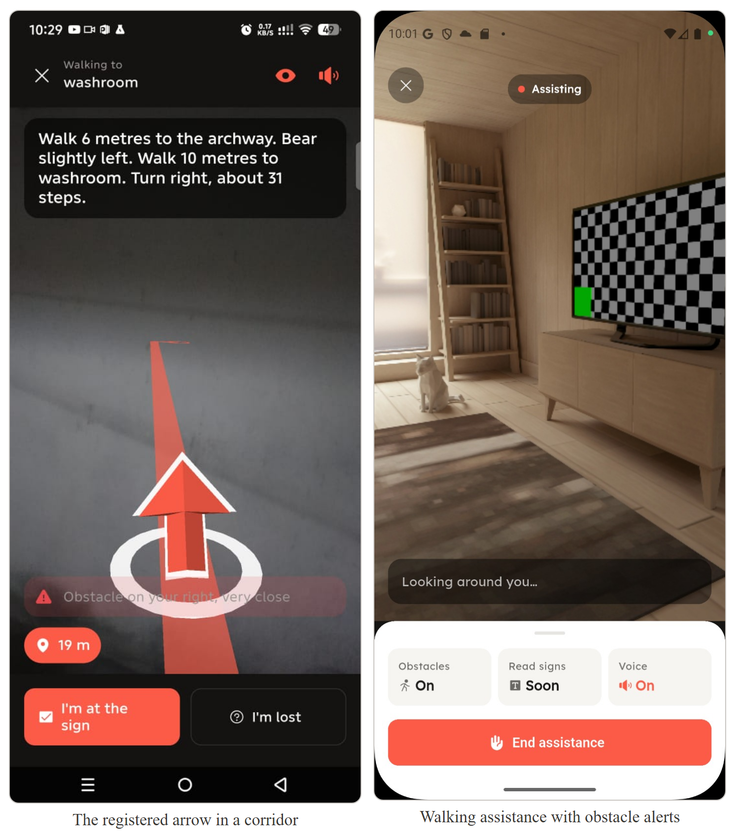
Figure 4.6: The Augmented-Reality Guidance Arrow, and Walking Assistance

4.1.8 Implementation of the Semantic Detection Module
Google ML Kit object detection and text recognition run against the live camera feed to raise obstacle alerts and read room numbers and signage aloud (detection_service.dart, text_recognition_service.dart). Both run on-device; no image leaves the phone.
The service resolves its frame source at start, preferring an already-streaming AR session, since ARCore holds the camera exclusively. landmark_matcher.dart matches recognised text against known landmarks with a tightened edit-distance tolerance — room codes differ by single characters, and a tolerant match confidently reports the wrong room. What is announced, and how often, sits in callout_policy.dart, tunable without touching detection.

4.1.9 Implementation of the Acoustic Digital Signal Processing Pipeline
The pipeline emits a linear FMCW up-sweep and analyses the return to characterise the space. This is the project’s Digital Signal Processing contribution.
The signal parameters in chirp_params.dart — a 13–19 kHz linear up-sweep of 120 ms at 44.1 kHz — are the values specified in §3.11.2, not those first proposed: band and duration were both changed deliberately during implementation, toward better performance, and §3.11.2 was revised to match. Table 4.3 records the change and its reason. The change was assessed for its effect on the ambient noise floor; its effect on the dynamic range above that floor, on which reverberation measurement depends, was not assessed at the time — §4.3.6 reports the consequence.
Parameter | First proposed | Implemented (and specified in §3.11.2) | Reason
Band | 2–8 kHz | 13–19 kHz | Speech, footsteps and HVAC put almost all energy below ~8 kHz. Above that band ambient noise contributes little to the correlation, so the noise floor falls in a crowded room rather than rising. The band is also faint or inaudible to most listeners. Bandwidth is unchanged at 6 kHz, so range resolution is unaffected.
Duration | 40 ms | 120 ms | Matched-filter gain follows the time–bandwidth product. At 6 kHz, 40 ms gives TB = 240 (≈ 24 dB); 120 ms gives TB = 720 (≈ 28.6 dB). The compressed pulse stays equally sharp, its width set by bandwidth, not duration.
Sample rate | 44.1 kHz | 44.1 kHz | Unchanged; keeps the band below Nyquist with margin for microphone roll-off.
Table 4.3: FMCW Signal Parameters as First Proposed and as Implemented
Feature extraction (reverb_analyzer.dart) derives four quantities from the energy decay curve: RT60, extrapolated from a reliable portion of the decay rather than a full 60 dB; early decay time, the same slope over the first 10 dB; fit quality r², since a real decay in dB is close to linear and a low value means noise was measured; and usable decay range, since an RT60 from 8 dB is a weaker claim than one from 25 dB. The last two gate the estimate rather than classify it.
Classification (room_classifier.dart) applies interpretable rules. The EDT/RT60 ratio is the key discriminator: in a diffuse room energy arrives from all directions and decays at one rate throughout, so early and late decay agree; in a corridor, strong parallel reflections make early decay much shorter. That ratio separates corridors from rooms in a way neither value achieves alone.
The thresholds are given in Table 4.4. Each is a constructor parameter rather than a constant, so the evaluation in §4.3.5 can re-fit them against measured rooms.
Threshold | Value | Meaning
smallRoomMaxRt60 | 0.6 s | At or below, a small, well-absorbing space
hallMinRt60 | 1.2 s | At or above, a large, lightly absorbing volume
maxDiffuseRatio | 0.8 | Below, the field is non-diffuse — a corridor
minCorridorRt60 | 0.4 s | Floor below which a corridor reading is not believed
Table 4.4: Room-Classification Thresholds
The original proposal specified a TensorFlow Lite classifier; rules were implemented instead and §3.11.2 revised accordingly. The choice is argued, not conceded: Sabine’s relation ties reverberation time to volume and absorption, so classes separate along RT60 for physical reasons, and every decision can be defended from room acoustics. A network trained on the few samples obtainable in twelve weeks carries unquantified generalisation risk for little added separation. Every classification also returns a reason string, so a wrong answer can be diagnosed rather than merely observed, and the interface stays unchanged for a learned classifier to replace it later.
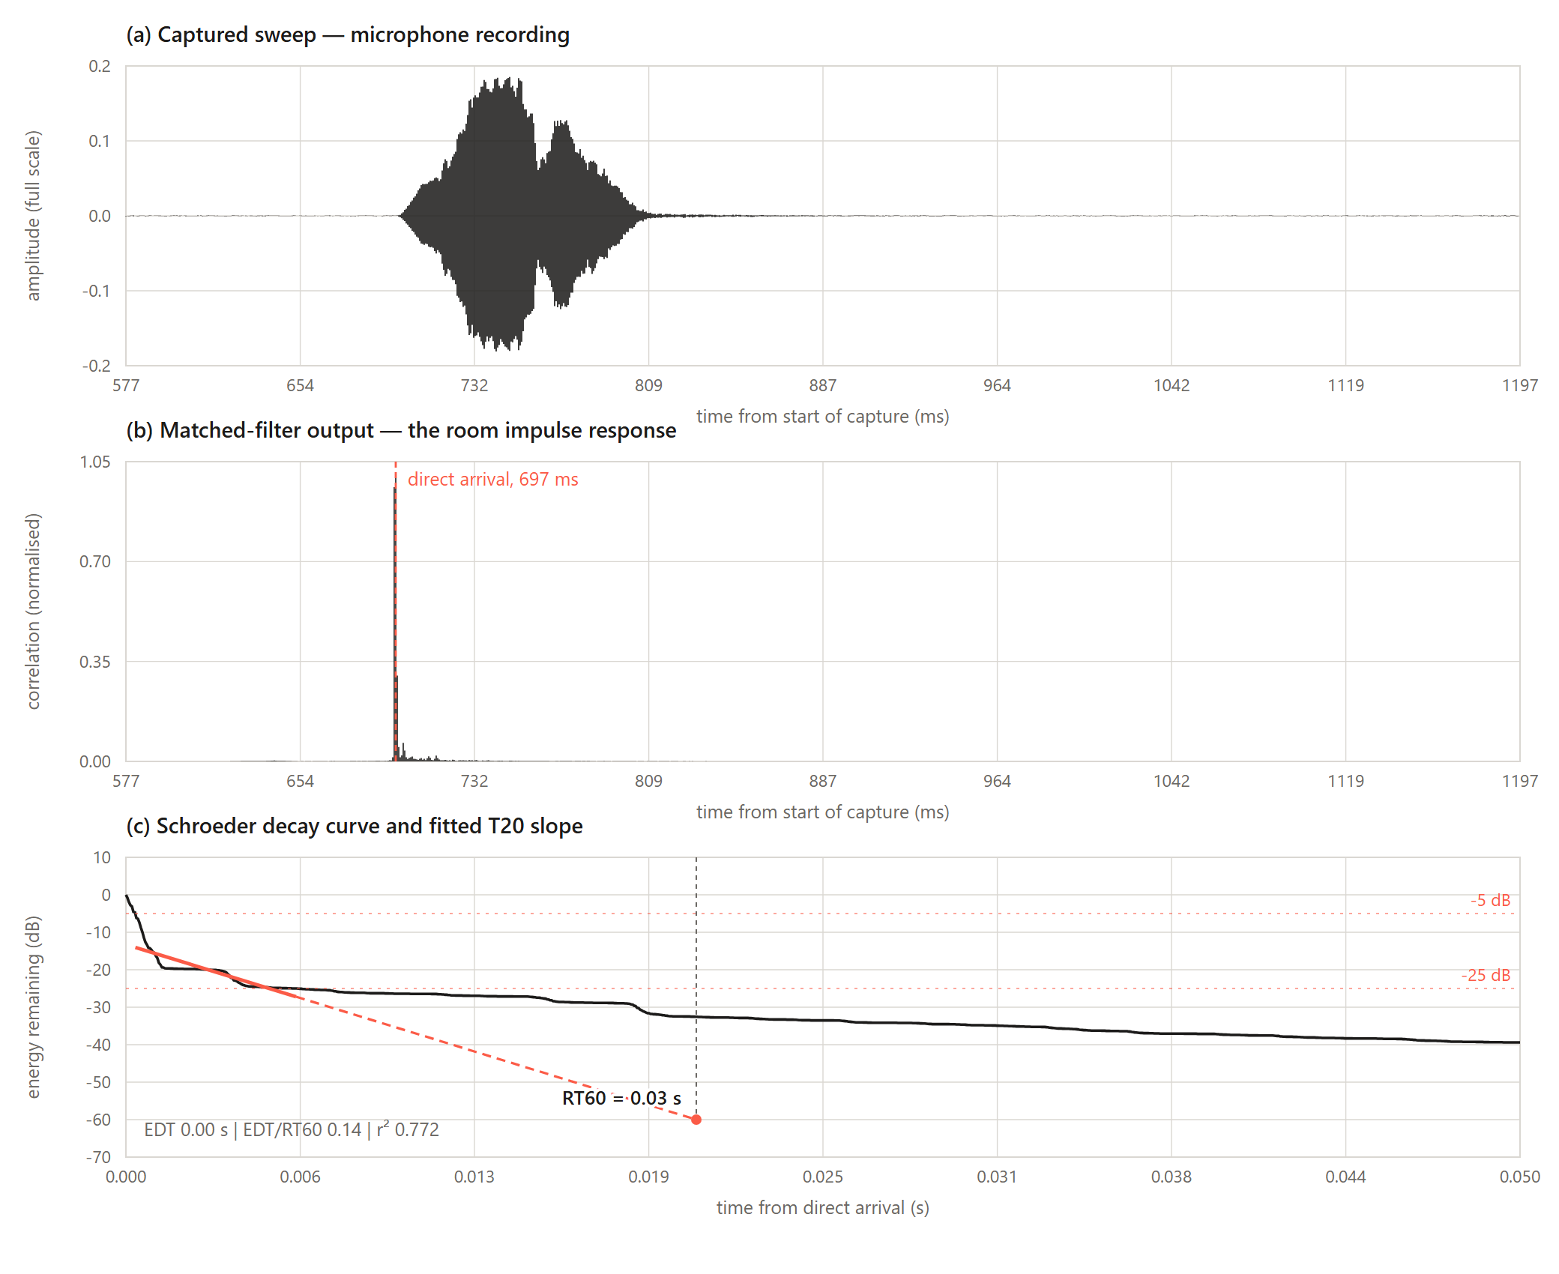
Figure 4.7: A Captured FMCW Sweep, its Correlation, and the Fitted Decay Curve. Capture 3 of Table 4.9, taken in a quiet room of about 8 m × 10 m using the 2–8 kHz sweep. Panels (a) and (b) show the emission and the matched filter compressing it to a sharp impulse response; panel (c) shows the T20 fit falling inside the collapse of the direct pulse rather than the room’s decay — the failure diagnosed in §4.3.6.

4.1.10 Implementation of the Accessibility and Motion Services
Guidance is delivered as synthesised speech and haptic patterns, so the system is usable with the phone in a pocket and the screen dark.
A single AudioArbiter mediates every use of microphone and speaker, since the voice interface and the acoustic pipeline want the same hardware. StepService wraps Android’s hardware TYPE_STEP_COUNTER rather than deriving steps from raw accelerometer data, so the count survives the phone being held still while a walker reads a sign. Distances are stored in metres but spoken in the walker’s own paces: StrideCalibrationCubit measures step length, and an uncalibrated user falls back to a documented default rather than being blocked.
One principle governs the subsystem: distance is a measurement, never a decision. Where ARCore is available it measures along-leg progress better than counting footfalls against an estimated stride, and that number is reported to the guidance engine. It can never advance a leg, end a route or move a walker onto another — landmarks do all of that, and a distance disagreeing with a sign is the distance that is wrong. This keeps the route working unchanged on phones with no ARCore and no step counter.

4.2 Testing
Verification is by automated test at unit and widget level, supported by walked trials on physical hardware for anything involving the camera, microphone, step counter or ARCore. Table 4.5 summarises the automated suite.
Measure | Value
Test files | 64
Test cases | 927
Lines of test code | 18,258
Ratio of test to production code | approximately 1 : 2.2
Table 4.5: Automated Test Suite Summary

4.2.1 UI Testing
Widget tests render principal screens against fake repositories and assert that each state branch produces the right interface, in both themes. Covered screens include the plan editor, room trace, navigation, room navigate and the room-plan probe, with the shared painters and views (floor_plan_painter_test.dart, route_map_view_test.dart, room_plan_view_test.dart).
Tests assert behaviour a user would notice — that the room sheet refuses to add a room before a category is chosen, that a route is drawn in both themes, that an error state shows a readable message rather than an exception.

4.2.2 Database Testing
Persistence is tested at the repository boundary: caching behaviour (repository_mixin_test.dart), draft isolation from published plans, and JSON round-tripping (room_plan_repository_test.dart, route_repository_test.dart, building_repository_test.dart, settings_repository_test.dart).
The round-trip tests matter more than they appear to. A plan must survive encoding to JSON, storage in PostgreSQL and decoding back with its nested geometry intact; a silent change in that path would corrupt plans rather than fail loudly, so the tests pin the exact shape.

4.2.3 Integration Testing
Integration is tested by substituting fakes at the service boundary, so a Bloc’s behaviour under a stream of frames, steps or poses is exercised without a device. guidance_bloc_test.dart, ar_guidance_cubit_test.dart and floor_map_bloc_test.dart cover the paths where components must agree — that a confirmed landmark advances a leg, that reported distance refines but never overrides it, that losing the walker triggers recovery rather than silence.
Pure cross-module pipelines are tested end to end without mocks at all: traced geometry through cleanup, graph derivation, routing and direction generation (room_plan_bridge_test.dart, room_directions_test.dart, graph_route_path_test.dart, route_registration_test.dart).

4.2.4 System Testing
System testing was carried out by walking routes in real buildings on a physical Android device, since camera, microphone, step counting and AR tracking cannot be exercised in a host test environment. Both navigation modes were walked against floors traced by the team.
The procedure for characterising augmented-reality guidance — odometry scale, yaw drift and off-route distance — is documented in docs/ar-navigation-accuracy.md.
Two Android handsets were used, and the difference between them is itself part of what is under test. Everything involving augmented reality was exercised on an Infinix Note 50 Pro, model X6855, specified in Table 4.6. It is ARCore-certified and carries Google Play Services for AR, so it can run the registered-arrow path in full. The last row of that table is a measurement rather than a manufacturer figure: the rate at which the camera background renderer actually presented frames during a walk.
Property | Value
Device | Infinix Note 50 Pro (model X6855)
Chipset | MediaTek Helio G100 Ultimate, 6 nm
CPU | Octa-core — 2 × 2.2 GHz Cortex-A76, 6 × 2.0 GHz Cortex-A55
GPU | Mali-G57 MC2
Memory | 8 GB RAM, 256 GB UFS 2.2 storage
Display | 6.78-inch AMOLED
Operating system | Android 16
Augmented-reality support | ARCore-certified; Google Play Services for AR (com.google.ar.core) installed
Sensors exercised | Rear camera, microphone and speaker, hardware step counter (TYPE_STEP_COUNTER), inertial sensors by way of ARCore
Measured camera-preview rate | Median 16.64 ms per presented frame — 60.1 fps — read from dumpsys SurfaceFlinger
Table 4.6: Augmented-Reality Test Handset Specification
The second handset is an Infinix Smart 5 (X657C) — a MediaTek Helio A20 running Android 10 at API level 29, an entry-level 2020 device — on which the application was developed and run throughout. ArCoreApk reports it uncertified: a capability request returns −100, and no arrow can be drawn on it. That is precisely its value: every path exercised on it needs no ARCore, so the §4.3.2 claim — that map-and-sound guidance runs on ordinary uncertified hardware, what most intended users own — is tested rather than asserted. The §4.3.6 acoustic captures were taken on the same device.
The walked trials were carried out in the College of Science building at KNUST, on its first floor, against a plan the team traced and scaled by a measured span (§4.1.5). The traced floor carries the building’s own numbering FF1 through FF24, with the washroom and stairwell as named landmarks. Eight routes were walked door to door — three by map-and-sound, five by augmented reality — each beginning at the doorway of the declared starting room and ending at a destination chosen before setting off, since AR registration solves its rotation from that first heading (§4.1.7).
The routes were spread across the floor rather than repeated along one corridor, so no single run carries the result: map-and-sound walks cross the floor in both directions, and AR walks mix numbered rooms with the washroom and stairwell as endpoints, two beginning where an earlier one ended. Each walk is recorded individually in Table 4.8 (§4.3.3).

4.3 Results

4.3.1 Functional Results
The system delivers end to end: a contributor traces a floor plan and publishes it; another user loads it, chooses a destination, and is guided there turn by turn. Table 4.7 records the outcome against each revised objective in Chapter One.
Objective (revised, Chapter One) | Outcome
1. Human-in-the-loop plan authoring | Delivered — metrically scaled plans, draft-protected
2. Navigable graph from traced geometry | Delivered
3. Graph-based route planning (A*) | Delivered — door-to-door, with spoken instructions
4. Map-and-sound guidance | Delivered — walked trials reached the destination
5. AR route registration and arrow | Delivered — with landmark re-anchoring; heading accuracy is the open issue
6. On-device semantic detection | Delivered — obstacle alerts and sign reading
7. Acoustic room classification (DSP) | Delivered — awaiting threshold re-fitting against measured rooms
8. Crowdsourced repository, local-first | Delivered
9. Evaluation and documented performance boundaries | Partially delivered — walked trials complete, quantitative measurement outstanding (§4.3.5)
Table 4.7: Revised Objectives against Delivered Outcome

4.3.2 The Two Navigation Modes
EchoLocate presents a planned route in two ways, co-equal features serving different users and different hardware, not a primary mode and a fallback.
Map-and-sound guidance draws the route over the plan and speaks the walk turn by turn with haptic cues and step counting. Needing no camera and no ARCore, it runs on any Android phone and is the mode a blind or low-vision user walks in. Augmented-reality guidance adds a registered arrow laid into the building, for a sighted walker who would rather see the way than hear it.
Both are driven by the same GuidanceBloc over the same A* route; the AR layer only mirrors the current leg into the camera and can be toggled off mid-walk. Route, instructions and arrival logic are identical in both.
This division is a design position, not a limitation. ARCore certification is a property of the handset, and the phones most widely owned in this project’s setting are not certified. A system whose navigation depended on ARCore would be unavailable to most of the people it is meant to serve, so map-and-sound guidance is expected to be the more used of the two and was built to that standard rather than as a degraded alternative.

4.3.3 Walked Trial Results
Routes were walked in real buildings against traced floors, in both modes.
Map-and-sound guidance was successful. Following the spoken guidance, a walker arrives at the intended destination; the instructions name the right rooms and doors in the right order, and arrival is announced.
Augmented-reality guidance was functional, with heading inaccuracy. The arrow appears, registers into the room and re-anchors at landmarks, but its heading is not consistently accurate over a full route. The registration solves rotation from a single observed heading at the start of the walk (§4.1.7), so an error there propagates until the first confirmed landmark corrects it.
One contributing factor was found and corrected while preparing this chapter: the minimum leg length for wall-grid voting had been reduced from 2.5 m to 0.5 m, letting route segments far too short to indicate a building’s orientation influence the grid that sets the arrow’s yaw. The threshold has been restored (§4.3.4). The walked trials predate that correction, so the heading behaviour should be re-observed before the measurements in §4.3.5.
The interpretation is straightforward. The mode that must work for the project’s primary users — eyes-free, on uncertified hardware — is the mode that works; the mode with an open accuracy problem is the optional overlay on top of it. That follows from §4.1.10: distance and pose refine guidance while landmarks decide it, so an inaccurate arrow cannot mislead the route.
Table 4.8 records every route walked, the mode it was walked in, and whether the walker reached the destination.
Building | Floor | Start | Destination | Mode | Outcome
College of Science | First (FF) | FF1 | FF12 | Map-and-sound | Reached destination
College of Science | First (FF) | FF24 | FF17 | Map-and-sound | Reached destination
College of Science | First (FF) | FF12 | FF5 | Map-and-sound | Reached destination
College of Science | First (FF) | Washroom | FF1 | Augmented-reality | Reached destination
College of Science | First (FF) | Stairwell | Washroom | Augmented-reality | Reached destination
College of Science | First (FF) | Washroom | FF12 | Augmented-reality | Did not reach destination
College of Science | First (FF) | Stairwell | FF18 | Augmented-reality | Reached destination
College of Science | First (FF) | FF1 | FF24 | Augmented-reality | Did not reach destination
Table 4.8: Routes Walked in Both Navigation Modes, with Outcome

4.3.4 Test Results
All 927 tests pass.
One defect found while preparing this chapter illustrates what the suite is for. The case in route_registration_test.dart asserting that a path with no leg long enough has no grid was failing, expecting null and receiving 0.0, because the minimum grid-voting leg length had been reduced from 2.5 m to 0.5 m.
The consequence was not cosmetic. That path is the corridor centreline measured door to door, so its shortest legs are the hop from a doorway onto the centreline. Letting those vote meant a doorway jink could rotate the estimated grid, and that grid sets the arrow’s yaw. The threshold has been restored and the test passes.
At the time of writing, flutter analyze reports 12 issues and no errors, flutter test reports 927 passing and none failing, and flutter build apk --debug produces a build. Any claim in this chapter can be checked by running those three commands.

4.3.5 Outstanding Measurement
Quantitative measurement has not yet been carried out: the walked trials establish that guidance works but do not put numbers on how well. Three measurements remain — dimensional accuracy of traced plans against a calibrated tape measure across at least three environments (a small room, a corridor, an open hall); acoustic classification accuracy across room types, which will also re-fit the thresholds in Table 4.4; and navigation success rate over repeated runs in both modes, for sighted and eyes-free users.
Automated testing establishes that instructions are generated consistently from geometry; it cannot establish that an instruction is correct in the building. The walked trials in §4.3.3 are the first evidence that it is, and quantifying that is the next step.

4.3.6 Acoustic Pipeline: First Measurement and Diagnosis
A first attempt at the acoustic measurement of §4.3.5 was carried out on the Infinix X657C in a quiet room of about 8 m × 10 m. Three captures were taken through the application’s Room Acoustics screen, each recording retained for offline re-analysis. The attempt did not produce a usable reverberation time, for a reason specific and consequential enough to record here.
Table 4.9 gives the three captures. The first two used the implemented 13–19 kHz band; the third repeated the measurement with the originally proposed 2–8 kHz sweep, so the effect of the band could be separated from everything else.
Capture | Band | Recorded peak | RT60 | Fit r² | Decay range
1 | 13–19 kHz | 0.052 | 0.002 s | 0.935 | 18.1 dB
2 | 13–19 kHz | 0.051 | 0.006 s | 0.748 | 18.2 dB
3 | 2–8 kHz | 0.194 | 0.026 s | 0.772 | 20.0 dB
Table 4.9: Three Acoustic Captures in a Quiet 8 m × 10 m Room
No room has a reverberation time of two milliseconds: Sabine’s relation places a space of these dimensions, at ordinary ceiling height and furnishing, between roughly 0.4 s and 1.4 s, so the estimates are wrong by more than an order of magnitude. Capture 1 nevertheless satisfied the reliability gate of §4.1.9 — r² of at least 0.9 across at least 10 dB of decay — and was classified as a small room at almost full confidence, since that confidence term rises as RT60 falls further below smallRoomMaxRt60: the more impossible the measurement, the more certain the classifier appears. Captures 2 and 3 were rejected, but on r² alone — how noisy the noise floor happened to be, not physical plausibility.
The cause is neither a dead room nor a failed emission. Matched filtering recovered the sweep cleanly in every capture, at 2666 times the noise floor in capture 1, and Figure 4.7 shows the impulse response it produces. The energy decay curve was therefore re-fitted over successively later windows, with the result in Table 4.10.
Fit window | RT60 at 13–19 kHz (capture 1) | RT60 at 2–8 kHz (capture 3)
−5 to −25 dB (implemented) | 0.002 s (r² 0.935) | 0.026 s (r² 0.772)
−20 to −40 dB | 0.081 s (r² 0.867) | 0.173 s (r² 0.950)
−30 to −50 dB | 19.2 s (r² 0.855) | 0.288 s (r² 0.993)
Table 4.10: Reverberation Time Recovered over Successively Later Fit Windows
The room’s decay is present in the recording; the fit window does not reach it. ISO 3382 (ISO, 2008) specifies the T20 fit between 5 dB and 25 dB below the initial level, assuming a source separated from the receiver. Here both sit on one handset a few centimetres apart, so direct sound dominates the total energy against which Schroeder integration (Schroeder, 1965) normalises: the whole −5 to −25 dB window closes within six milliseconds, inside the collapse of the compressed direct pulse, never reaching the reverberant field beginning some 30 dB further down. Moved later, the fit converges: 0.288 s at r² = 0.993 for the 2–8 kHz capture, credible for a room this size.
The band is a second, lesser constraint. At 13–19 kHz the decay can be followed only to about −40 dB before meeting the noise floor, so the later windows that recover a plausible figure at 2–8 kHz collapse into noise — the 19.2 s entry in Table 4.10 is the noise floor being fitted, not a room. The near-ultrasonic band does lower ambient noise, as §4.1.9 argues, but radiates less usable power from a phone speaker and is absorbed faster in air; reverberation measures exactly the part that disappears first. Table 4.3’s justification considered the noise floor, not the dynamic range above it.
Two corrections follow, neither yet made. The fit window must sit relative to the onset of the reverberant decay rather than to total energy — by excluding the direct pulse before integration, or fitting a later span such as T30. The analyser also needs a physical plausibility floor below which a decay is refused rather than fitted, since no room decays in milliseconds. Until both are in place the §4.3.5 classification-accuracy study cannot meaningfully run: Table 4.4’s thresholds are stated in seconds, and the corridor branch requires an RT60 of at least 0.4 s, which the pipeline never produces.
This is one room, one device and three captures — a diagnosis, not a characterisation, of the method. It establishes where the fault lies: in the analysis window rather than the emission, the recording or the room — the more useful thing to know, since the signal chain up to the impulse response is demonstrably sound.

CHAPTER FIVE: FINDINGS, CONCLUSIONS AND RECOMMENDATIONS

5.1 Introduction
Chapter Four reported what was built, how it was verified and what it achieves. This chapter draws the findings out of that record, states the conclusions they support, sets down the challenges met and the lessons taken from them, argues what is new in EchoLocate against the systems reviewed in Chapter Two, and recommends the work that should follow.
The findings are confined to what was observed. Where a result is quantified, the measurement and the conditions under which it was taken are named; where a claim rests on walked trials rather than on numbers, it is presented as such; and where the system did not do what was intended, the failure is reported with its diagnosis rather than omitted. One component — the acoustic reverberation analysis — produced a wrong answer for a reason that was traced to its cause, and that diagnosis is treated here as a finding in its own right.

5.2 Findings
The findings are grouped by subsystem and summarised against their evidence in Table 5.1.

5.2.1 Human-in-the-Loop Authoring Removes the Hardware Barrier to an Indoor Map
Tracing a photographed or observed floor produces a metrically scaled plan of a storey in roughly twenty minutes, on any Android handset, with no dependence on depth hardware or on tracking quality (Section 4.1.5). This is the finding on which the rest of the system rests. The reviewed tools each require something the ordinary user does not have — LiDAR on a premium Apple device for MagicPlan (Sensopia, 2023; Prattico et al., 2021), a £14,000 instrument for the Leica BLK360 (Leica Geosystems, 2022), an iPhone and physical contact with every wall for RoomScan Pro (Locometric, 2022) — and Google Measure produces no plan at all (Google LLC, 2021). Substituting a person for the sensing removes that barrier entirely: the marginal cost of authoring a floor becomes a contributor’s time.
The finding is not that tracing is more accurate than depth reconstruction; it is that a plan good enough to route over can be produced by anyone with a phone, and that this is the property crowdsourcing actually needs. Geometry is cleaned rather than trusted — near-coincident corners merged, near-orthogonal walls squared, degenerate polygons discarded — so the tolerance of a hand trace is absorbed before the graph is derived.

5.2.2 A Traced Plan Yields a Routable Graph, and A* Routes Over It Reliably
Converting traced polygons into a graph of rooms and corridors as nodes and doorways as weighted edges produced door-to-door routes in every case tested (Section 4.1.6). The A* search of Hart, Nilsson and Raphael (1968) is admissible here because the plan preserves recorded distances, so a straight-line heuristic never overestimates. Two implementation findings proved to matter more than the search itself: placing both endpoints on doorways rather than room centres, because a route between centres begins and ends in open floor with no door in sight; and keeping the waypoints separate from the drawn polyline, so that instructions are generated per decision point while the line still follows the hallway round its corners. Merging the two would generate an instruction at every bend.
The whole path from traced geometry through cleanup, graph derivation, routing and instruction generation is exercised end to end with no mocks at all, so this finding is verified by construction rather than by observation alone.

5.2.3 Eyes-Free Guidance Works, on the Hardware the Intended Users Own
Eight routes were walked door to door in the College of Science building at KNUST, against a floor the team traced through the application’s own tracing flow. All three map-and-sound walks reached their destination; of the five augmented-reality walks, three reached and two did not (Table 4.8). The mode that must work for this project’s primary users is the mode that worked.
The more consequential half of this finding concerns hardware. Every map-and-sound path was exercised on an Infinix Smart 5 (X657C), an entry-level 2020 handset running Android 10 that ARCore reports as uncertified — a capability request returns −100 and no arrow can be drawn on it. Because the eyes-free mode needs no camera and no ARCore, its availability on such a device is tested rather than asserted (Section 4.2.4). Accessible indoor navigation that runs only on certified hardware is unavailable to most of the people it is meant to serve, and the reviewed systems are uniformly visual in their assumptions (Prattico et al., 2021; Locometric, 2022; Leica Geosystems, 2022; Google LLC, 2021).

5.2.4 Route Registration Reduces to Three Unknowns, and Landmarks Retire the Assumption
The augmented-reality arrow could not work while guidance bridged the plan frame and the ARCore world frame by refusing to — walking a chain of relative turns whose accuracy was set by whichever way the phone happened to be pointing at the first link. The finding is that the bridge is cheaper than it appears. A planar similarity transform has four unknowns, but scale is not among them: the contributor sets the plan’s metres-per-unit, so both frames are already metric. Three unknowns remain, and one known point plus one observed direction supplies exactly three constraints (Section 4.1.7). The point is free — the walker chose the room they are standing in — and the direction arrives a few steps later, when ARCore knows the heading of travel and the plan knows the bearing of the first leg (Umeyama, 1991; Google, 2024).
A second finding follows from the geometry of buildings rather than of transforms: because corridors are rectilinear, route legs imply a grid, and summing leg bearings as unit vectors at four times their bearing makes legs at 0°, 90°, 180° and 270° reinforce rather than cancel. Averaging bearings directly would place a corridor and the one crossing it at 45°, the one answer that cannot be right.

5.2.5 Heading Accuracy Is the Open Defect, and One Cause Was Isolated
The arrow appears, registers into the room and re-anchors at confirmed landmarks, but its heading is not consistently accurate over a full route (Section 4.3.3). Since rotation is solved from a single observed heading at the start of a walk, an error there propagates until the first confirmed landmark corrects it.
One contributing cause was found and corrected while Chapter Four was being prepared: the minimum leg length for wall-grid voting had been reduced from 2.5 m to 0.5 m, letting segments far too short to indicate a building’s orientation — the hop from a doorway onto the corridor centreline — vote on the grid that sets the arrow’s yaw. The regression was caught by an existing test in route_registration_test.dart that had encoded the reason for the constant rather than merely its value. The threshold was restored and the test passes; the walked trials predate the correction, so the heading behaviour must be re-observed before it is measured.

5.2.6 On-Device Semantic Detection Coexists with the Augmented-Reality Layer
Object detection and text recognition run against the live camera feed to raise obstacle alerts and read room numbers and signage aloud, entirely on-device (Section 4.1.8). The finding of note is architectural: ARCore holds the camera exclusively, so the detection service resolves its frame source at start and prefers an already-streaming augmented-reality session rather than opening the camera itself. Matching recognised text against known landmarks also required tightening the edit-distance tolerance first specified, because room codes differ by single characters and a tolerant match confidently reports the wrong room — a wrong answer delivered with the same authority as a right one.

5.2.7 The Acoustic Signal Chain Is Sound; the Analysis Window Is Not
This is the project’s principal negative finding, and it is specific. Three captures taken in a quiet room of approximately 8 m × 10 m returned reverberation times of 0.002 s, 0.006 s and 0.026 s (Table 4.9). No room decays in milliseconds: Sabine’s relation (Sabine, 1922) places a space of these dimensions, at ordinary ceiling height and furnishing, between roughly 0.4 s and 1.4 s, so the estimates are wrong by more than an order of magnitude.
The emission and the recording are not at fault. Matched filtering recovered the transmitted sweep cleanly in every capture — at 2,666 times the noise floor in the first — and produced the impulse response shown in Figure 4.7. Re-fitting the energy decay curve over successively later windows converged on a credible value: 0.288 s at r² = 0.993 for the 2–8 kHz capture (Table 4.10). The room’s decay is present in the recording; the implemented fit window does not reach it.
The cause is a mismatch between a standard and the instrument applying it. ISO 3382 (ISO, 2008) specifies the T20 fit between 5 dB and 25 dB below the initial level, a convention that assumes a source separated from the receiver (Kuttruff, 2016). In EchoLocate both sit on one handset a few centimetres apart, so direct sound dominates the total energy against which Schroeder integration normalises (Schroeder, 1965); the whole −5 to −25 dB window therefore closes within about six milliseconds, wholly inside the collapse of the compressed direct pulse, and never reaches the reverberant field beginning some 30 dB further down. The finding generalises beyond this project: a room-acoustic convention written for a loudspeaker and a distant microphone cannot be transplanted unexamined onto a single handheld device.

5.2.8 A Statistical Reliability Gate Is Not a Test of Physical Plausibility
The pipeline was designed to refuse an estimate it could not support, gating on decay-fit linearity (r² ≥ 0.9) and on a usable decay range of at least 10 dB. Capture 1 satisfied both, was classified as a small room, and — because the confidence term rises as RT60 falls further below the small-room threshold — was returned at almost full confidence. The more physically impossible the measurement became, the more certain the classifier appeared. Captures 2 and 3 were rejected, but on r² alone, which reflects how noisy the noise floor happened to be rather than any test of whether the answer could be true.
This finding has application well beyond acoustics. A gate that asks whether a model fits the data does not ask whether the data can describe the world; a sensing system that returns a confidence needs a plausibility floor as well as a goodness-of-fit test.

5.2.9 The Near-Ultrasonic Band Trades Noise Floor Against Dynamic Range
Moving the sweep from the proposed 2–8 kHz to an implemented 13–19 kHz was justified on the ground that speech, footsteps and ventilation put almost all their energy below about 8 kHz, so ambient noise contributes little to the correlation, and that the band is faint or inaudible to most listeners (Table 4.3). Both statements hold. What was not assessed at the time is the quantity on which reverberation measurement actually depends: the dynamic range above that noise floor. A phone speaker radiates less usable power near 19 kHz and air absorbs it more rapidly, so at 13–19 kHz the decay can be followed only to about −40 dB. The later fit windows that recover a plausible figure at 2–8 kHz collapse into noise in the higher band — the 19.2 s entry in Table 4.10 is the noise floor being fitted, not a room.

5.2.10 Local-First Persistence and the Crowdsourced Repository Behave as Designed
Plans, drafts and cached queries are held on-device, so authoring and browsing remain fully available offline, with a Supabase tier defined across fourteen migrations holding what a contributor chooses to publish (Section 4.1.3). Three design decisions were validated in use: drafts are isolated from published plans by key prefix, so an interrupted trace can never overwrite the plan it is a draft of; plans are stored as encoded JSON rather than as maps, because the nested immutable models within a plan are not types the local store recognises and it fails at the moment of saving; and plan replacement is last-write-wins by design, because two contributors tracing one floor produce two opinions of the same geometry and merging polygons is not decidable without asking a person which is right.

5.2.11 The Delivered System Is Substantial and Verified at Unit and Widget Level
The system comprises 40,389 lines of Dart across 179 files, 4,749 lines of Kotlin implementing the native augmented-reality layer, and 18,258 lines of test code — 927 test cases across 64 test files, a test-to-production ratio of about 1 : 2.2. All 927 tests pass; static analysis reports 12 issues and no errors; a debug build is produced. Twenty-four screens are implemented in both light and dark themes. Eight of the nine revised objectives of Chapter One are delivered in full and the ninth, evaluation, is partially delivered: the walked trials establish that guidance works, but the quantitative measurements — dimensional accuracy against a tape measure across three environments, classification accuracy across room types, and navigation success rate over repeated runs — remain outstanding (Section 4.3.5).
Table 5.1: Summary of Principal Findings and Their Evidence
# | Finding | Evidence
1 | Human-in-the-loop tracing produces a metrically scaled storey in about twenty minutes on any Android handset, removing the hardware barrier to authoring an indoor map. | Sections 4.1.5, 4.3.1
2 | A navigable graph derived from traced polygons supports door-to-door A* routing with turn-by-turn instructions; endpoints on doorways and waypoints separated from the drawn polyline are what make the instructions usable. | Section 4.1.6; end-to-end tests without mocks
3 | Map-and-sound guidance reached the destination on all three walked trials; augmented-reality guidance reached it on three of five. | Table 4.8
4 | The eyes-free mode runs on an ARCore-uncertified handset (Infinix X657C, capability request −100), so its availability on ordinary hardware is tested rather than assumed. | Sections 4.2.4, 4.3.2
5 | Route registration has only three unknowns, because the contributor’s metric scale removes the fourth; one known point and one observed direction supply them, and each confirmed landmark replaces the heading assumption with a measurement. | Sections 3.11.4, 4.1.7
6 | Arrow heading is not consistently accurate over a full route; one cause — a wall-grid voting threshold reduced from 2.5 m to 0.5 m — was isolated by a failing test and corrected after the trials. | Sections 4.3.3, 4.3.4
7 | Semantic detection runs on-device and shares the camera with ARCore by preferring an already-streaming session; landmark matching required a tighter edit-distance tolerance than first specified. | Section 4.1.8
8 | The acoustic signal chain is sound and the fault is in the analysis window: matched filtering recovered the sweep at 2,666× the noise floor, and re-fitting a later window returned 0.288 s at r² = 0.993. | Tables 4.9, 4.10; Figure 4.7
9 | A gate on fit quality and decay range does not test physical plausibility: an impossible 0.002 s decay passed the gate and was returned at almost full confidence. | Section 4.3.6
10 | The 13–19 kHz band lowers the ambient noise contribution but limits usable decay to about −40 dB, which is the quantity reverberation measurement depends on. | Tables 4.3, 4.10
11 | Local-first persistence keeps authoring and browsing available offline; drafts are isolated by key prefix and plan replacement is last-write-wins by design. | Section 4.1.3
12 | 927 automated tests across 64 files all pass, over 40,389 lines of Dart and 4,749 of Kotlin; eight of nine objectives delivered, evaluation partially delivered. | Sections 4.2, 4.3.1, 4.3.4

5.3 Conclusions
The aim of this project was to design, implement and evaluate a Flutter application allowing ordinary users to author metrically scaled floor plans of unmapped indoor spaces, share them through a crowdsourced repository, and be guided inside them turn by turn, including without sight. That aim is achieved end to end: a contributor traces a floor and publishes it, and another user loads it, chooses a destination and is walked there by map and sound or behind a registered arrow.
The first conclusion is that the binding constraint on indoor navigation is the map, not the sensing. Every system reviewed in Chapter Two invests in better measurement, and none produces a corpus of maps anybody can navigate. By making plan production cheap enough that an untrained contributor can complete a storey in an afternoon, EchoLocate converts a hardware problem into a participation problem — which is the form of the problem that crowdsourcing can actually solve.
The second conclusion is that accessibility on commodity hardware is an architectural commitment, not a feature. The eyes-free mode is not a degraded fallback: it is driven by the same route, the same instructions and the same arrival logic as the augmented-reality mode, and it was deliberately built to need neither camera nor ARCore, because the handsets most widely owned in this project’s setting are not ARCore-certified. The walked trials bear this out — the mode with no optional hardware is the mode with no failures.
The third conclusion is that layering guidance so that landmarks decide and sensors only refine is what allows an imperfect component to sit safely on top of a working one. Distance from ARCore or from the step counter can shorten or lengthen the sense of progress along a leg, but it can never advance a leg, end a route or move a walker onto another; landmarks do all of that. The arrow’s heading problem is therefore contained: an inaccurate arrow cannot mislead the underlying route, and the same architecture is what keeps the route working unchanged on a phone with no ARCore and no step counter at all.
The fourth conclusion concerns the acoustic component, and it is deliberately unflattering. The digital signal processing chain — chirp generation, emission, capture, matched filtering, energy decay — is demonstrably sound, and the classifier’s rules are defensible from room acoustics. But the reverberation times the pipeline currently produces are not physical, so room classification is implemented and not yet validated. Two corrections are identified and neither is yet made: the fit window must be placed relative to the onset of the reverberant decay rather than to total energy, and the analyser needs a plausibility floor below which a decay is refused rather than fitted. Until both are in place the classification-accuracy study cannot meaningfully be run. Stating this plainly is itself a conclusion: knowing that the fault lies in the analysis window rather than in the emission, the recording or the room is a more useful result than an unexplained number would have been.
The fifth conclusion is that the system as delivered is a working prototype with a documented boundary, not a finished product. Eight of nine objectives are met; the ninth is met in kind but not in degree, because walked trials establish that guidance works without establishing how well. The performance boundaries are named in Section 4.3.5 and restated as recommendations below, so that what remains to be measured is unambiguous to anyone continuing the work.

5.4 Challenges Encountered
The following challenges shaped the system materially; each is recorded with how it was met.
- Two coordinate frames that did not meet. Plan geometry uses the contributor’s frame — +x east, +y north, origin wherever tracing began — while ARCore invents a frame at session start with +y up and the floor in the x–z plane, and the two are of opposite handedness. Guidance initially avoided the problem by chaining relative turns, which made the arrow only as accurate as the direction its first link was hung from. Resolving it required deriving the similarity transform in closed form and correcting handedness explicitly.
- One camera and three consumers. ARCore holds the camera exclusively, so the augmented-reality layer, the ML Kit analysis stream and the on-screen preview cannot each open it. An arbitration object was introduced to own the session between screens, and the preview was moved onto an external texture shared with Flutter rather than encoded frames, removing a per-frame encode and decode from the render path.
- Device fragmentation and ARCore certification. The handset used for daily development is not ARCore-certified and cannot draw the arrow at all, so the augmented-reality path could be exercised only on a second device. The constraint was turned into part of the test design: everything that must work for the primary users was developed on the uncertified phone, which is why the claim that eyes-free guidance runs on ordinary hardware could be tested rather than asserted.
- An acoustic result that looked reliable and was not. The pipeline returned a millisecond-scale reverberation time that passed its own quality gate at almost full confidence. The error was visible only against a physical expectation — that no room decays in milliseconds — and diagnosing it required re-running the recorded captures offline over successively later fit windows to show that the room’s decay was present in the data all along.
- Two proposed approaches that did not survive contact with the hardware. Automatic plan generation from an ARCore depth point cloud by plane and line fitting (Fischler & Bolles, 1981; Duda & Hart, 1972) was replaced by human-in-the-loop tracing, and a TensorFlow Lite room classifier was replaced by interpretable rules, because a network trained on the few samples obtainable in twelve weeks would carry unquantified generalisation risk for little additional separation. Both replacements required the corresponding specifications in Chapter Three to be revised rather than quietly abandoned.
- Persistence failures that appeared only at the moment of saving. The nested lists of immutable models inside a plan are not types the on-device store recognises, so a plan could be built, traced and edited and then fail to persist. Encoding the plan to a JSON string once at the repository boundary converted an intermittent runtime failure into an impossible one.
- Concurrent authorship with no correct merge. Two contributors tracing the same floor produce two opinions of the same geometry, and polygons cannot be merged sensibly without asking a person which is right. Last-write-wins was adopted as a stated design position rather than as a defect to be fixed later.
- Verifying sensing without a device in the loop. Camera, microphone, step counting and augmented-reality tracking cannot be exercised in a host test environment. Fakes were substituted at the service boundary so that a Bloc’s behaviour under a stream of frames, steps or poses could be tested off-device, with walked trials on physical hardware reserved for what only hardware can establish.
- A twelve-week window across five sensing layers. Augmented-reality registration, acoustic signal processing, semantic detection, guidance and crowdsourcing each carried its own uncertainty. The iterative process model with acceptance gates absorbed this, but the quantitative evaluation was compressed to the end of the schedule and is the part of the work that remains incomplete.

5.5 Lessons Learned
- Gate a measurement on physical plausibility, not only on statistical fit. The reliability gate asked whether the decay curve was linear and long enough, and a physically impossible answer satisfied both. A sensing system that reports a confidence must first ask whether its answer could be true of the world (Kuttruff, 2016).
- A parameter changed for one good reason must be re-justified against every quantity it affects. Moving the sweep band was correct for the ambient noise floor and wrong for the dynamic range above it, and the justification recorded at the time considered only the first. The lesson is to enumerate what a change touches, not only what motivated it.
- Design so an unreliable layer cannot corrupt a reliable one. Because landmarks decide progress and sensors only refine it, an inaccurate augmented-reality heading degrades an optional overlay instead of misrouting a walker. The same discipline is what let the system ship on handsets that have neither ARCore nor a step counter.
- Prefer the interpretable model when the data needed to validate a learned one cannot be obtained. Rules derived from Sabine’s relation can be defended, and every classification returns a reason string, so a wrong answer can be diagnosed rather than merely observed. Keeping the classifier behind an unchanged interface leaves the learned model available later, once a labelled corpus exists.
- Develop on the hardware the intended users own. Building daily on an entry-level, ARCore-uncertified handset made the accessibility claim testable and prevented the eyes-free mode from quietly acquiring dependencies it could not carry.
- Human-in-the-loop is a legitimate engineering answer when automation is the schedule risk. Reconciling traced wings by dragging one into place against another replaced pose-graph optimisation with a contributor who can see the building, and produced a usable plan inside the project window.
- Write the test that encodes the reason for a constant, not merely its value. The assertion that a path with no sufficiently long leg yields no wall grid caught a silent regression whose consequence — a doorway jink rotating the arrow’s yaw — would have been very hard to attribute from a walked trial.
- Report a negative result with its diagnosis. A failed measurement that localises the fault to the analysis window, with the corrections named, is more useful to the next person than either a silent omission or a clean-looking number nobody can reproduce.
- Accessibility costs less when it is designed in than when it is retrofitted. Redundant audio and haptic channels, semantic labelling, generous touch targets and a token-driven light and dark theme were cheap as part of the original design and would have been expensive as a later pass (W3C, 2018).
- An iterative process model with acceptance gates earns its keep on projects carrying genuine technical uncertainty. It is what allowed two proposed sensing approaches to be implemented, evaluated on hardware and replaced by better-evidenced alternatives inside twelve weeks.

5.6 Novelty of the System
Novelty is claimed here against the four systems reviewed in Chapter Two and the five research gaps identified from them, and is summarised in Table 5.2.
The central novelty is that EchoLocate closes the loop from authoring to navigation. MagicPlan, Google Measure, the Leica BLK360 and RoomScan Pro all stop at measurement or capture: each produces an artefact and none routes a person to a door (Sensopia, 2023; Google LLC, 2021; Leica Geosystems, 2022; Locometric, 2022). EchoLocate derives a navigable graph from the plan a contributor traced and walks a user to a destination over it, so the map is not the deliverable but the input.
The second novelty is the crowdsourced indoor map repository. Every reviewed system treats a plan as a private artefact captured for one user’s own purposes; none contributes to a shared corpus. Publishing a traced floor so that a stranger can navigate a building the author has never met is a change in what the artefact is for, and it is what makes the low authoring cost of the first novelty worth having.
The third is the registration technique itself. Augmented-reality measurement applications place free markers in a session frame that means nothing outside it. EchoLocate carries a whole planned route from the plan frame into the world frame from one known position and one observed direction, exploiting the fact that scale is not an unknown once a contributor has set the metric scale, and then re-solves at every confirmed landmark so that the initial heading assumption is progressively replaced by measurement (Umeyama, 1991). A rectilinear wall grid recovered from the route’s own leg bearings supplies a second, independent constraint on yaw.
The fourth is that accessibility is a co-equal navigation mode rather than a screen-reader retrofit. None of the four reviewed systems offers audio or haptic spatial guidance at all. Prior accessible indoor navigation research has generally depended on installed infrastructure — beacon-instrumented buildings, as in NavCog (Ahmetovic et al., 2016) — or on positioning systems requiring surveyed radio maps (Gu et al., 2009; Mirowski et al., 2013). EchoLocate requires neither: a traced plan, a declared starting room and a hardware step counter are enough to speak a route through an uninstrumented building on an uncertified phone.
The fifth is the use of acoustics for space-type inference rather than for ranging. RoomScan Pro is the only reviewed system using smartphone audio spatially, and it does so by contact — the phone is touched to each wall (Locometric, 2022). EchoLocate emits a frequency-modulated sweep and interprets the reverberant decay to infer what kind of space the user is in, from a handset held in the hand, and — distinctively — refuses to answer when the measurement will not support one. That refusal mechanism, and the diagnosis in Section 4.3.6 of why a T20 window written for a separated source and receiver fails on a single handset, are contributions in their own right to anyone attempting single-device room acoustics (ISO, 2008; Kuttruff, 2016).
The sixth is integration at zero marginal hardware cost. Authoring, graph derivation, routing, registration, semantic detection, acoustic analysis and persistence all execute on one commodity Android handset, with the network used only to share finished maps. Against a £14,000 instrument, a LiDAR-tier Apple device or an iOS-only application, a system that adds nothing to what a user already carries is a different proposition, and it is the proposition that matters in the setting this project was built for.
Table 5.2: Novel Elements of EchoLocate against the Nearest Prior Capability
Novel element | Nearest capability among the reviewed systems | What is new in EchoLocate
Authoring-to-navigation loop | Automatic 2D/3D plan generation, with no routing (Sensopia, 2023) | A traced plan becomes a navigable graph and a walked, turn-by-turn route
Crowdsourced indoor map repository | Private cloud storage of one user’s own projects (Sensopia, 2023) | Published plans any user can browse, load and navigate, with contributor attribution
Registered route in the world frame | Free AR markers placed in a session frame (Google LLC, 2021) | A whole route carried into the building from one point and one direction, re-anchored at every confirmed landmark
Accessibility as a co-equal mode | None; all four are visually oriented | Spoken and haptic guidance over the same route, requiring neither camera nor ARCore, on an uncertified handset
Acoustics for space-type inference | Contact-based wall detection by microphone (Locometric, 2022) | Reverberation analysed from a hand-held sweep to infer the type of space, with explicit refusal when unsupported
Cost and privacy envelope | £14,000 instrument or LiDAR-tier handset (Leica Geosystems, 2022) | All sensing and computation on one commodity Android phone; the network carries only shared maps

5.7 Recommendations for Future Works
The recommendations are ordered so that the work needed to close the report’s own open items comes first.
- Correct the reverberation fit and re-run the classification study. Place the fit window relative to the onset of the reverberant decay rather than to total energy — by excluding the direct pulse before Schroeder integration, or by fitting a later span such as T30 — and add a plausibility floor below which a decay is refused rather than fitted (ISO, 2008; Kuttruff, 2016). Only then re-fit the thresholds of Table 4.4 against measured rooms and run the classification-accuracy study.
- Reconsider the sweep band, or use two. The lower band preserves the dynamic range that reverberation measurement needs while the near-ultrasonic band preserves inaudibility; emitting both and analysing decay in the lower one while retaining the higher for unobtrusiveness would keep each property where it is needed.
- Complete the outstanding quantitative evaluation. Measure dimensional accuracy of traced plans against a calibrated tape measure in at least three environments — a small room, a corridor and an open hall — navigation success rate over repeated runs in both modes, and classification accuracy across room types, so that the performance boundaries stated qualitatively in Chapter Four are given numbers.
- Re-observe and then instrument augmented-reality heading. Repeat the walked trials now that the wall-grid leg threshold has been restored, and record odometry scale, yaw drift and off-route distance per run rather than only whether the destination was reached.
- Strengthen route registration beyond the single-heading assumption. Solve rotation from two confirmed landmarks where two are available, use the magnetometer as a weak prior on the initial heading, and evaluate cloud or geospatial anchors on devices that support them, so that the one assumption the technique makes is retired earlier in a walk.
- Extend the plan model to multiple storeys and vertical transitions. Stairs, lifts and ramps should become graph edges with their own traversal cost and accessibility attributes, so a route can cross floors and a wheelchair user can exclude stairs.
- Introduce plan versioning and moderation in the repository. Last-write-wins is an honest position for a prototype but not for a community corpus; contributor reputation, per-floor version history and a review path for conflicting traces would let a shared map improve rather than merely change.
- Conduct a formal user study with blind and low-vision participants. The eyes-free mode has been walked but not evaluated with the users it was designed for; a study with an accessibility specialist should measure task success, wayfinding confidence and error recovery, not merely whether the destination was reached (W3C, 2018).
- Close the loop between semantic detection and authoring. Room numbers already read from signage could label traced polygons automatically and confirm a walker’s position against the plan, turning detection from an alerting feature into a source of map data.
- Reduce the reliance on a declared starting room. Fusing Wi-Fi or Bluetooth signal fingerprints with the existing landmark confirmations would let the system infer where a user is rather than ask (Gu et al., 2009; Mirowski et al., 2013), which matters most for the users least able to read a door sign.
- Replace the rule-based classifier once a labelled corpus exists. The classifier interface was deliberately left unchanged so a learned model can be substituted; collecting labelled captures across many rooms and devices — which the corrected pipeline makes worthwhile — is the prerequisite.
- Build and validate the iOS target, and profile power and thermal behaviour. Cross-platform parity is a stated objective not yet exercised, and sustained camera, ARCore and text-to-speech use over a long route has not been characterised for battery drain or thermal throttling.

REFERENCES
All sources cited in Chapters One to Five are listed below in American Psychological Association (APA) style. No reference list appears in any individual chapter.
Ahmetovic, D., Gleason, C., Ruan, C., Kitani, K., Takagi, H., & Asakawa, C. (2016). NavCog: A navigational cognitive assistant for the blind. In Proceedings of the 18th International Conference on Human-Computer Interaction with Mobile Devices and Services (MobileHCI ’16) (pp. 90–99). Association for Computing Machinery. https://doi.org/10.1145/2935334.2935361
Duda, R. O., & Hart, P. E. (1972). Use of the Hough transformation to detect lines and curves in pictures. Communications of the ACM, 15(1), 11–15.
Faggion, F., Dominici, D., Grussenmeyer, P., & Tournadre, V. (2020). Handheld devices and apps for 3D indoor mapping: An overview. Remote Sensing, 12(10), 1621. https://doi.org/10.3390/rs12101621
Fischler, M. A., & Bolles, R. C. (1981). Random sample consensus: A paradigm for model fitting with applications to image analysis and automated cartography. Communications of the ACM, 24(6), 381–395.
Google. (2024). ARCore developer documentation. Google Developers. https://developers.google.com/ar
Google LLC. (2021). Google Measure AR app – ARCore developer documentation. Google Developers. https://developers.google.com/ar/develop/
Gu, Y., Lo, A., & Niemegeers, I. (2009). A survey of indoor positioning systems for wireless personal networks. IEEE Communications Surveys & Tutorials, 11(1), 13–32. https://doi.org/10.1109/SURV.2009.090103
Hart, P. E., Nilsson, N. J., & Raphael, B. (1968). A formal basis for the heuristic determination of minimum cost paths. IEEE Transactions on Systems Science and Cybernetics, 4(2), 100–107.
ISO. (2008). ISO 3382-2: Acoustics — Measurement of room acoustic parameters — Part 2: Reverberation time in ordinary rooms. International Organization for Standardization.
Kuttruff, H. (2016). Room acoustics (6th ed.). CRC Press.
Leica Geosystems. (2022). Leica BLK360 imaging laser scanner – Technical specifications. Hexagon AB. https://leica-geosystems.com/products/laser-scanners/scanners/blk360
Locometric. (2022). RoomScan Pro – Floor plan app for iPhone and iPad. Apple App Store. https://apps.apple.com/app/roomscan-pro/id673673795
Mirowski, P., Ho, T. K., Yi, S., & MacDonald, M. (2013). SignalSLAM: Simultaneous localisation and mapping with mixed WiFi, Bluetooth, LTE and magnetic signals. In Proceedings of the 2013 International Conference on Indoor Positioning and Indoor Navigation (IPIN) (pp. 1–8). IEEE. https://doi.org/10.1109/IPIN.2013.6817853
Nielsen, J. (1994). Usability engineering. Morgan Kaufmann.
Prattico, F. G., Lamberti, F., Cannavaro, I., Morra, L., & Montuschi, P. (2021). Comparing state-of-the-art and emerging augmented reality interfaces for autonomous vehicle external human–machine interaction. IEEE Transactions on Vehicular Technology, 70(3), 2487–2500. https://doi.org/10.1109/TVT.2021.3054338
Republic of Ghana. (2012). Data Protection Act, 2012 (Act 843). Ghana Publishing Company.
Sabine, W. C. (1922). Collected papers on acoustics. Harvard University Press.
Schroeder, M. R. (1965). New method of measuring reverberation time. Journal of the Acoustical Society of America, 37(3), 409–412.
Sensopia. (2023). MagicPlan – Floor plan & home design application. App Store & Google Play. https://www.sensopia.com/
Umeyama, S. (1991). Least-squares estimation of transformation parameters between two point patterns. IEEE Transactions on Pattern Analysis and Machine Intelligence, 13(4), 376–380.
W3C. (2018). Web Content Accessibility Guidelines (WCAG) 2.1. W3C Recommendation.
World Health Organization. (2019). World report on vision. World Health Organization.

